Daily Report: Tracking the Plume of Dispersed Oil using Particle Size Distribution Measurements and Fluorescence Intensity Ratios

June 7, 2010

Water samples were collected at three stations for particle size distribution measurements using the LISST-100X particle counter. A total of 49 LISST samples were analyzed, including duplicates. Samples at depths of elevated fluorescence were selected from the CTD trace for fluorescence intensity ratio measurements and analyzed using a Quantech Life Sciences fixed wavelength fluorometer.

Figure 1 presents the small droplet (∑ 2.5 - 60µm) particle size data and fluorescence intensity ratios for stations BM72 through BM74. Station BM72 was 1.5km northwest of the wellhead; Station BM73 was 1.5km south southwest of the wellhead; and Station BM 74 was 7.5km southwest of the wellhead.

Slightly elevated concentrations of small particles were detected in the deepwater plume (approx. 1100m) at Station BM74. The increase in small particle concentrations at these depths also corresponds to data from the in situ CTD fluorometer. Stations BM72 and BM74 also had high concentrations of small particles in the surface water samples (0.5 – 2m). The deepwater plume was not evident at Stations BM73 in either the CTD fluorescence trace or LISST particle size measurements.

The results of fluorescence intensity ratios showed that generally lower ratios were observed in the near surface waters (2m or less) than in samples taken from deeper water. The ratios were similar to those on June 5-6, with the difference between surface and deeper samples being not great as seen in some earlier stations.

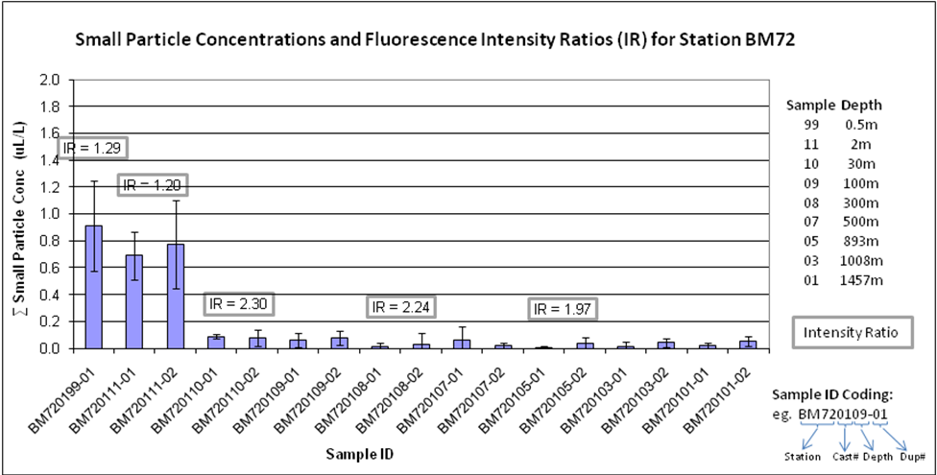

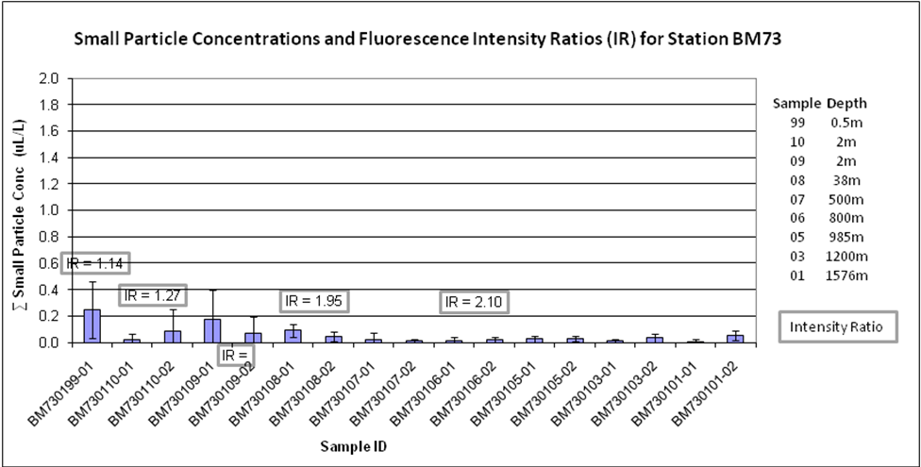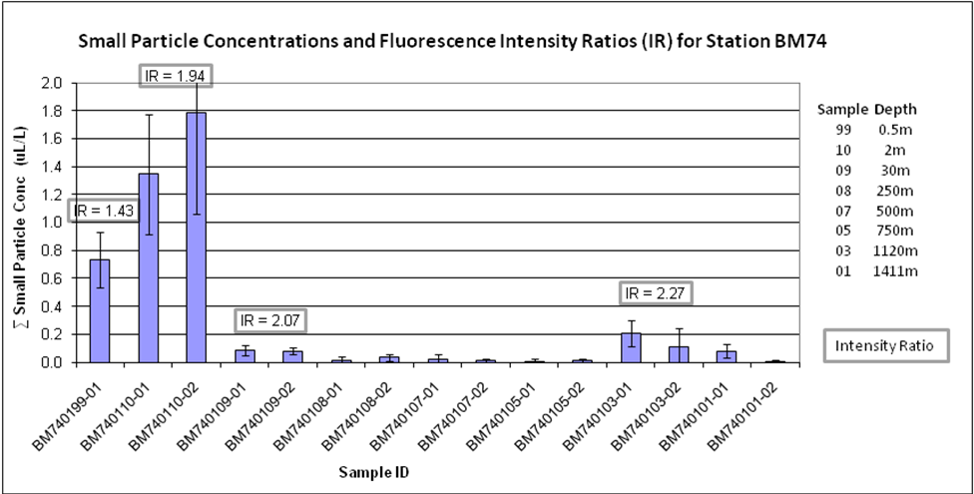

Figure 1: Average small particle concentrations and fluorescence intensity ratios as a function of depth for stations BM72 to BM74.

