Daily Report: Tracking the Plume of Dispersed Oil using Particle Size Distribution Measurements and Fluorescence Intensity Ratios

June 23, 2010

Water samples were collected at three stations for particle size distribution measurements using the LISST-100X particle counter. A total of 49 LISST samples were analyzed, including duplicates. Selected samples from depths of elevated fluorescence from the CTD trace were also collected for fluorescence intensity ratio measurements and analyzed using a Quantech Life Sciences fixed wavelength fluorometer.

Figure 1 presents the small droplet (∑ 2.5 - 60µm) particle size data and fluorescence intensity ratios for stations BM100 through BM102. Station BM100 was 5km south southeast of the wellhead, while station BM101 was 5km to south and BM102 was 2.7km to the south southwest of the wellhead.

The concentration of small particles was low at all depths for stations BM100 and BM101. Station BM102 at all depths, except at 2m, showed no evidence of small particles. As this had not been observed previously, a field calibration was performed. This calibration showed that the instrument was functioning properly and indicated that the data at BM102 was valid.

In the near surface waters (2m or less) at station BM100, the fluorescence intensity ratios were similar to those seen previously. The ratios were slightly higher at stations BM101 and BM103 than what have been recently observed at other sampling stations.

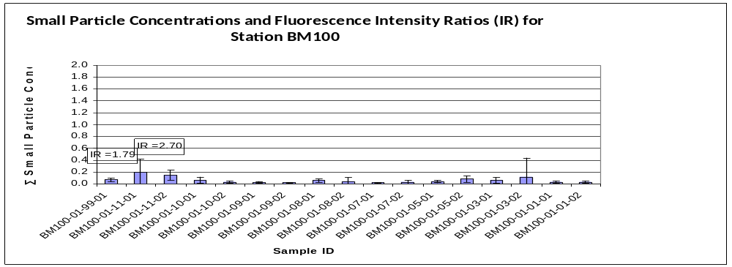
Sample
99
11
10
09
08
07
05
03
01
Depth
0.5m
2m
100m
250m
500m
750m
900m
1150m
1595m
Intensity Ratio (IR)
Sample ID Coding:
eg. BM1000109-01

Station Cast# Depth Dup#

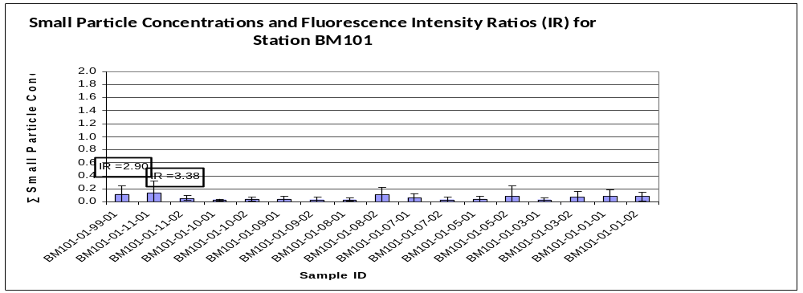
Sample
99
11
10
09
08
07
05
03
01
Depth
0.5m
2m
100m
250m
500m
750m
900m
1150m
1616m
Intensity Ratio(IR)
Sample ID Coding:
eg. BM1010109-01

Station Cast# Depth Dup#
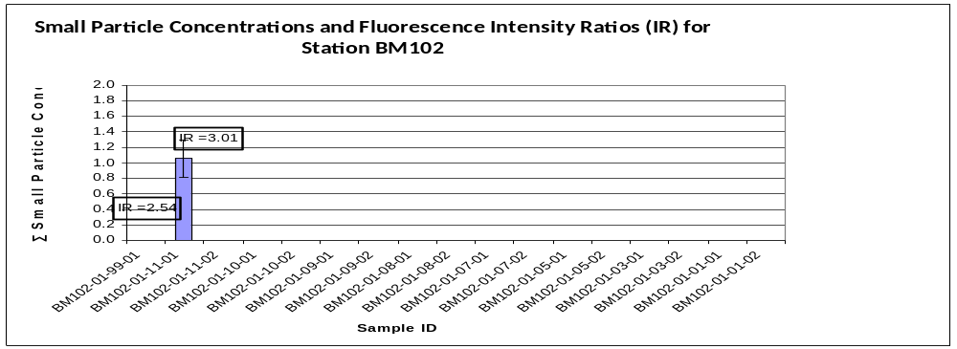
Sample
99
11
10
09
08
07
05
01
Depth
0.5m
2m
250m
500m
750m
1050m
1150m
1581m
Intensity Ratio (IR)
Sample ID Coding:
eg. BM1020109-01

Station Cast# Depth Dup#

Figure 1: Average small particle concentrations and fluorescence intensity ratios as a function of depth for stations BM100 to BM102.

