Daily Report: Tracking the Plume of Dispersed Oil using Particle Size Distribution Measurements and Fluorescence Intensity Ratios

June 24, 2010

Water samples were collected at four stations for particle size distribution measurements using the LISST-100X particle counter. A total of 63 LISST samples were analyzed, including duplicates. Selected samples from depths of elevated fluorescence from the CTD trace were also collected for fluorescence intensity ratio measurements and analyzed using a Quantech Life Sciences fixed wavelength fluorometer.

Figure 1 presents the small droplet (∑ 2.5 - 60µm) particle size data and fluorescence intensity ratios for stations BM103 through BM106. Station BM103, BM104 and BM105 were 2km, 5km, and 7km west of the wellhead respectively. Station BM106 was 5km south southwest of the wellhead.

The concentration of small particles was low at all depths for stations BM104 and BM106, but were slightly elevated near the surface (<100m) for station BM103. A subsurface plume was detected at stations BM103, BM104 and BM106 by the CTD fluorometer. Only at station BM103 were there elevated small particles.

The fluorescence intensity ratios tended to be similar at the surface to those observed in the previously, except at station BM103 which appeared higher. The ratios associated with the subsurface plume were similar to those seen in previous plumes, with those observed at BM103 being slighter higher then those seen at either BM104 or BM106.

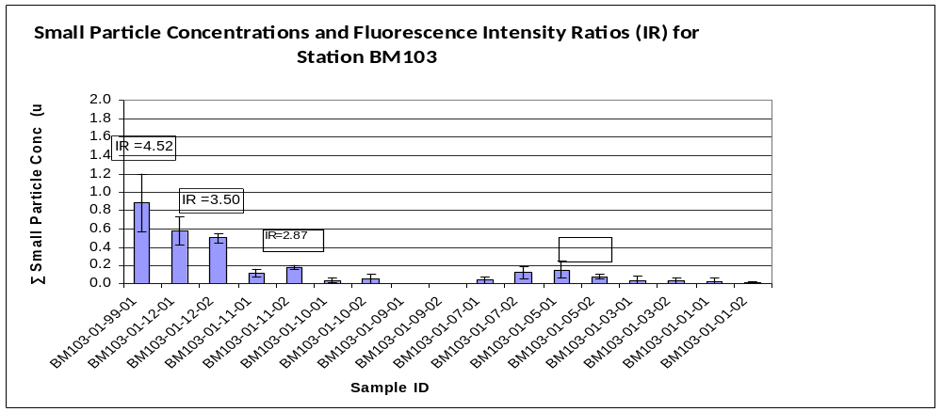
Sample
99
12
11
10
09
07
05
03
01
Depth
0.5m
2m
50m
250m
500m
1099m
1154m
1249m
1479m
Intensity Ratio (IR)
Sample ID Coding:
eg. BM103-01-09-01

Station Cast# Depth Dup#
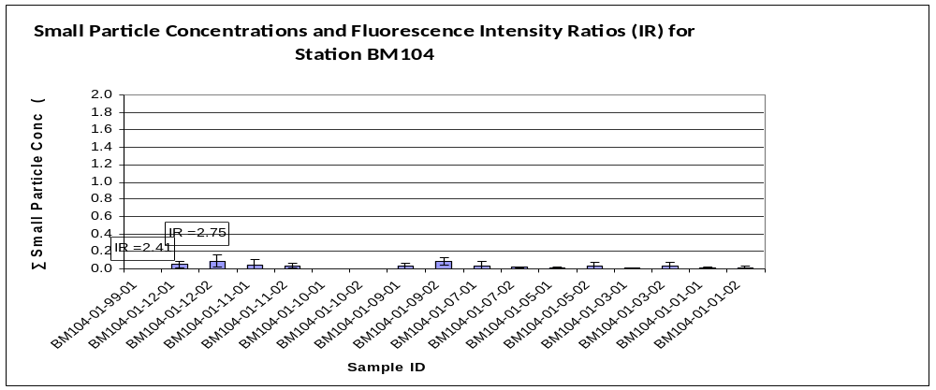
Sample
99
12
11
09
07
05
03
01
Depth
0.5m
3m
500m
1049m
1109m
1159m
1224m
1494m
Intensity Ratio (IR)
Sample ID Coding:
eg. BM104-01-09-01

Station Cast# Depth Dup#
IR=3.30
IR=3.29
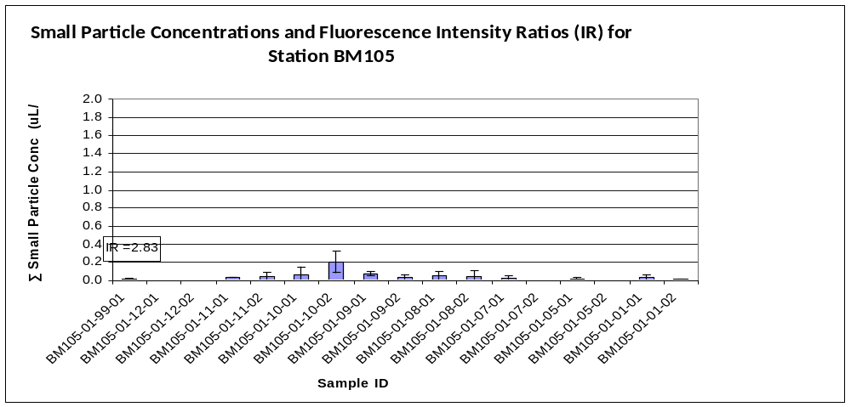
Sample
99
11
10
09
08
07
05
01
Depth
0.5m
2m
250m
499m
750m
899m
1110m
1454m
Intensity Ratio (IR)
Sample ID Coding:
eg. BM105-01-09-01

Station Cast# Depth Dup#
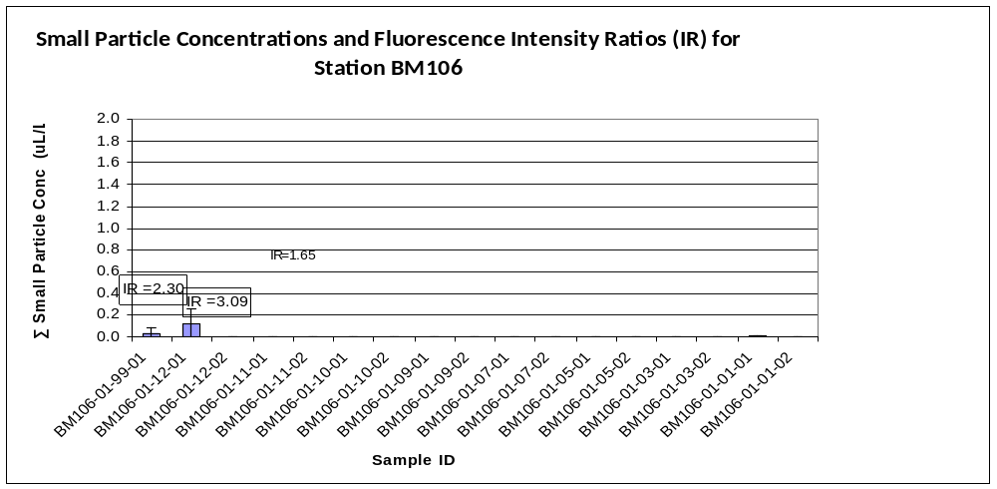Figure 1: Average small particle concentrations and fluorescence intensity ratios as a function of depth for stations BM103 to BM106.
Sample
99
12
11
10
09
07
05
03
01
Depth
0.5m
2m
81m
225m
600m
1079m
1149m
1199m
1520m
Intensity Ratio (IR)
Sample ID Coding:
eg. BM106-01-09-01

Station Cast# Depth Dup#
IR=2.00

