Daily Report: Tracking the Plume of Dispersed Oil using Particle Size Distribution Measurements and Fluorescence Intensity Ratios

June 25, 2010

Water samples were collected at four stations for particle size distribution measurements using the LISST-100X particle counter. A total of 77 LISST samples were analyzed, including duplicates. Selected samples from depths of elevated fluorescence from the CTD trace were also collected for fluorescence intensity ratio measurements and analyzed using a Quantech Life Sciences fixed wavelength fluorometer.

Figure 1 presents the small droplet (∑ 2.5 - 60µm) particle size data and fluorescence intensity ratios for stations BM107 through BM111. Station BM107 was 2.7km southwest, BM108 was 2.5km to the south of southwest, BM109 was 1.2km southwest, BM110 was 5km to the southwest, and BM 111 was 3.3km to the northwest of the wellhead.

Elevated concentrations of small particles were observed at depths corresponding to the subsurface plume detected by the CTD fluorometer. The subsurface plume was found at stations BM107, BM108, and BM109, but not at the other two. A slightly higher concentration of small particles was seen at the surface at stations BM 109 and BM111 as compared to the other three.

Generally speaking fluorescence intensity ratios were lower than those recently observed. There appeared to be very little difference in the ratios at the surface versus those at depth, and as well as little variation between stations.

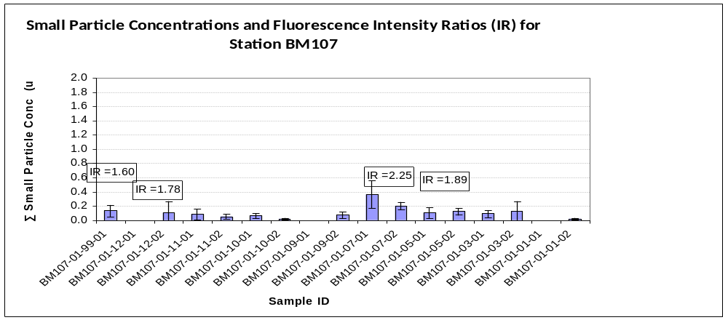

Sample Depth
99 0.5m
12 2m
11 150m
10 500m
09 939m
07 1130m
05 1159m
03 1199m
01 1538m

Intensity Ratio (IR)
Sample ID Coding:
eg. BM107-01-09-01

Station Cast# Depth Dup#

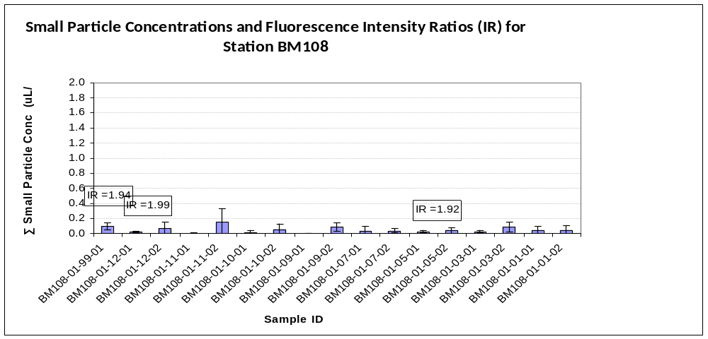

Sample Depth
99 0.5m
12 2m
11 250m
10 499m
09 950m
07 1100m
05 1153m
03 1199m
01 1566m

Intensity Ratio (IR)
Sample ID Coding:
eg. BM108-01-09-01

Station Cast# Depth Dup#
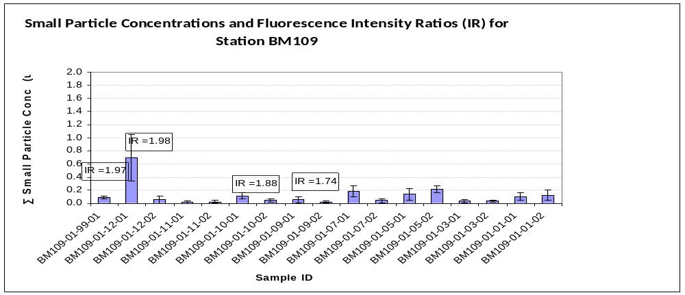

Sample Depth
99 0.5m
12 2m
11 250m
10 749m
09 950m
07 1079m
05 1120m
03 1249m
01 1541m

Intensity Ratio (IR)
Sample ID Coding:
eg. BM109-01-09-01

Station Cast# DepthDup#
IR=1.65
IR=1.81
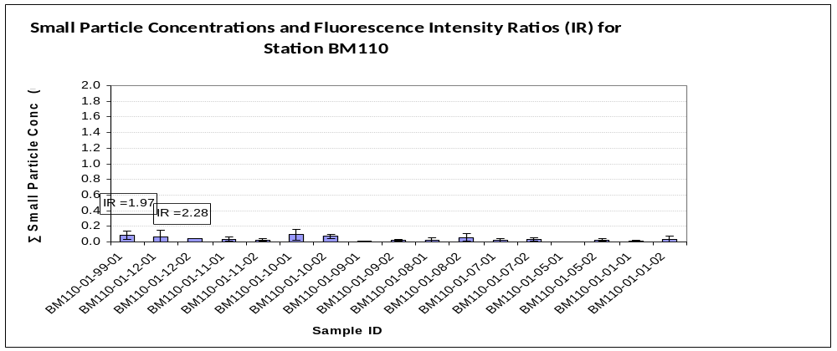

Sample Depth
99 0.5m
12 2m
11 250m
10 250m
09 500m
08 750m
07 1020m
05 1149m
01 1552m

Intensity Ratio (IR)
Sample ID Coding:
eg. BM110-01-09-01

Station Cast# Depth Dup#
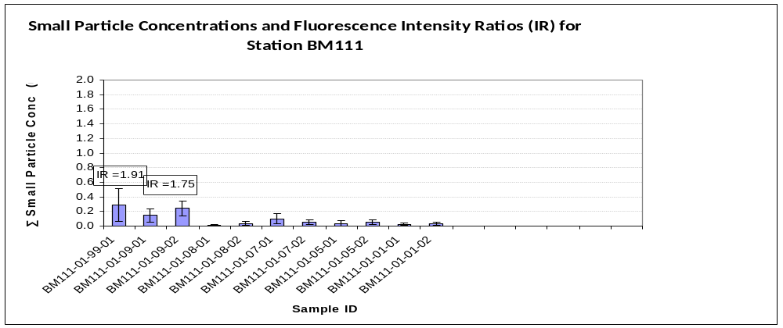Figure 1: Average small particle concentrations and fluorescence intensity ratios as a function of depth for stations BM107 to BM111.

Sample Depth
99 0.5m
09 2m
08 249m
07 899m
05 1149m
01 1405m

Intensity Ratio (IR) Sample ID Coding:
eg. BM111-01-09-01

Station Cast# Depth Dup#

