Daily Report: Tracking the Plume of Dispersed Oil using Particle Size Distribution Measurements and Fluorescence Intensity Ratios

July 18, 2010

Water samples were collected at four stations for particle size distribution measurements using the LISST-100X particle counter. A total of 24 LISST samples were analyzed, including duplicates. Samples at depths of elevated fluorescence or other significance were selected from the CTD trace for fluorescence intensity ratio measurements and analyzed using a Quantech Life Sciences fixed wavelength fluorometer.

Station | Latitude | Longitude
BM135 | 28.62048 | -88.41716
BM136 | 28.61849 | -88.41128

Station BM135 showed slightly elevated concentrations of small particles at 0.5m and between 1225 and 1250m depth. Station BM136 showed moderate-high small particle concentrations at the surface (0.5m) and slightly elevated concentrations down to 100m but low concentrations at depth.

Both stations sampled today showed fluorescence intensity ratios which were slightly higher at depth than at the surface, but overall, all fluorescence ratios were low.

Due to CTD problems encountered during station BM135 we were only able to complete two stations on this day.
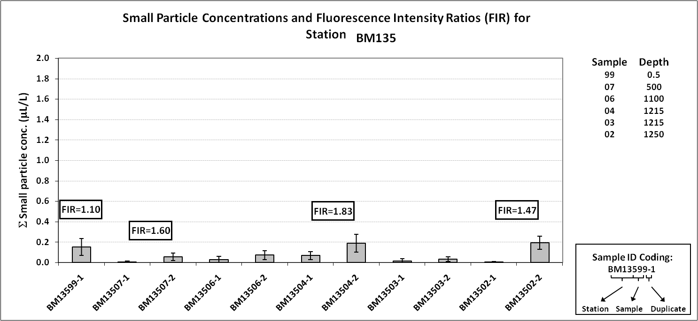

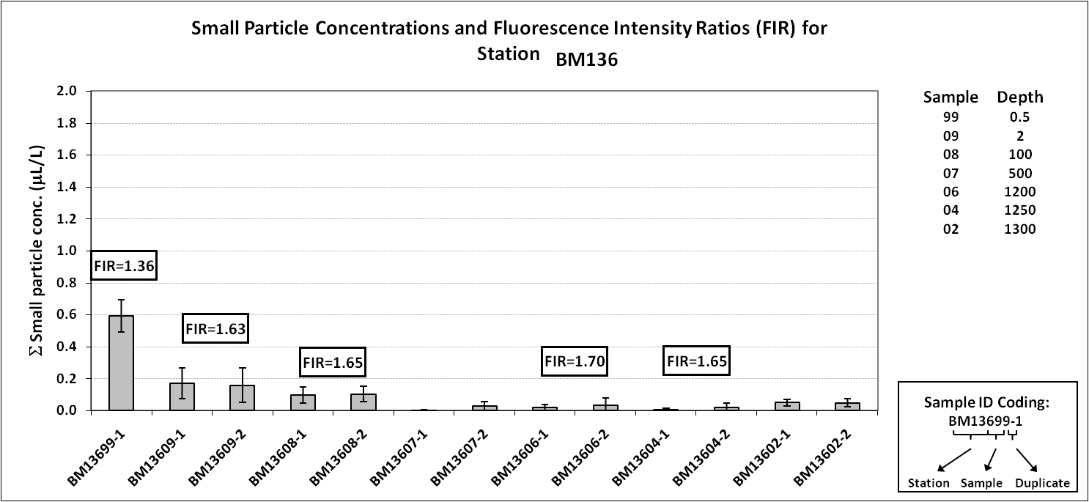
Figure 1: Average small particle concentrations and fluorescence intensity ratios as a function of depth for stations BM135 and BM136.

