17 July 2010 R/V Ferrel Status Report, Cruise 2 – Day 2

Complied by Tony Parkin, Chief Scientist

1.) Site Conditions, Daily Activities and Sampling Locations

Rain with thunder and lightening in the morning then sunny skies, calm seas with wave height only approximately 1-2 feet and light winds throughout the day.

This morning were able to locate an area of thick surface oil and heavy sheen and collected water samples immediately beneath the oil and then collected a surface sample of the oil itself. A water sample was collected from immediately beneath the surface for dissolved oxygen analysis and water quality data using a Hydrolab probe was collected from two feet beneath the surface. The remainder of the day was spent searching for another surface location but no suitable location was found. During transit to the original sample location to prepare for continued sampling in the morning the vessel was re-directed to standby south of the well head to start conducting CTD casts and water sampling in the morning.
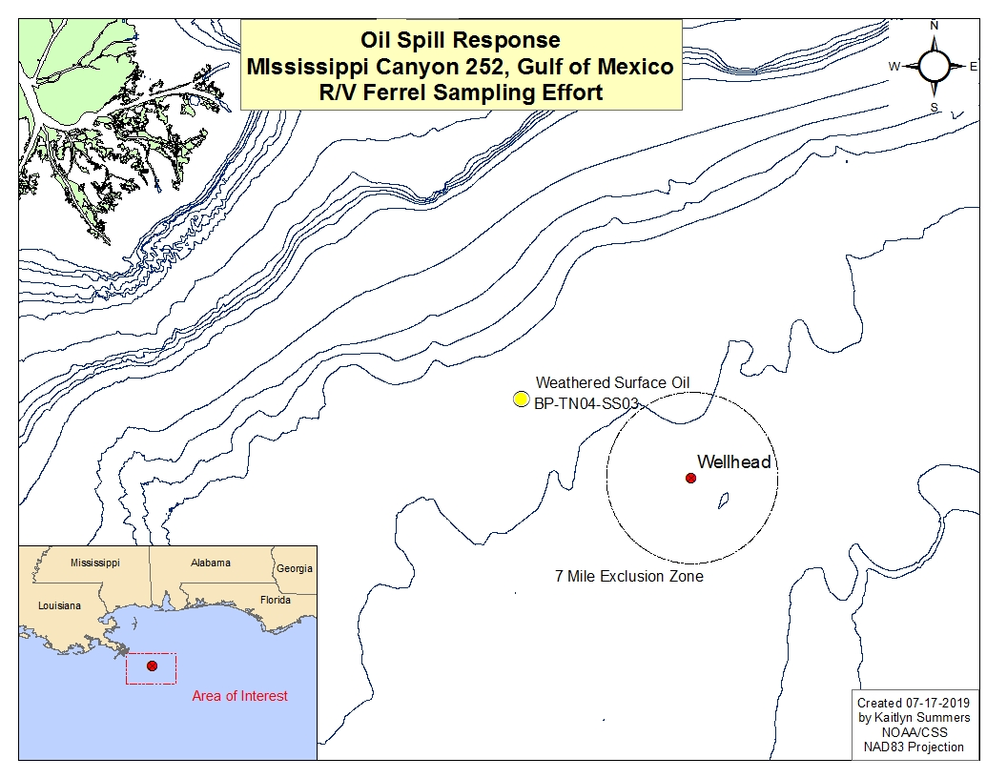

2.) Air Quality

The Industrial Hygienist conducted air monitoring measurements analyzing for CO, H₂S, LEL, O₂ and VOC’s. Samples were collected in the work area during sample collection and hourly throughout the day. Data collected showed no air quality concerns.

3.) Science Crew

Name | First Name | Affiliation | Role
Weber | Zach | CTEH | Assistant Scientist
Parkin | Tony | EM&A | Chief Scientist
Weiand | Corey | Entrix | Water Samples
Pelling | Ray | Entrix | Water Samples
Smith | Craig | C&C | Party Chief Team
Daigle | Brad | C&C | Oceanography Team
Burke | Emily | C&C | Oceanography Team
Wu | Cindy | LBNL | Microbiologist
Piceno | Yvette | NOAA | Microbiologist
Summers | Kaitlyn | NOAA | Data Management
Pawloski | Rod | Bureau Veritas | IH
Pendleton | Marcia | SMU | Microbiologist

