19 July 2010 R/V Ferrel Status Report, Cruise 2 – Day 4

Complied by Tony Parkin, Chief Scientist

1.) Site Conditions, Daily Activities and Sampling Locations

Today was generally sunny skies, calm seas with wave height only approximately 1-2 feet and light winds throughout the day. The R/V Ferrel stood-by overnight approximately 10 miles south east of the well head and conducted a CTD cast and water sampling during the morning. We then transited back to the original surface oil sampling location, approximately 10 miles west of the well head and we tracked to the northwest to locate the area of surface oil that we sampled originally. The direction was based on the predominant wind direction over the past few days and large patches of weathered oil, similar in appearance to the original oil patch was encountered 10 miles to the northwest of the original site and a second surface oil and water sample were collected.
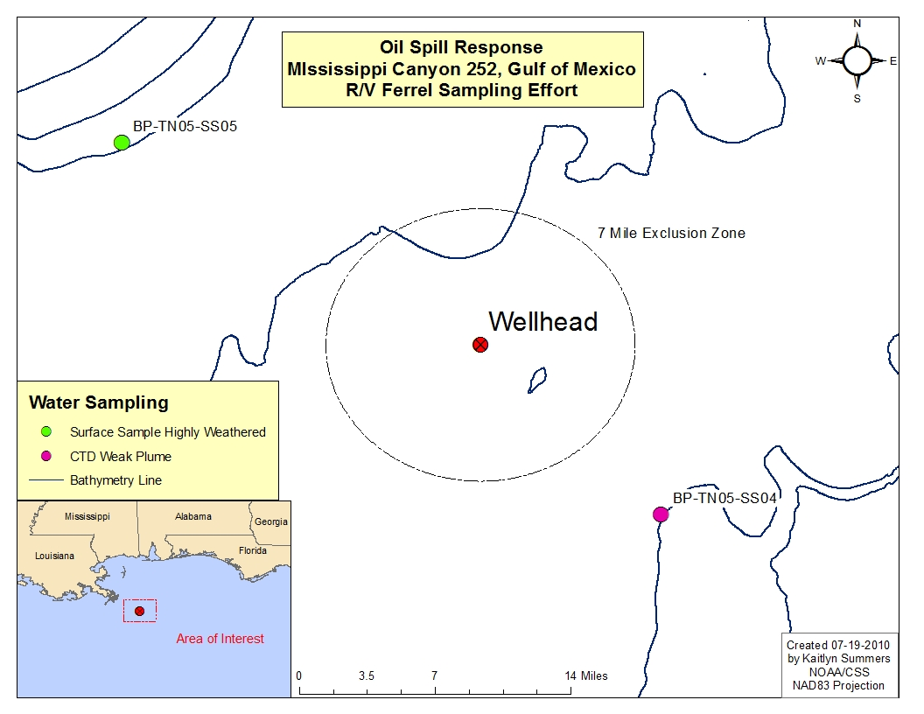

The results of the CTD cast are:

Station | Position from wellhead | Fluorescence  signal | Signal depth | Comment
BP-TN05-SS04 | 10 miles SE | Weak | 1200m – 1280m | One very weak signal centered at 1220m. No DO decrease with the peak in fluorescence.

2.) Air Quality

The Industrial Hygienist conducted air monitoring measurements analyzing for CO, H₂S, LEL, O₂ and VOC’s. Samples were collected in the work area during sample collection and hourly throughout the day. Data collected showed no air quality concerns.

3.) Science Crew

Name | First Name | Affiliation | Role
Weber | Zach | CTEH | Assistant Scientist
Parkin | Tony | EM&A | Chief Scientist
Weiand | Corey | Entrix | Water Samples
Pelling | Ray | Entrix | Water Samples
Smith | Craig | C&C | Party Chief Team
Daigle | Brad | C&C | Oceanography Team
Burke | Emily | C&C | Oceanography Team
Wu | Cindy | LBNL | Microbiologist
Davis | Yvette | NOAA | Microbiologist
Pecino | Kaitlyn | NOAA | Data Management
Pawloski | Rod | Bureau Veritas | IH
Pendleton | Marsha | Univ of S. Miss | Microbiologist

