Subsurface Monitoring Unit and NOAA NRDA
Responsibilities for Data Managers &
Explanation of Cruise Sampling Scheme

Version History
Version | Date | Author | Change Description
1.0 | 06/30/2010  7/7/2010 | SMU Data Manager/Tharyan George & Lauren Decker  NRDA Data Manager/Kelley Kugel | Initial Draft

The following guidance was written to cover the basic data manager responsibilities for both NOAA NRDA and response vessels. However, please realize that while on the vessel you will most likely need to provide assistance where necessary

SMU DATA MANAGER RESPONSIBILITIES

Introduction
Data managers on a cruise will fill out the required paper work, help the sampler with labeling bottles with the correct nomenclature, and ensure the paperwork and pertinent information make it to the response and NRDA FTP sites. You are expected to create a set of documents and associated CTD plots for each day of each cruise. These documents are referred to as Daily Deliverables, and are sent to EPADWH@gmail.com. Templates and examples are available on the response FTP site (listed below).
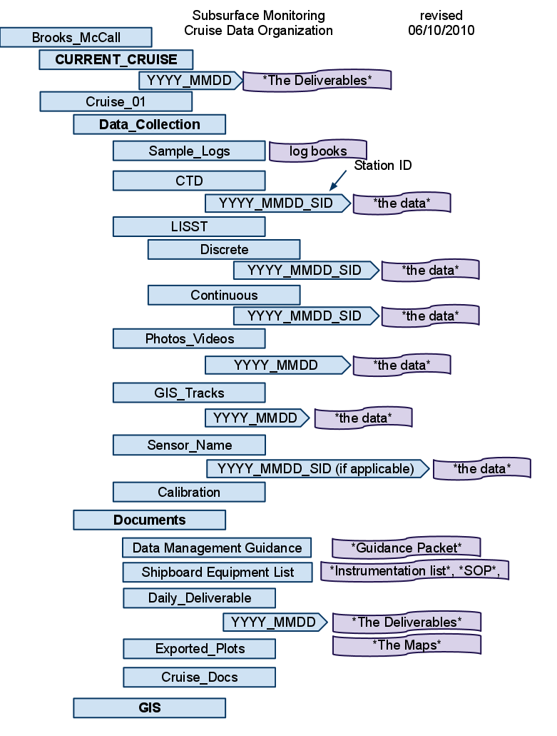
In addition, all the raw data, Chain of Custody (COC), pictures, GPS information, and Photologger form are required documentation for cruise data.
We staff a shore based Data Manager at the Houma Unified Incident Command Center to answer any questions that arise out of your duties as a ship based Data Manager.

Daily Deliverables
- Status Report
- Vessel Monitoring Log

- Sample Spreadsheets
- Rototox Spreadsheets (if applicable)
- CTD Plots (jpgs)

Location of Response Data Uploads
- Response SFTP location: sftp.orr.noaa.gov
- Email data.smu@noaa.gov for log in credentials
- See figure at right for example of folder structure

Explanation of Sample IDs
Example for Brooks McCall (BM): SW-20100608-BM08-01
(Matrix Code)-(Date)-(Vessel Code)-(Sequential#)
  - SW: (Matrix Code) SW for water samples, or an oil matrix code.
  - 20100608: (Date) The date the sample was collected in YYYYMMDD format.
  - BM08: (Vessel Code) – An alphanumeric string describing the vessels and cruise number.
  - 01: (Sequential#) – A number that is advanced for each sample collected on the same day, of the sample matrix type, and governed by the same Sample Program (or by the same Sampling Team).

Post-Cruise Required Documentation
After the cruise, zip your entire cruise folder structure into one zip file, and make sure the sample intake team uploads your sample’s Chain of Custody, Photos , Photologger Form, GPS track log, All Raw data & daily deliverables.

More Detailed Guidance
- For more information logon to our Wiki:
https://www.st.nmfs.noaa.gov/confluence/display/OOP/Home
[Relevant documents under “Data Management”]
- For detailed data management instructions, navigate on the sftp to:
/Deepwater_Horizon_Ext/Subsurface_Monitoring
/Vessel_Name/Cruise_##/Documents/Data_Management_Guidance
- Complete NOAA NRDA protocols and sample intake or shipping guidance are available on the FTP site (navigate to Home/Trustee Private Communications/Sample_Data/0_Instructions_and_Forms/ ).

For login information and help, email: data.SMU@noaa.gov or dwhnrda@gmail.com

