|  |  |  |  |  |  |  |  |  |
| --- | --- | --- | --- | --- | --- | --- | --- | --- |
| **CRUISE PLAN - SCOPE OF WORK**    Sediment Sampling  R/V Gyre  **Deepwater Horizon Oil Spill**    **Gulf of Mexico**  **September 2010**  **tdi-bi test2** | | | | | | | | |
|  |  | |  |  |  |  |  | |
| B | Version for additional details | | 6 Sept 2010 | NS |  | JB |  | |
| A | Draft for general comments | | 5 Sep 2010 | NS |  | JB |  | |
| Rev | Status | | Date | Originator | Checker | Approver | COMPANY | |
| **TDI-BI Project No.** | | **Client Reference or Document No.** | | | | | | **Total Pages** |
| J10868 | |  | | | | | | 13 |
| **TDI-BI Document No.** | | | | | |
|  | | | | | |
|  | | | | | | | | |

**INTRODUCTION**

The purpose of this work is to acquire data from sea floor sediment and water samples around the Macondo well (MC252), under known slick areas and in background “far-field” areas. This data includes measure of hydrocarbons in sediments, benthic community surveys, toxicity assessment and other variables such as sediment grain size and organic carbon content. The data will provide the means to understand the fate and effect of any oil deposited in the deep sea benthos since escaping from the well.

This field survey has been designed to provide information on the fate and effect of oil on the deep sea benthos as the execution phase of the overall project plan described in “Response of Deepwater Benthic communities to the Deepwater Horizon Oil Spill, Document # XXXXXX, version 9, 4 Sept 2010). The objectives of this project are to:

* Reoccupy historical sampling (DGoMB) sites and occupy other “far-field” sites under surface oil slicks and sheens, beneath sub-surface dispersed oil plumes and control sites, to measure:
* oil-spill derived contaminants in sediments,
* benthic community indicators of ecosystem health,
* toxicity, and
* other variables such as sediments grain size and organic carbon content.
* Sample in close proximity to the MC252 well to establish “near-field” measures of:
* oil-spill derived contaminants in sediments,
* benthic community indicators of ecosystem health,
* toxicity, and
* other variables such as sediments grain size and organic carbon content.

Marine Assurance and HSE issues raised by COMPANY will require resolution before operations can start.

All Navigation systems will be checked during vessel mobilization. Setup and calibration of the USBL system are detailed in Appendix 11.

Operations will be delivered in conformance with COMPANY HSE policies and standards for the task to be performed.

definitions and Acronyms

COMPANY British Petroleum

CONTRACTOR Subcontactor assigned for a specific task

DGoMB Deepwater Program: Northern Gulf of Mexico Continental Slope Habitats and Benthic Ecology

HSE Health, Safety and Environmental

MOC Management of Change

NOTMAR Notice to Mariners

TDI-BI TDI-Brooks International

USBL Ultra short baseline system

General Operations

Operations are to be performed according to the description laid out in this Scope of Work and in conformance with technical protocols appended to this document.

Onshore, the immediate point of contact for program direction, coordination, and support of the vessel from COMPANY shall be:

**Marine Science Coordinator:** Anthony Parkin

(410) 474 9813

Offshore the overall responsible person for control and safe delivery of the survey operations is the Party Chief.

**Gyre Party Chief:**  Neil Summer

(979) 220-3806

The Technical Team (Survey and Science) shall liaise with the Party Chief on all forward Survey Plans and issues arising.

The Party Chief will liaise with Jim Brooks (TDI-Brooks principal) regarding any engineering or supply issues ahead of any Port Call. The Party Chief will have overall responsibility for safety of sampling operations and HSE reporting to COMPANY.

The Science Party will be lead and coordinated by the Chief Scientist.

**Gyre Chief Scientist:** Neil Summer

(979) 220-3806

## The Chief Scientist will be responsible for overall delivery of the Science program aboard the vessel and laboratory safety. All safety incidents will be reported to the Party Chief for onward communication and action by COMPANY.

**BP Representative:** Brian Critchley

(504) 628-1126

The BP representative will be responsible for overseeing the work being performed by the contractor andby his sub-contractors in the execution of the scope of work, ensuring that the terms of the contract are met and that the work is carried out to the required standard and the COMPANY’s satisfaction.

This is an *Adaptive Cruise Plan* requiring onboard decision-making based on real-time data analysis. The ultimate responsibility for data acquisition locations shall be agreed between the Chief Scientist/Party Chief, BP representative, and on-shore project manager and COMPANY Marine Science Coordinator.

Prioritization of testing will rest with the vessel Chief Scientist in consultation with the COMPANY Marine Science Coordinator and the on board COMPANY representative.

**Sampling Stations -** Final sample locations and analytical plan will be provided to the vessel after COMPANY approval. Preliminary locations have been identified based on historical studies and the recent oil spill response surveys, and deemed clear of seafloor obstructions and outside of infrastructure exclusion zones. It is expected that locations will change and be added as the project.

The current plan consists of :

* Thirteen (13) “far-field” sites survey stations beneath where the subsurface oil plume has been tracked and possibly came into contact with the seabed. These stations will be used in a Before vs. After and Control vs. Impact (BACI) analysis to determine if oil is present and if the benthic community has responded.
* Nineteen (19) stations which have the highest probability of plume contact with sediments. Data from these stations will identify the spatial extent of effects.
* Sixteen (16) “near-field” wellhead stations laid out in a classic “bulls eye” design.

**Station Approach:** Upon approach to the sample station the vessel speed shall be dropped to 4 knots survey speed. Once the depth has been verified, the vessel will maintain station over the site.

**Corer Deployment and recovery:** When given permission to proceed, the winch operator will lower the corer equipped with a USBL beacon over the side of the vessel. The winch operator will lower the corer at 80-100m/minute under control so that it does not flip and tangle. The Bridge crew will “fly” the corer into a 30m radius bullseye on the seafloor as displayed on their bridge “Winfrog” display. At 50m off the sea floor the winch operator will slow descent to ensure corer verticality, and gently lower the unit onto the sea floor. After 10 seconds or enough time to obtain a good USBL fix, the corer will be retrieved to the surface and secured on the coring platform. Cores can either be processed on the platform or can be removed and carried vertically into the lab.

**Sampling Plan**

**Position Fixing**:

* DGPS fix of the vessel shall be recorded upon sampling
* USBL fix of the corer on bottom at the sampling station.

The average of 5-10 USBL fix coordinates shall be recorded as the “final” recorded sample location in the sample logs.

A log of the following shall be kept by the on watch Surveyor in a spreadsheet:

* Unique Sample Station Number [from the Science Team]
* Fix numbers
* Water depth in feet
* Date
* Time (local)
* Surface Conditions (surface sheen, water, “Black” oil, mousse)
* General Location description
* Weather conditions to include:
* Wind strength and direction,
* Current strength and direction of set,
* Wave height (feet),
* Swell (feet)
* Temperature,
* Cloud cover (oktas).

The spreadsheet entries recorded by the on-watch surveyor shall be shared with the Science Team on a regular basis.

**Sampling:** Samples shall be taken at Sample Stations using the Multicorer. Two units will be on board; the Mega (12 cores) and the Maxi (8 cores).

The mega corer will be preferentially used. The corer will be loaded with “tube carriers” consisting of head, core tube and bottom closer plunger. The 12 carriers will be sequentially numbered 1-12.

The 12 sediment cores will be allocated as per the project design to Macrofauna (3 cores), Meiofauna/toxicology (1 core), sediment properties (1 core), contaminants (1 core), bacteria (2 cores). Thus 8 good cores are required per drop. The 4 spare cores will either be utilized by one of the groups, or will be archived.

Cores will be assessed and accepted by the chief scientist in accord with the BP representative and science team recipients. Good cores will consist of an undisturbed water sediment interface, a ‘water head” and sufficient material for the recipient scientist to adequately complete their task. If the core is deemed unacceptable, one of the remaining spares will be assigned. If less than 8 acceptable cores are obtained in a single drop, then all material will be dumped, returned to the ocean and the station will be “reshot.”

Core allocation will be random as per the project design document and overseen by the Data Manager. Chain of custody will be maintained for all samples in accordance with…… (protocol) and documented by the Data Manager.

# Data Quality / Sampling Quality Control Plan

This section provides guidance for data quality assurance for the collection of field samples and data collection.

All data collection shall be recorded in a bound laboratory notebook with numbered pages, per general laboratory practices.

Data or log entry errors will be stricken with a single line and will be initialled by the person making the correction.

The sample number and sampling station shall be recorded on the Laboratory Management Program (LaMP) *“Project Information Form”* and *“Chain of Custody Record”* form, both which will be available to the science crew via Excel spreadsheet.

All sample equipment will be visually inspected before sampling. Decontamination or replacement of equipment will occur when fouling of equipment is noted. Any malfunction of data collection equipment or onboard testing shall be clearly documented.

All equipment requiring calibration will be done so in accordance with the manufacturer’s recommendations.

Any onboard QA/QC issues will be resolved with the onboard Chief Scientist in consultation with the BP on-board representative and if necessary, BP’s POC for Laboratory Quality Control:

Rock J. Vitale, CEAC, CPC

Consulting Chemistry

Environmental Standards, Inc.

Cell phone: 610-304-9972

# Data Management Plan

## 

## **Sample Data**

Data that is collected ship-board will be received in electronic (spreadsheet or graphic) or paper format and will be incorporated into a field sampling database.

All laboratory chemical analysis that is performed on collected water samples (PAH Analysis) will be received in digital spreadsheet format and incorporated into the field sampling database.

## 

**Waste Disposal**

All waste generated as part of this operation, such as equipment wash water and consumables, will be handled in compliance with the Houma IC Waste Management Plan.

**Health and Safety**

All oncoming crew shall receive a safety briefing and vessel orientation upon joining the vessel.

The Party Chief and Chief Scientist with the Vessel Master shall hold a pre-sail safety session with all other crewmembers. This safety briefing will cover all standard *R/V Gyre* vessel, safety and medical emergency protocols. Other topics to cover shall include communication issues, air quality, biological and chemical hazards, weather hazards, shipboard hazards, equipment use, etc.

All crew members must sign a Pre-Sail Meeting Safety form to verify they attended the meeting and complete the Emergency Notification Form. Completed details shall be provided to the Vessel Owner, TDI-Brooks international and COMPANY each time the vessel departs port.

Anyone onboard has the right to “*STOP THE JOB*” if they feel work is unsafe, or they feel they do not understand the work that is about to be performed and their own role in it.

Any HSE incidents shall be properly recorded and fully investigated if deemed necessary UAC HSE Advisors.

The shipboard COMPANY Industrial Hygienist (IH) will review all Material Safety Data Sheets for hazardous materials used onboard and ensure that appropriate safety protocols are being observed. In addition the IH will assess health and safety issues for the cruise to ensure the safety of the team. The IH has the authority to put additional safety protocols in place as the need arises.

Daily toolbox meetings will be held at 11am with representatives from both shifts. Shift changes must have at least 15 minutes of overlap to ensure good communications and continuity.

**Location, Vessel, and Crew Overview**

|  |  |  |  |  |
| --- | --- | --- | --- | --- |
| **1. Location Details** | |  | | |
| Gulf of Mexico | | Locations to be finalized | | |
| **2. Summary of Acquisition Methods** | | |  | |
| Lead Contractor: | | TDI-Brooks International | | |
| Vessel: | | R/V Gyre  Bridge: TBA  Laboratory : TBA  Departure Port: Fourchon, LA | | |
| Surface Navigation: | | DGPS | | |
| **3. Operational Survey and Science Team** | | | | |
| **Name** | **Organization** | **Role** | | **Cell Phone** |
| SUMMER, Neil | TDI-Brooks | Party Chief/Chief Scientist | | 979 220-3806 |
| SPENCER, Wayne | TDI-Brooks | Navigator/USBL | |  |
| WEBB, Eddy | TDI-Brooks | Navigator/USBL | |  |
| CRITCHLEY, Brian | Metoc | BP Representative | | 504 628 1126 |
|  | Entrix | Data Manager | |  |
|  | Entrix | CoC/Inventory | |  |
|  | Entrix | CoC/Inventory | |  |
| FORTNEY, Julian | LBL | Microbial Scientist | |  |
|  | LBL | Microbial Scientist | |  |
| KALKE, Rick | TAMUCC | Fauna Analysis | |  |
| ARISMENDEZ, Sandra | TAMUCC | Fauna Analysis | |  |
| SPENCER, Abby | TDI-Brooks | Sediment Sampling | |  |
|  | TDI-Brooks | Sediment Sampling | |  |
|  |  | Toxicity Analysis | |  |
|  |  | Toxicity Analysis | |  |
| GREEN, Billy | TDI-Brooks | Winch Operator | |  |
| BOHN, Marty | TDI-Brooks | Winch operator | |  |
|  | TDI-Brooks | Coring Technician | |  |
|  | TDI-Brooks | Coring technician | |  |
|  |  | NOAA Representative | |  |
|  |  | NOAA Representative | |  |
|  |  |  | |  |

The Scientific party is comprised of personnel from a number of contractors. CONTRACTOR personnel will make every effort to cooperate with others in the crew and scientific party to ensure a safe and efficient operation.

# Communications Plan

This section outlines the basic communications event schedule for the monitoring cruise. The objective is to ensure clear communication between the vessel and the Unified Area Command (UAC) Environmental Unit.

## 

## **Responsibility for Transfer of Scientific Data**

Research Vessel: Chief Scientist – Neil Summer.

Unified Area Command Environmental Unit: COMPANY Environmental Consultant - TBD

## 

## **Summary of Scheduled Communication Events**

|  |  |  |  |  |
| --- | --- | --- | --- | --- |
| **Events** | **Scheduled Time** | **Frequency** | **Initiator** | **Recipient** |
| Daily Situation Update | 0900 | Daily (vox) | UAC Marine Science Coord. | Party Chief / Chief Scientist |
| Daily Activity Summary | 2000 | Daily (vox) | Party Chief /  Chief Scientist | UAC Marine Science Coord. |
| Significant Events:   * HSE Incident * Program completion * Significant finding * Departure for Port | As Required | As Required | Either | Either |
| DPR | 2400 | Daily (e-mail) | Party Chief /  Chief Scientist | UAC Marine Science Coord. |

## **Communication Protocols**

The contact for scientific information and coordination is:

Dr Gina Coelho: Scientific Cruise Coordination

UAC Environmental Unit

Cell phone: 410-474-0633

(subject to change with staffing changes)

Responsible for -

* Sharing all daily reports with the AC Environmental Unit representatives
* Coordinating all questions or requests for information related to the vessel research mission
* Integrating any changes to the original monitoring objectives into this adaptive cruise plan
* Coordinating transfer of samples to an approved laboratory for analysis

The contact for operational information and coordination is:

Dr Al Maki, Simultaneous Operations (SIMOP) - Houma ICP - Cell phone: 307-654-7135 (subject to change with staffing changes)

Responsible for -

* Ensuring the research vessel operations are integrated into daily on-water operations briefs
* Ensuring the research vessel Captain is updated daily with operational activities that will impact the research mission, including communication channels, NOTMARs, etc.
* Coordinating transfer of samples from the research vessel to shore via support boats (if required)
* Coordinating transfer of additional equipment to the vessel via support boats (if required).

**Deviation to Scope of Work**

All deviations from specification are to be immediately drawn to the attention of BP Representative, and the Marine Science Coordinator and pre-agreed with the UAC Science Team prior to continuing with the works.

Work shall not continue if agreement has not been reached on the acceptability or non-acceptability of the deviation to specification.

**Attachments**

**Attachment 1: Geodesy**

**Attachment 2: Acknowledgement of Safety Training and Emergency Contact Information**

**Attachment 3: Adaptive Monitoring Plan – Change Tracking Form**

**Attachment 4: Deepwater Horizon Analytical Request Form (ARF) Process Plan MC252-SOP-07**

**Attachment 5: ARF Form Completed Sample**

**Attachment 6: Data Package Deliverable Requirements**

**Attachment 7: Deepwater Horizon Standard Operating Procedure for Sample Labelling, Packing, and Transport MC252-SOP-01**

**Attachment 8: Deepwater Horizon Standard Operating Procedure for Sample Management Program MC252-SOP-03**

**Attachment 9: LBNL Sampling Protocol (July 3, 2010)**

**Attachment 10: Project Design - Response of Deepwater Benthic Communities to the Deepwater Horizon Oil spill**

**Attachment 11 USBL positioning system**

**Attachment 12 Multicorer – Standard operating procedure**

Attachment 1

Geodesy

The survey is based on NAD27/UTM Zone 16/US Survey Feet and the following related grid projection, spheroid and geodetic parameters :

|  |  |  |
| --- | --- | --- |
| **Project Geodetic Parameters** | | |
| Coordinate Reference System (CRS, a.k.a., Projected CRS or simply Grid System) | Common Coordinate Reference System Name | Universal Transverse Mercator (UTM) Zone 16 North as defined for use in conjunction with the North American Datum of 1927 in U.S. Survey Feet  (a.k.a. NAD27 / BLM 16N / ftUS) |
|  | EPSG Code | 32066 |
|  | CRS or Grid System Units | U.S. Survey Feet |
|  | Projection Function Employed | Transverse Mercator (Gauss Kruger) |
|  | Central Meridian (CM) | 87° W |
|  | Latitude of Origin | 0° N |
|  | False Easting 1 | 1640416.667 U.S. Survey Feet |
|  | False Northing | 0.000 U.S. Survey Feet |
|  | Scale Factor on CM | 0.9996 |
| Horizontal Datum | Local Datum Name | North American Datum 1927 |
|  | Ellipsoid Employed | Clarke 1866 |
|  | Semi-Major Axis (a) 2 | 6,378,206.4 meters |
|  | Semi-Minor Axis (b) 2 | 6,356,583.8 meters |
|  | Eccentricity Squared (e^2) 3 | 0.006768657997 |
|  | Inverse Flattening (1/f) 4 | 294.9786982139 |
|  | NAD27 <-> NAD83 Datum Transformation 5 | NADCON 2.1 |

Important Notes:

1. Equivalent to 500,000.0 meters where 1 U.S. Survey Foot = 1200/3937 SI Meters exactly

2. Taken as exact values

3. Derived from a and b where e^2 = 1-b^2/a^2

4. Derived from a and b where f = 1-b/a

5. The transform between NAD27 and NAD83 should be done through NADCON 2.1 (where NAD83 is considered to be functionally equivalent to WGS84/ITRF for GoM operations)

Attachment 2

**Acknowledgement of Safety Training and Emergency Contact Information**

|  |  |  |  |  |  |
| --- | --- | --- | --- | --- | --- |
| **Your Name** | **Signature to Verify Receipt of Safety Training** | **Emergency Contact Information** | | | |
| **Name** | **Relation to You** | **Phone** | **Alternate Phone** |
|  |  |  |  |  |  |
|  |  |  |  |  |  |
|  |  |  |  |  |  |
|  |  |  |  |  |  |
|  |  |  |  |  |  |
|  |  |  |  |  |  |
|  |  |  |  |  |  |
|  |  |  |  |  |  |
|  |  |  |  |  |  |
|  |  |  |  |  |  |
|  |  |  |  |  |  |
|  |  |  |  |  |  |
|  |  |  |  |  |  |
|  |  |  |  |  |  |

# Attachment 3

**Adaptive Monitoring Plan – Change Tracking Form**

|  |  |  |  |
| --- | --- | --- | --- |
| **Date** | **Person Issuing Change** | **Description of Change** | **Rationale for Change** |
|  |  |  |  |
|  |  |  |  |
|  |  |  |  |
|  |  |  |  |
|  |  |  |  |
|  |  |  |  |
|  |  |  |  |
|  |  |  |  |
|  |  |  |  |
|  |  |  |  |
|  |  |  |  |
|  |  |  |  |
|  |  |  |  |
|  |  |  |  |
|  |  |  |  |

**Attachment 11**

### USBL Positioning System: Kongsberg Simrad HPR400P

The HPR 400P is an Ultra-Short Baseline (USBL) system (**Figure 5**) for navigating and tracking the position of the core rigs with respect to the vessel. Together with dedicated USBL software, transceiver deck-box, in-water transducer, and deployed transponders, this system is a complete underwater-deployed-gear tracking system. The calculation of position is based on range, vertical and horizontal angle measurements, giving three dimensional transponder positions relative to the system’s transducer. Specifications are given in **Table 9**.



Figure 5. Kongsberg Simrad HPR400.

Table 9. Kongsberg Simrad HPR400P specifications.

|  |  |  |  |
| --- | --- | --- | --- |
| **Transducer type** | **Accuracy** | **TD type** | The specification is based on:  • Line of sight from transducer to transponder  • No influence from ray-bending  • Signal-to-Noise ratio in the receiver ≥ 20 dB rel. 1μPa  • Relevant signal output from transponder  • No error from heading and roll / pitch sensors |
| HPR PMT 301, MF 20-32 kHz - Wide beam ±80° | ≤ 2 % of slant range | PMT-089962 |
| HPR Standard, MF 20-32 kHz - Wide beam ±80° - Medium beam ±55° | ≤ 5 % of slant range ≤ 2 % of slant range | TDS-067538 |
| HPR Narrow beam, MF 20-32 kHz - Wide beam ±80° - Narrow beam ±22.5° | ≤ 5 % of slant range ≤ 1 % of slant range | TDN-081633 |
| HPR, LF 10-15 kHz  - Wide beam ±80°  - Medium beam ±55° | ≤ 5 % of slant range  ≤ 2 % of slant range | TDL-0834290 |
| **Transponder type** | **Operating range** | | The range capabilities depends on; the vessels  noise level, transponder signal level and transducer type. Ray-bending effects may also reduce the operating range. |
| Standard transponder w/ 188 dB SL | Typical 800 m - 1500 m | |
| High power transponder w/ 195 dB SL | Typical 1500 m - 2000 m | |
| High power transponder w/ 206 dB SL | Typical 2500 m - 4000 m | |

***Integrated Navigation System Mobilization***

**TDI-Brooks** will use the Kongsberg HPR400P portable Ultra-Short Baseline (USBL) core rig positioning system in conjunction with a vessel navigation computer system for the placement of the core rigs on the seabed. Precise navigation of the vessel and the core rig will be provided by integrating this USBL system with the DGPS signals using a C&C Technologies C-Nav 2050M GPS receiver, the vessel’s gyroscope, and a motion reference unit (MRU). This gear is electronically integrated using serial (RS232) interfaces into our navigation computers. The locations of installed components of this system are re-measured with respect to a defined Central Reference Point (CRP) on the vessel during each mobilization, and re-confirmed in the navigation software.

Each deployed core rig will be fitted with a Kongsberg MST342 (3,000 m) transponder that responds to the USBL system’s pole-mounted transducer’s interrogations when deployed in the water on the core rig. The pole-mounted transducer then translates the acoustic responses from each deployed transponder to produce the transponder’s current position in ***X***, ***Y***, and ***Z*** (m), relative to the transducer head. A schematic of this integrated system is shown in **Figure 1**.

**Side-Mounted Pole**

**Motion Reference Unit (MRU) for pitch and Roll**

**DGPS**

**signal**

**WinFrog**

**Navigation**

**Computer**

**MST 342 transponder on Core Rig**

**Figure 1. Integrated Vessel and Core Rig Navigation System**

The C-Nav antenna used for the primary DGPS signal will be mounted at a fixed and known offset location with respect to the vessel’s defined Central Reference Point (CRP), as will be the sheave-points of the A-frames used for coring, the USBL transducer head, and the MRU. The current working hardware reference points and their offsets from CRP on ***R/V Brooks McCall*** are shown in **Table 1** below. Each of these offsets will be measured for the Gyre and confirmed during mobilization.

**Table 16. Hardware Offsets (m) with respect to the vessel CRP. (Books McCall)**



The Geodetic System as specified by the waypoints issued by the Client will be entered into the navigation computer and the specified geodetic parameters will be confirmed. We will check that all offsets are being applied correctly at the surface, as a gross error check. For this, we will supply BP with real time and simultaneous data dump which shows:

* Raw DGPS antenna position
* Vessel Pitch, roll and heading
* Vessel offsets
* Computed position of vessel offset points (stern sheave and starboard A-frame sheave)

We will also be provided by BP a WGS84 test point to verify that datum transformations are being handled correctly. For this work, we will convert to NAD27, UTM15N, US Survey Feet. All conversions from WGS84 will use real time NADCON.

Because the locations of the transducer and the DGPS antenna are both accurately known with respect to the vessel CRP, the current position and depth of the core rig with respect to the working Datum is deduced by the USBL computer in real time using Kongsberg *APOS* *rev 4.4* USBL navigation software. This set of trigonometric calculations is represented in **Figure 2.** The *APOS* program processes incoming information about the vessel position, heading, and attitude in real time to determine the exact position in space of the transducer head several times per second. Then *APOS* applies the information it receives from interrogating the transponders deployed on the core rig to trigonometrically calculate the position in space of each transponder. The reported position of the transponder lags behind real time by the two-way travel time of sound.

The *APOS* computer will be interfaced to our standard ***Pelagos WinFrog rev 3.7*** navigation software via RS232 so that this real time position of the deployed transponder can be displayed on monitors in the navigation room, at the helm, and in the winch house. WinFrog will also log the reported positions of the active vessel devices and the transponders.

**Figure 2. Core rig navigation trigonometry.**

**Checkout and calibration**

***Transducer Alignment Procedure***

On the way to the job site, the USBL transducer will be re-calibrated. The purpose of such a calibration of the USBL hardware (more properly called transducer alignment) is to find and minimize the errors in the USBL transducer installation that translate into pitch, roll, and heading offsets from zero (or perfect) in each rotational dimension. A perfect installation would have the transducer perfectly aligned with the vessel attitude when the pole is down and secure, with no tilt of the transducer head in **pitch** or **roll** rotation, and no offset in heading (forward azimuth) **rotation** of the head compared to the vessel. Typical transducer head installation errors are less than 2° for each of these three dimensions of freedom. Once determined by our transducer alignment calibration exercise, offsets that mathematically cancel these installation errors are entered into APOS. Because we are trying to eliminate these errors by correcting for them mathematically, it is important that we obtain “clean” data so the processing program can resolve the errors from the measurement noise. It is for this reason that the alignment procedure is typically performed in 300 to 500 m water depth, as opposed to a deeper job site.

To begin an alignment procedure, a CTD cast will be performed at the 300-500 m water depth alignment site to gather salinity and temperature data for calculating a sound velocity profile in the water column. This profile will be put into the USBL computer in order to accurately determine distances using the travel time of sound waves propagating through the seawater. A transponder will then be placed on the sea floor and the vessel maneuvered around the transponder, staying within 30-50 meters laterally, depending on actual water depth. Transponder position data will be gathered during this exercise, and submitted to the *APOS* alignment algorithm. The maneuvering pattern for data-gathering will be a circle at a reasonably constant heading (**Figure 3**).

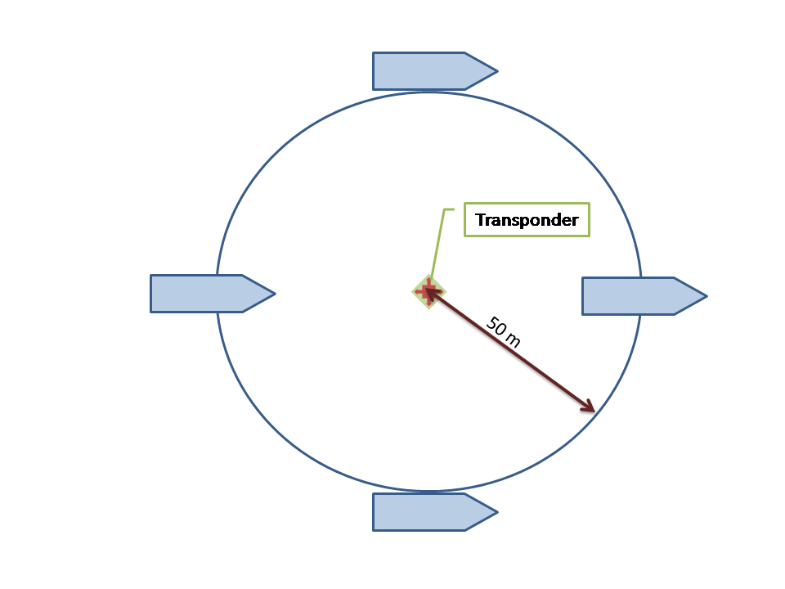

**Figure 3. Schematic vessel manoeuvres during USBL transducer alignment procedure.**

This alignment algorithm considers the apparent position of the transponder in X, Y, and Z for each navigational fix during the maneuvers, and then proposes a set of offsets for the pitch, roll, and rotation of the installed transducer head that make the transponder fixes the most consistent over the entire data set. These calculated offsets will then be entered into *APOS* to correct for installation error.

***Example Transducer Alignment***

On a recent job, we transited to a site for the USBL transducer alignment in water depth of about 400 m. We performed a CTD cast there using a Seabird SBE-19 recently-calibrated instrument. We measured conductivity, temperature, and pressure once per second while lowering then raising the CTD instrument at about 1 m/s. Upon retrieval of the CTD, we uploaded the data from the cast via RS232 into a computer for processing using Seabird *SeaTerm* software. We then produced a table of water depths and sound velocities as a CSV file using the Seabird *SBEDataProcessing* software.

The CSV-formatted sound velocity profile from the CTD cast at the USBL alignment site was loaded into *APOS*. **Figure 4** is a plot of the sound velocity profile and the derived “ray-bending” diagram from that cast. The ray bending diagram is used to discern any region of water structure nearby (due to atypical gradients of salinity or temperature) that would render the sound USBL transducer-transponder positioning communications ambiguous. From the diagram we determined that no significant ray bending would occur at this site. With this sound velocity profile entered into the *APOS* software, the communications between the transducer head and the deployed transponder will yield sound travel-time data that translate into very accurate measurements of distance and direction between them.

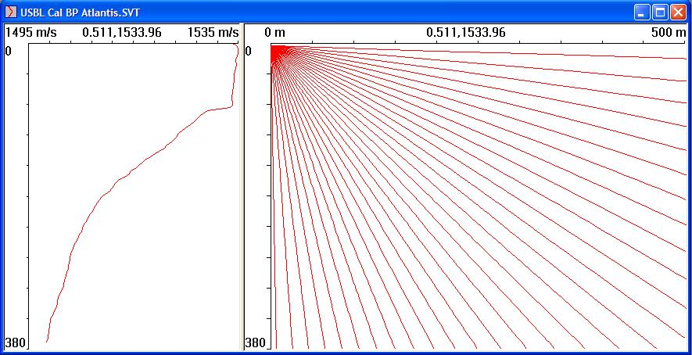

**Figure 4. Sound velocity profile at USBL transducer alignment site.**

A USBL transponder was then placed on the sea bed in preparation for alignment manoeuvres. The GPS antenna position signal was fed directly from the C-Nav DGPS unit into the *APOS* computer and the antenna position corrected in real time for pitch and roll using the MRU. A circle of radius 50 m was placed on the WinFrog navigation monitor, and this image was repeated at the helm and winch house, as usual. The helmsman was instructed to manoeuvre to each of four points around the circle, as indicated on the helmsman’s monitor. **Figure 5** below shows the vessel manoeuvring track during this calibration. The colors on the plot correspond to data that were accepted (non-red) and rejected (red) after data processing.

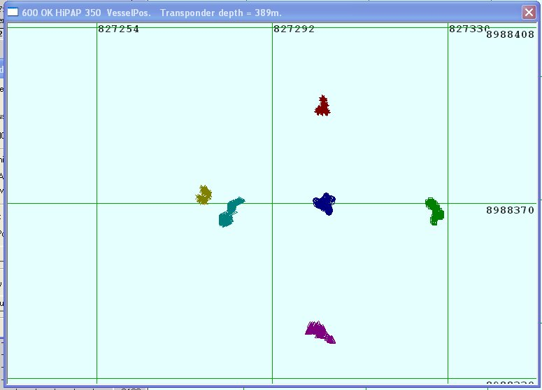

**Figure 5. Vessel track during USBL transducer alignment maneuvers.**After these maneuvers were completed, we applied the *APOS* algorithm to process the data and determine the best transducer head installation error offsets for the data set. A plot of the calculated transponder position for each of the fixes during the maneuvering exercise, after application of the compensating algorithm, is shown as **Figure 6** below.

|  |
| --- |
| A USBL cal cast 1 -- started 24JUN09 -- A |
| B USBL cal cast 1 -- started 24JUN09 -- A calculated |

**Figure 6. Raw transponder positions before USBL calibration (A) and transponder positions after application of the compensating algorithm (B).**

Red circles in the figure indicate measurements that were not used by the algorithm in the calculation. As it is known that the transponder will be at a constant depth, variations in the depth value are primarily caused by pitch and roll errors. The program adjusts the values of the pitch and roll to obtain a uniformed depth for all the readings. The precision of the compensated data is shown in the header of this figure. We also reviewed the data manually and reject a few other points that are outliers.

**Figure 23** is a screen capture from the APOS program of the USBL system, listing the pertinent results of this calibration exercise. The “Std Dev Tp Pos” values for **North** and **East** are less than 20 meters and for **Depth** is less than 3 meters. Such values are in the acceptable range for this calibration, and show the USBL system to be operating properly. Most pertinent of these alignment results are the derived **Transducer parameters** presented on the right middle of the figure. Rotational offsets of the transducer head in terms of **Roll**, **Pitch**, and **Gear**, are presented in degrees under **Calculated**. Pitch and Roll values are acceptable if less than 3°. The **Gear** parameter references the rotational offset between the USBL transducer heading and the vessel heading as reported by its gyro. Therefore, this USBL calibration exercise includes an extremely robust and independent gyro calibration. It is acceptable if between 355° and 5° relative to heading.

When the transducer installation rotational errors in pitch, roll, and heading are compensated (or nullified) by the measured rotational offsets in the application of the calibration results, the accuracy of a single position fix delivered by the system for a deployed transponder attached to a coring rig is specified to be ±1.0% of water depth or better. Because the gear is essentially directly beneath the vessel for coring, any residual heading error is rendered moot, improving accuracy to better than spec. When we accumulate several position fixes while the rig is at the seabed, we can apply statistical treatments to yield a mean position with a calculated variance about that mean, further improving accuracy of reported position as compared to a single fix. All in all, we believe that we are reporting core positions for this program to within perhaps ±0.5% of water depth at one standard deviation of probability.

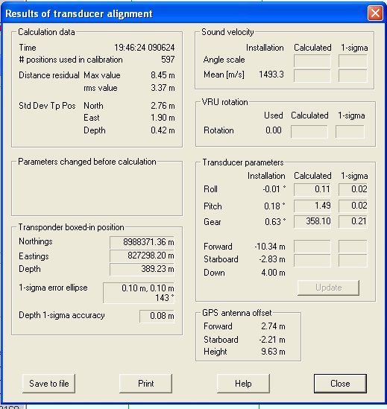

**Figure 7. Results of an example transducer alignment exercise.**