Vessel Cruise # Daily Report Report

Period covered: 0000 hrs 06/08/2010- 2400 hrs 06/08/2010

# Vessel science party:

|  |  |  |
| --- | --- | --- |
| Name | Position | Email/Phone |
| Jon Hare  Paul Walline  Jim Burkitt*  Vince Guida  Nick Mitchell*  Tamara Holzwarth-Davis  Betsy Broughton  Ashok Deshpande  Lauren Ridley  Liza Baskin  David Graves  Doug Alvey  Regina Easley  Christopher Sumner | Chief Scientist  Acoustic Lead  Acoustics  Acoustics  Acoustics  CTD  CTD  Chemistry Lead  Chemsitry  Chemistry dO  SMU Data Manager  SMU IH  NRDA Sample Rep  BP/Entrix | [jon.hare@noaa.gov](mailto:jon.hare@noaa.gov)  [paul.walline@noaa.gov](mailto:paul.walline@noaa.gov)  [james.w.burkitt@noaa.gv](mailto:james.w.burkitt@noaa.gv)  [Vincent.guide@noaa.gov](mailto:Vincent.guide@noaa.gov)  [nickolas.mitchell@noaa.gov](mailto:nickolas.mitchell@noaa.gov)  [tamara.holzwarth-davis@noaa.gov](mailto:tamara.holzwarth-davis@noaa.gov)  [Elisabeth.broughton@noaa.gov](mailto:Elisabeth.broughton@noaa.gov)  [Ashok.deshpande@noaa.gov](mailto:Ashok.deshpande@noaa.gov)  [lauren.ridley@student.shu.edu](mailto:lauren.ridley@student.shu.edu)  [lbaskin@me.com](mailto:lbaskin@me.com)  [dgraves@consolidatedsafety.com](mailto:dgraves@consolidatedsafety.com)  [Doug.Alvey@louisberger.com](mailto:Doug.Alvey@louisberger.com)  [reasley@mail.usf.edu](mailto:reasley@mail.usf.edu)  [CSumner@entrix.com](mailto:CSumner@entrix.com) |
| * ships crew working on acoustics with science party | | |

# Daily Operations:

|  |  |  |  |  |  |
| --- | --- | --- | --- | --- | --- |
| Y | CTD Casts | Y | Sampling – VOA |  | PAH Detection |
| Y | Fluorometry |  | GCMS |  | Biota |
|  | LISST | Y | Acoustics |  | Rototox |
| Y | Sampling – TPH |  | MOCNESS |  | Other: |
|  | | | | | |

# Cruise notes:

Conducted acoustic surveys until dawn. Picked up winch rep from PISCES. Retrminated forward winch and repaired aft winch late morning to early afternoon; made two passes over wellhead; performed one CTD – dip in dO2 at 1100 m evident – water samples collected; CTD about to be deployed

Science results and preliminary interpretation:   
*Acoustics*

One seep detected during 24 hour period south-southeast of well head; crossed wellhead 2x (Figure 2); acoustic signal weak but still there

# (please attach any images at end of document)

*Fluorometry and Dissolved Oxygen results*

|  |  |  |  |  |  |  |
| --- | --- | --- | --- | --- | --- | --- |
| Station | Lat/Lon | Position from Wellhead | DO anomaly | Fluorescence Range | Signal Depth | Comments |
|  |  |  |  |  |  |  |
|  |  |  |  |  |  |  |
|  |  |  |  |  |  |  |
|  |  |  |  |  |  |  |
|  |  |  |  |  |  |  |
|  |  |  |  |  |  |  |
|  |  |  |  |  |  |  |
|  |  |  |  |  |  |  |

See data manager report

*Chemistry: GCMS / HAPSITE*

dO dip at 1100 m on 1 ctd cast (Figure 1)

*Microbial analysis (if applicable)*

*Other Observations*

## Operational / Logistical issues:

## Planned activities for next 24 hours:

Conduct acoustic surveys in morning

Start 24 hour ctd ops at 1200

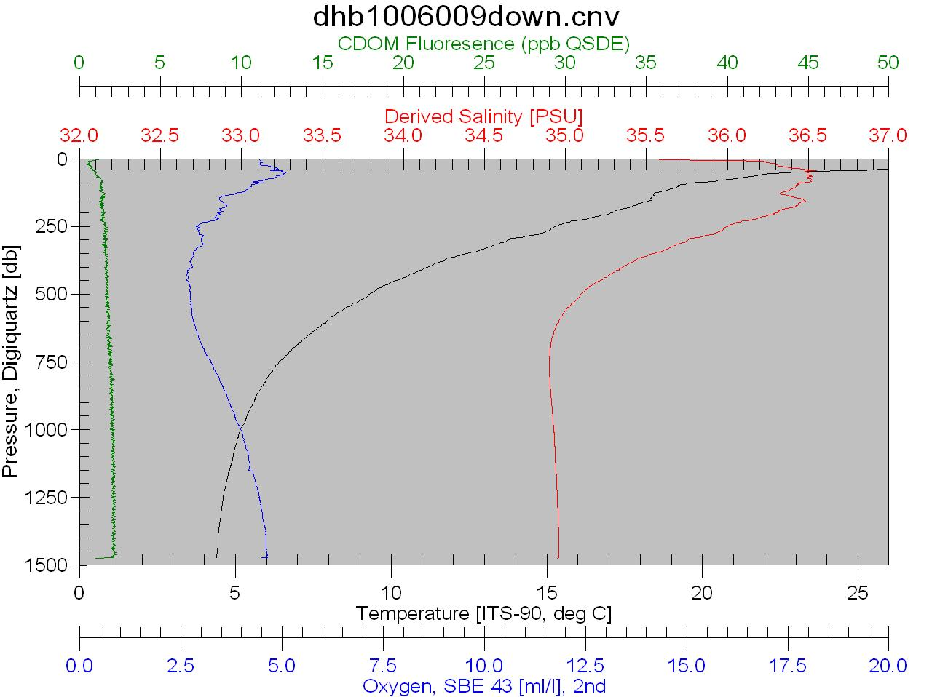

Figure 1 – CTD 2 miles south-southeast of wellhead – small dO2 dip at ~1100



Figure 2 – Screenshots of pre and post wellhead monitoring. Acoustic return in post-feature is low relative to the pre-feature and background noise is higher post-feature than pre-feature.