Henry B. Bigelow Cruise HB-10-06 Leg 2 Daily Report
Period covered: 0000 hrs 08/16/2010- 2400 hrs 08/16/2010
Vessel science party:Name | Position | Email/Phone
Vince Guida  Michael Jech  Jim Burkitt*  Steven Fromm  Nick Mitchell*  Cristina Bascunan  Betsy Broughton  Allison Candelmo  Rich Langton  Beth Langton  Norma Clark  Jason Sadler  Christopher Sumner  Jon Terpening  Indraneel Deshpande | Chief Scientist  Acoustic Lead  Acoustics  Acoustics  Acoustics  CTD  CTD  Chemistry Lead  Chemsitry  Chemistry  SMU Data Manager  NRDA Sample Rep  BP/Entrix, IH  KD GC-MS Chemist  Chemistry | Vincent.Guida@noaa.gov  Michael.Jech@noaa.gov  james.w.burkitt@noaa.gv  Steven.Fromm@noaa.gov  nickolas.mitchell@noaa.gov  Cristina.Bascunan@noaa.gov  Elisabeth.broughton@noaa.gov  Allison.Candelmo@noaa.gov  Rich.Langton@noaa.gov  elangton@snook.sh.nmfs.gov  nmc_2002@yahoo.com  peopeomoxmox@gmail.com  CSumner@entrix.com jon.terpening@kdanalytical.com  Ashok.Deshpande@noaa.gov
* ships crew working on acoustics with science party

Daily Operations:
Y | CTD Casts | Y | Sampling – VOA |  | PAH Detection
Y | Fluorometry | Y | GCMS |  | Biota
 | LISST | Y | Acoustics |  | Rototox
Y | Sampling – TPH |  | MOCNESS |  | Other:

Cruise notes:
Station map figure 1

Science results and preliminary interpretation:
Acoustics
Ten passes were made over the wellhead in early afternoon. The water column over the wellhead was still quite noisy, but with no clear evidence of oil or gas discharge. While less well-developed, the “acoustic void” phenomenon was still evident in the deep scattering layer (Fig. 2). Unlike during Saturday’s pass (8/14), no ROVs active on the BP website were “parked” at 1000 m depth waiting to be lowered to the bottom during our passes. One ROV from Skandi Nepute was being lowered continuously during our passes on 8/16, however. The arrangement of vessels and rigs within the wellhead area prevented Bigelow from transiting in its usual N-S path and dictated a roughly NNW-SSE path instead. This makes comparison of data with that from previous transits more difficult.

(please attach any images at end of document)

Fluorometry and Dissolved Oxygen results
No anomalies detected in CDOM or DO profiles in any CTD casts.

Chemistry: GCMS / HAPSITE
Toluene detections made via onboard GC/MS in the vicinity of the wellhead since 8/14 are listed in Table 1. Values range from 0 to 9.7 µg/L. There was no consistent pattern with regard to certain bottles (i.e. bottle contamination), or times of day that might point to shipboard activities as the source of contamination. All detections were within 35 m of the surface and within 10 km of the wellhead. No such detectons were made at stations 75 to 90 km east (Fig. 1A). Results from 30-45 km southwest of the wellhead are not yet available. No other hydrocarbons have been detected from any depths at any sites sampled thus far.

Table 1. GC/MS detections from water samples taken in the
5 and 10 km rings from depths <40 m.

Range (km) | Bearing (deg.) | Bottle # | Depth (m) | Toluene (µg/L)
5 | 210 | 12 | 2.5 | 3.5
5 | 120 | 12 | 2.8 | 3.7
5 | 210 | 11 | 32.0 | nd
5 | 90 | 11 | 35.7 | nd
10 | 180 | 11 | 34.8 | 2.8
10 | 180 | GoFlo | 35.0 | 1.4
10 | 90 | 12 | 3.7 | 9.7

Microbial analysis (if applicable)
N/A

Other Observations
A surface oil sheen and gumball-sized floating white balls were observed in the water while making passes through the wellhead zone.

Operational / Logistical issues:
The CTD rosette sampler bottle closure mechanism is still an occasional problem, although we can get around it by manually triggering bottles. We are running low on coolers for storing sampling, but have scheduled resupply and sample transfer for late on the 17th.

Planned activities for next 24 hours:
We have returned to within 5 km of the wellhead this morning and have taken additional water and CTD samples, then begun doing acoustic “mowing the lawn” lines south of the exclsion zone to look for more natural seeps. We anticipate a sample transfer and resupply in late afternoon of the 17th, and thereafter will conduct further water sampling near the wellhead. We will remain close to the wellhead for the rest of thei night so as not to miss an opportunity for another series of acoustic passes on Wednesday (8/18).
Figure 1 – Bigelow CTD stations and trackline 15 Aug 2010. A. 24 hour map . Dark blue line is trackline, yellow triangles are CTD stations. Yellow numbers are consecutive CTD identification numbers, continued from Leg 1 of cruise HB10-06. The magenta square is the wellhead, and the 5 and 10 km rings are indicated with dashed circles., B. Detail of wellhead pass period; red rings are 500, 1000, and 1500 m from the wellhead.
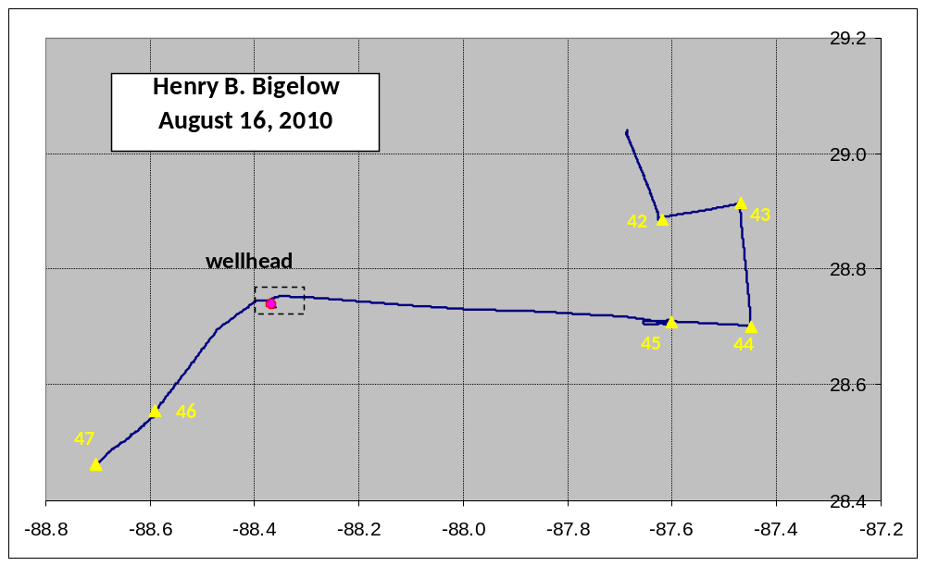
A.

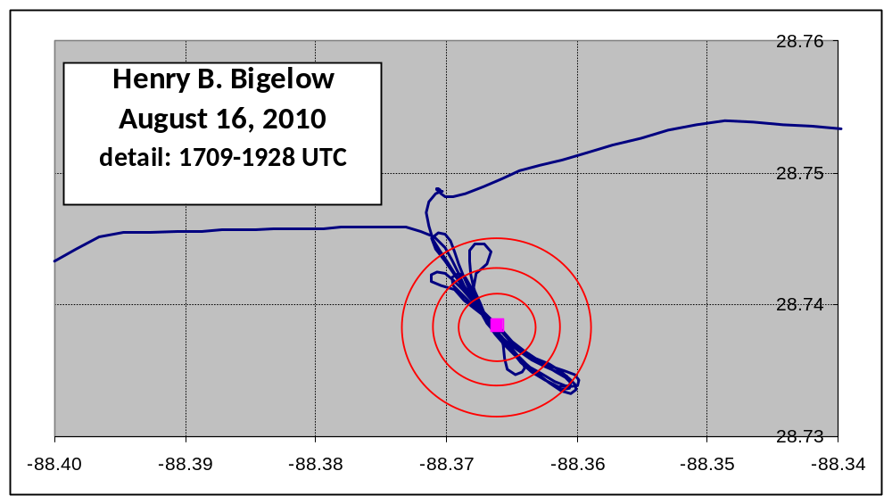
B.

Fig. 2 Echograms (18 kHz) from EK60 aboard Henry B. Bigelow made during August 16, 2010 passes over the Deepwater Horizon MC252 wellhead site.


