Henry B. Bigelow Cruise HB-10-06 Leg 2 Daily Report

Period covered: 0000 hrs 08/17/2010- 2400 hrs 08/17/2010
Vessel science party:Name | Position | Email/Phone
Vince Guida  Michael Jech  Jim Burkitt*  Steven Fromm  Nick Mitchell*  Cristina Bascunan  Betsy Broughton  Allison Candelmo  Rich Langton  Beth Langton  Norma Clark  Jason Sadler  Christopher Sumner  Jon Terpening  Indraneel Deshpande | Chief Scientist  Acoustic Lead  Acoustics  Acoustics  Acoustics  CTD  CTD  Chemistry Lead  Chemsitry  Chemistry  SMU Data Manager  NRDA Sample Rep  BP/Entrix, IH  KD GC-MS Chemist  Chemistry | Vincent.Guida@noaa.gov  Michael.Jech@noaa.gov  james.w.burkitt@noaa.gv  Steven.Fromm@noaa.gov  nickolas.mitchell@noaa.gov  Cristina.Bascunan@noaa.gov  Elisabeth.broughton@noaa.gov  Allison.Candelmo@noaa.gov  Rich.Langton@noaa.gov  elangton@snook.sh.nmfs.gov  nmc_2002@yahoo.com  peopeomoxmox@gmail.com  CSumner@entrix.com jon.terpening@kdanalytical.com  Ashok.Deshpande@noaa.gov
* ships crew working on acoustics with science party

Daily Operations:
Y | CTD Casts | Y | Sampling – VOA |  | PAH Detection
Y | Fluorometry | Y | GCMS |  | Biota
 | LISST | Y | Acoustics |  | Rototox
Y | Sampling – TPH |  | MOCNESS |  | Other:

Cruise notes:
Station map figure 1

Science results and preliminary interpretation:
Acoustics
No acoustic passes were made on this date. Two series of lines were traversed within 10 km to the south (Fig. 1) of the wellhead to detect natural seeps, particularly along the margins of the salt dome that lies SE of the wellhead. Plumes, presumably from gas bubbles from six such seeps were detected.

(please attach any images at end of document)

Fluorometry and Dissolved Oxygen results
No flurorometric or DO anomalies were detected in this day’s profiles. However, reinspection of those taken on August 16th revealed small dissolved oxygen depressions in profiles 46 and 47 (both bearing 225 deg T, 30 and 45 km respectively from the wellhead. Profile 46 showed a depression of about 0.2 mg/L centering around 1200 m depth, while 47 showed a less well-defined depression of <0.1 mg/L centering around 1150 m (Fig. 2). No corresponding peaks in CDOM were observed. These have been the only cases in which such deepwater oxygen depressions have been detected to date.

Chemistry: GCMS / HAPSITE
Toluene detections made via onboard GC/MS in the vicinity of the wellhead since 8/14 are listed in Table 1. Values range from 0 to 9.7 µg/L. All detections were within 35 m of the surface and within 10 km of the wellhead and between the hours of 04:26 and 12:15 CDST (0946 – 1715 UTC). No detectons were made at stations outside 10 km of the wellhead, nor in any locations after 8/15. Two CTD rosette samples (50 and 51: Fig. 1) were taken on this date to sample exclusively depsths of 5, 15, and 30 m for GC/MS samples only just for detection of toluene. These produced no detections. . It is suspected that this contamination is related to surface activities around the wellhead site, but it is unclear what kind of activity might be producing such a single contaminant signal.

Table 1. GC/MS detections from water samples taken in the
from depths <40 m at all sites sampled

UTC Collection Date | UTC CollectionTime | CTD sta | Range (km) | Bearing (deg.) | Bottle # | Depth (m) | Toluene (µg/L)
18-Aug | 6:48:03 | 53 | 2.5 | 180 | 12 | 2.9 | nd
18-Aug | 6:45:53 | 53 | 2.5 | 180 | 11 | 31.8 | nd
18-Aug | 5:09:01 | 53 | 2.5 | 180 | GoFlo | 35.0 | nd
17-Aug | 20:43:20 | 51 | 3.5 | 150 | 3 | 5.0 | nd
17-Aug | 20:43:20 | 51 | 3.5 | 150 | 3-dup | 5.0 | nd
17-Aug | 20:41:07 | 51 | 3.5 | 150 | 2 | 16.3 | nd
17-Aug | 20:41:07 | 51 | 3.5 | 150 | 2-dup | 16.3 | nd
17-Aug | 20:39:02 | 51 | 3.5 | 150 | 1 | 30.9 | nd
17-Aug | 20:39:02 | 51 | 3.5 | 150 | 1-dup | 30.9 | nd
15-Aug | 9:26:47 | 36 | 5 | 210 | 12 | 2.5 | 3.5
15-Aug | 11:52:56 | 37 | 5 | 120 | 12 | 2.8 | 3.7
15-Aug | 9:24:40 | 36 | 5 | 210 | 11 | 32.0 | nd
15-Aug | 14:44:09 | 38 | 5 | 90 | 11 | 35.7 | nd
18-Aug | 4:08:39 | 52 | 5 | 180 | 12 | 3.7 | nd
18-Aug | 4:06:04 | 52 | 5 | 180 | 11 | 31.2 | nd
17-Aug | 15:22:54 | 50 | 7 | 180 | 3 | 5.5 | nd
17-Aug | 15:20:22 | 50 | 7 | 180 | 2 | 16.4 | nd
17-Aug | 15:17:25 | 50 | 7 | 180 | 1 | 29.8 | nd
17-Aug | 15:17:25 | 50 | 7 | 180 | 1-dup | 29.8 | nd
14-Aug | 8:15:37 | 31 | 10 | 180 | 11 | 34.8 | 2.8
14-Aug | 6:38:41 | 31 | 10 | 180 | GoFlo | 35.0 | 1.4
15-Aug | 17:14:51 | 39 | 10 | 90 | 12 | 3.7 | 9.7
17-Aug | 9:17:49 | 49 | 14 | 180 | 12 | 3.0 | nd
17-Aug | 9:17:49 | 49 | 14 | 180 | 11 | 31.0 | nd
17-Aug | 5:44:00 | 48 | 22 | 180 | 12 | 2.8 | nd
17-Aug | 5:41:45 | 48 | 22 | 180 | 11 | 29.5 | nd
16-Aug | 22:49:24 | 46 | 30 | 225 | 12 | 3.3 | nd
16-Aug | 22:44:22 | 46 | 30 | 225 | 11 | 30.4 | nd
17-Aug | 1:45:09 | 47 | 45 | 225 | 12 | 3.5 | nd
17-Aug | 1:42:40 | 47 | 45 | 225 | 11 | 30.1 | nd
15-Aug | 21:48:28 | 40 | 60 | 60 | 12 | 4.0 | nd
15-Aug | 21:46:01 | 40 | 60 | 60 | 11 | 31.0 | nd
15-Aug | 20:04:45 | 40 | 60 | 60 | GoFlo | 35.0 | nd
15-Aug | 23:15:52 | 41 | 75 | 60 | GoFlo | 35.0 | nd
16-Aug | 13:20:02 | 45 | 75 | 90 | 12 | 3.1 | nd
16-Aug | 4:16:42 | 42 | 75 | 75 | 11 | 3.7 | nd
16-Aug | 4:16:42 | 42 | 75 | 75 | 12 | 3.7 | nd
16-Aug | 0:52:13 | 41 | 75 | 60 | 11 | 23.1 | nd
16-Aug | 13:17:57 | 45 | 75 | 90 | 11 | 31.4 | nd
16-Aug | 2:25:27 | 42 | 75 | 75 | GoFlo | 35.0 | nd
16-Aug | 11:30:12 | 45 | 75 | 90 | GoFlo | 35.0 | nd
16-Aug | 10:55:45 | 44 | 90 | 90 | 12 | 3.0 | nd
16-Aug | 7:10:27 | 43 | 90 | 75 | 12 | 3.1 | nd
16-Aug | 7:08:19 | 43 | 90 | 75 | 11 | 32.1 | nd
16-Aug | 5:28:59 | 43 | 90 | 75 | GoFlo | 35.0 | nd
16-Aug | 8:30:07 | 44 | 90 | 90 | GoFlo | 35.0 | nd
16-Aug | 10:55:45 | 44 | 90 | 90 | 11 | 39.0 | nd

Microbial analysis (if applicable)
N/A

Other Observations
None

Operational / Logistical issues:
The CTD rosette sampler bottle closure mechanism is still an occasional problem, although we can get around it by manually triggering bottles. The supply of coolers (8) brought out on the 17th was inadequate for our subsequent operations. At least as many additional coolers will be needed for a samples exchange – resupply mission at the end of our stay in the DWH MC252 ops area on Aug. 20th. These additional coolers will be needed to contain samples to pack samples temporarily stored in cardboard boxes aboard Bigelow for lack of enough coolers.

Planned activities for next 24 hours:
We plan to finish sampling within the 5 and 10 km rings around the wellhead , proceed to make our scheduled Wednesday acoustic pass on 8/18.
Figure 1 – Bigelow CTD stations and trackline 15 Aug 2010. A. 24 hour map . Dark blue line is trackline, yellow triangles are CTD stations. Yellow numbers are consecutive CTD identification numbers, continued from Leg 1 of cruise HB10-06. The magenta square is the wellhead, and the 5 and 10 km rings are indicated with dashed circles., B. Detail of wellhead pass period; red rings are 500, 1000, and 1500 m from the wellhead.

CTD profiles for casts #46. Arrow points to dissolved oxygen depression at 1250 m.

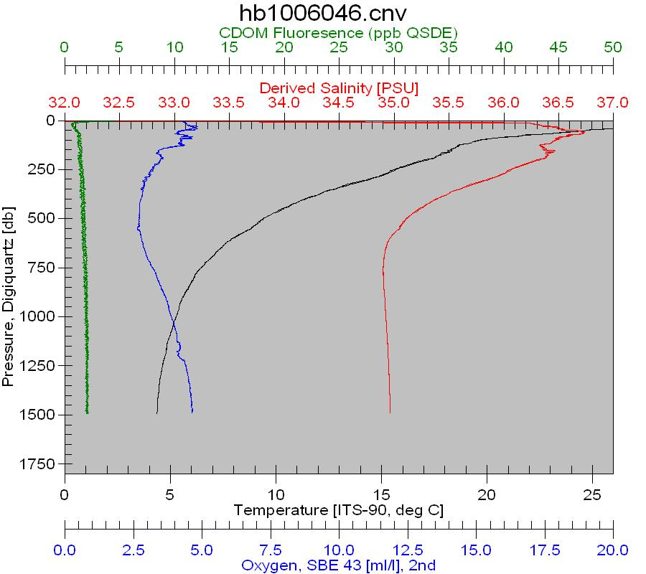
CTD profiles for casts #46. Arrow points to dissolved oxygen depression at 1250 m.



