Henry B. Bigelow Cruise HB-10-06 Leg 2 Daily Report

Period covered: 0000 hrs 08/14/2010- 2400 hrs 08/14/2010

Vessel science party:
Name | Position | Email/Phone
Vince Guida  Michael Jech  Jim Burkitt*  Steven Fromm  Nick Mitchell*  Cristina Bascunan  Betsy Broughton  Allison Candelmo  Rich Langton  Beth Langton  Norma Clark  Jason Sadler  Christopher Sumner  Jon Terpening  Indraneel Deshpande | Chief Scientist  Acoustic Lead  Acoustics  Acoustics  Acoustics  CTD  CTD  Chemistry Lead  Chemsitry  Chemistry  SMU Data Manager  NRDA Sample Rep  BP/Entrix, IH  KD GC-MS Chemist  Chemistry | Vincent.Guida@noaa.gov  Michael.Jech@noaa.gov  james.w.burkitt@noaa.gv  Steven.Fromm@noaa.gov  nickolas.mitchell@noaa.gov  Cristina.Bascunan@noaa.gov  Elisabeth.broughton@noaa.gov  Allison.Candelmo@noaa.gov  Rich.Langton@noaa.gov  elangton@snook.sh.nmfs.gov  nmc_2002@yahoo.com  peopeomoxmox@gmail.com  CSumner@entrix.com jon.terpening@kdanalytical.com  Ashok.Deshpande@noaa.gov
* ships crew working on acoustics with science party

Daily Operations:
Y | CTD Casts | Y | Sampling – VOA |  | PAH Detection
Y | Fluorometry | Y | GCMS |  | Biota
 | LISST | Y | Acoustics |  | Rototox
Y | Sampling – TPH |  | MOCNESS |  | Other:

Cruise notes:
Station map figure 1

Science results and preliminary interpretation:
Acoustics
We made 10 passes over the wellhead on 8/14/10 with the EK500 18 and 38 kHz systems engaged (Fig. 2). There was a considerable amount of noise over the wellhead, appearing as columns of vertical linear returns in the water column underlain by even stronger sub-bottom lines. There was no evidence of the plume of gas bubbles or any other material seen over the wellhead earlier. There was, however a peculiar “acoustic void” phenomenon evident in the deep scattering layer (DSL) above the wellhead at depths between approximately 600 and 850 meters. The otherwise level lower margin of DSL at about 850 m appears to be raised by about 200 m, leaving a relatively low density “void” in its place directly over the wellhead. Around the margins of the void is a region of increased acoustic density, and there is noticeable raising of high acoustic density layers above the end of the void, evident even to 200 m depth. The cause for this disturbance in DSL is not clear, but we suspect that it may be behaviorally driven, rather than simple physical displacement. We speculate that avoidance by fishes and other organisms that make up the DSL of underwater lights and sounds created by ROVs may be the cause. We know from the BP website that one ROV with its lights on was being held at 1000 m depth in anticipation of a bottom mission during the period of our acoustic transit.

Also, we again visited the “seep” now known to be associated with an underwater pipeline ESE of the wellhead (Fig. 1) that we had found on the previous leg of the cruise. We again found it to be producing a strong, tapering plume of what is probably gas bubbles (Fig. 3). By comparison with wellhead noise, this feature is more coherent and has a far weaker sub-bottom reflection that suggests a bubble plume.

(please attach any images at end of document)

Fluorometry and Dissolved Oxygen results
No anomalies detected in CDOM or DO profiles in any CTD casts.

Chemistry: GCMS / HAPSITE
Hydrocarbons were found only episodically and only from subsamples drawn from near-surface waters (< 50 m depth). The only hydrocarbon detected was toluene, with a maximum value of ~3 µg/L. Further investigation is planned to try to detect a pattern and source of this occurrence; it could be from the ship or sampling bottles themselves. A detailed account will appear in a subsequent report.

Microbial analysis (if applicable)
N/A

Other Observations
Visually detected remnants of oily “mousse” in surface water during wellhead passes. Lower portions of rigs were being washed down with fire hoses at the time. Green color of water suggested plankton bloom.

Operational / Logistical issues:
Despite fix in-port, continued to have rosette problems: occasional failure of 1 or more bottles to close. This appears to be a software problem; we can get around it using manual switch.

Planned activities for next 24 hours:
Finish CTDs for southern half of 5 km and 10 km radial stations begun today, proceed to eastern farfield stations for additional CTDs at 75 and 90 km.

Figure 1 – Bigelow cruise track 15 Aug 2010.

Fig 2 Wellhead pass image: EK60 18 kHz, EchoView image.
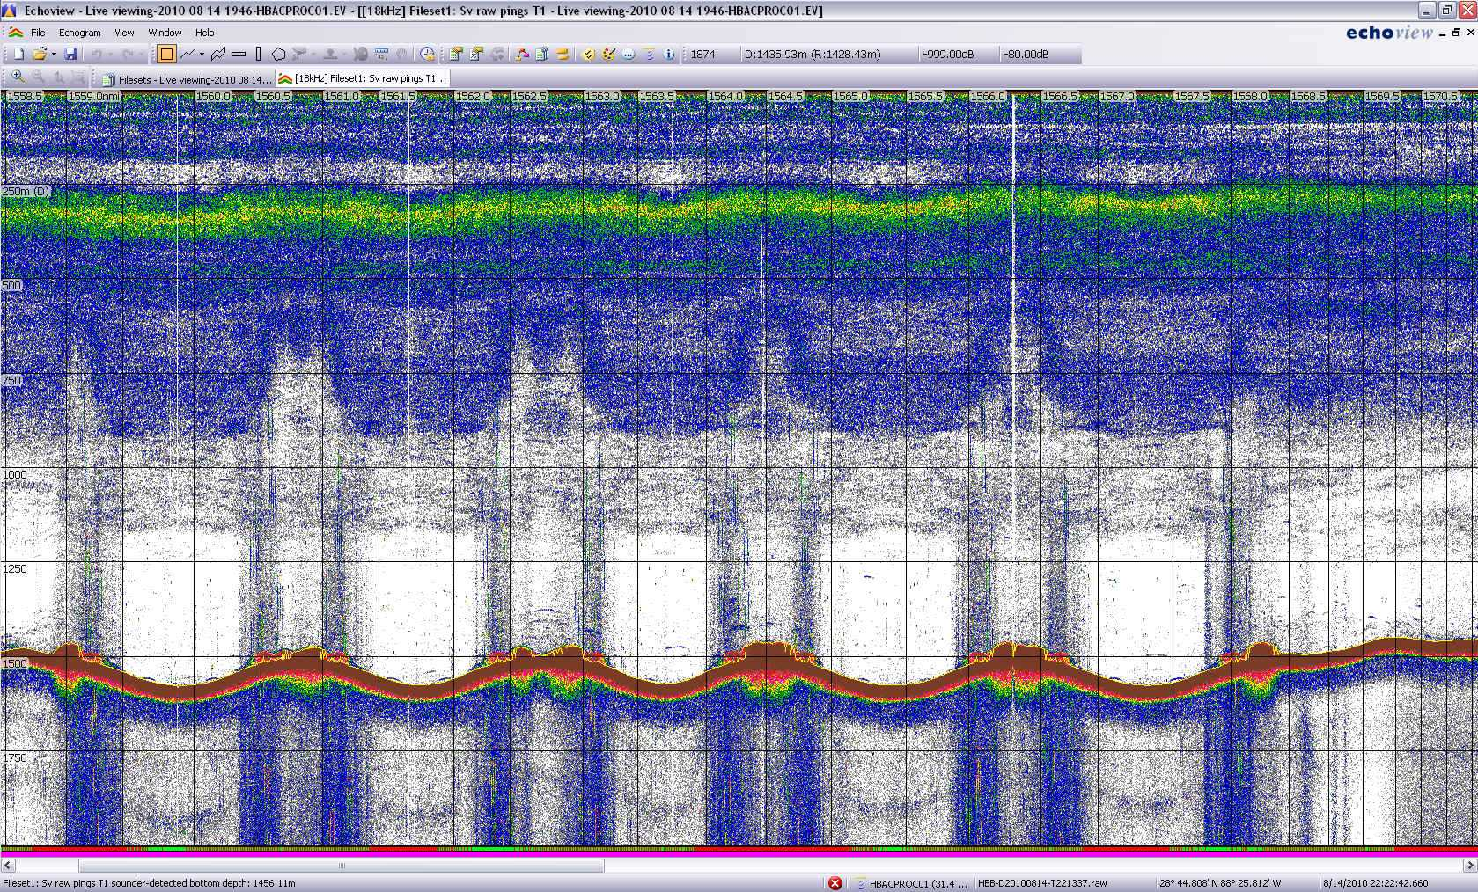

Fig. 3 Possible leak location centered around 28° 41.724’ N, 88° 13.422’ W.


