15 July 2010 Ocean Veritas Status Report, Cruise 9 – Day 2
Complied by Dr. Oliver Pelz (BP Sr. Environmental Toxicologist)

1. Site Conditions & Sampling Locations

Overcast skies, Mid-morning thunder storms and lightening, seas with wave height approximately 2-4 feet and winds 10 kts. throughout the day.

Day 1 of this cruise revealed no plume at stations OV106, OV108, and OV109 and a very weak signal at OV107 in a 2 - 5 km proximity SW to SSW to the wellhead. No plume was observed at station OV110 in the north-western direction from the wellhead. The mission of day 2 was to find a subsurface oil plume and to subsequently characterize it.

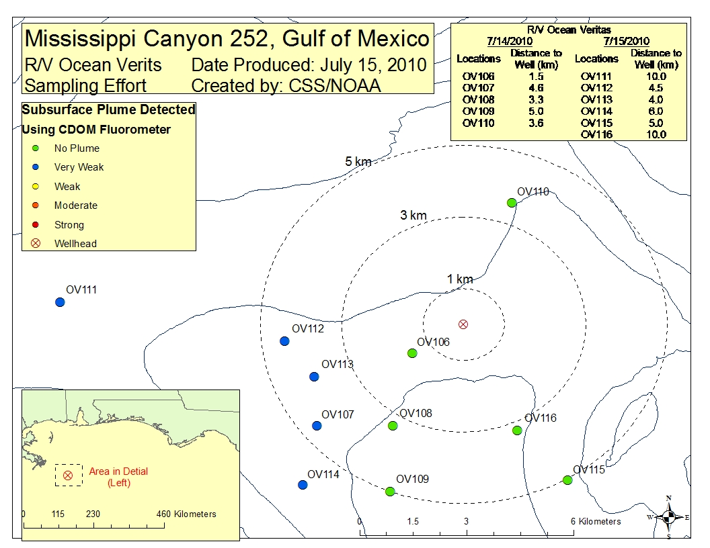
Figure 1 Sampling Stations

3. Air Quality

The Industrial Hygienist Doug Childress (CTEH) conducted air monitoring for VOC (4 × per hr), benzene (1 × per hr), H₂S (2 × per hr), and SO₂ (2 × per hr) while workers were on deck. His measurements showed level of VOC (between 4.2 ppm – 0.0 ppm), whereas benzene, H₂S, and SO₂ were found not to be detectable.

4. CTD Findings

All equipment functioned properly.

At station OV112, the sampling carousel was left at bottom for 50 min because workers were not allowed on deck due to the thunderstorm. During this time the carousel must have struck a sunken object that then caused bending of the frame and three of the Niskin water sampling bottles were either lost or destroyed. Thus, no water samples were collected from this location, but the CTD instruments collected reliable data on the way down (see table).

Today, a total of 6 CTD casts were completed and results are summarized below in the table and also shown in the above figure. Four CTD casts (OV111, OV 112, OV113, and OV114) had a very weak fluorometric signal at approximately 1200 m and for the two casts OV115 and OV116) no plume was identified. It can be assumed that some (environmental) event in the 1200 - 1300 m area is causing the observed slight deflections of the fluorescence and OD signals.

Station | Position  Description | Fluorescence  signal | Signal depth | Comment
OV111 | 9.9 km W of the well-head | Very Weak | Peak from 1210 - 1225 m, w/ peak maximum at 1223 m | No surface oil sheen was noticed on surface.  DO minimum at ca. 500 m.  Water sample handlers did not find oil sheens in sub-surface sample bottles  Some (environmental) event in the 1200 - 1300 m area is potentially causing the observed slight deflections of the fluorescence and OD signals.
OV112 | 4.5 km W of the well-head | Very Weak | Peak from 1995 - 1205 m, w/ peak maximum at 1200 m | No surface oil sheen was noticed.  Water sample handlers did not find oil sheens in sub-surface sample bottles  An abnormal CTD reading was noted at 1200 m. The cause of this signal may have been related to potential data stalling due to mechanical interruption and a stop during the cast downward because of cable problems.  DO minimum at ca. 500 m  Some (environmental) event in the 1200 - 1300 m area is potentially causing the observed slight deflections of the fluorescence and OD signals.
OV113 | 4.8 km WSW of the well-head | Very weak |  | Surface oil sheen was noticed.  Water sample handlers found light oil sheens in sub-surface sample bottle at 3 m, 50 m, and 1225 m  DO minimum at ca. 500 m  Some (environmental) event in the 1200 - 1300 m area is potentially causing the observed slight deflections of the fluorescence and OD signals.
OV114 | 6.0 km SW of the well-head | Very weak |  | Surface oil sheen was noticed.  Water sample handlers found light oil sheens in 1 sub-surface sample bottle at 1200 m  DO minimum at ca. 500 m  Further slight deflections in OD signals were noted in the 1200 - 1300 m area.
OV115 | 5.0 km SSE of the well-head | No plume |  | Surface oil sheen was noticed.  Water sample handlers found light oil sheens in sub-surface sample bottle at 3 m, 50 m, and 1135 m  DO minimum around 500 m  Further slight deflections in OD signals were noted in the 1100 - 1200 m area
OV116 | 3.2 km SSE of the well-head | No plume |  | This final cast was conducted at the end of the working day to assist in identifying potential target stations for cruise day 3’s sampling activities. No water samples were collected at this station.

5. LISST data

High particle concentrations were measured at the surface water (0.5 m) of all stations but one. An increase in small particle concentrations was also found in deep sub-surface water of the 1200 - 1300 m area, where the in-situ fluorometer detected only a very weak signal.

6. Aquatic Toxicity Testing

6.1 Cruise 9 – Day 1: Results of samples for Rotoxkit M analysis, collected from stations OV106, OV 107, and OV110, did not reveal an aquatic toxic adverse effect in any of the samples.

6.2 Cruise 9 – Day 2: Samples for Rotoxkit M analysis were collected from stations OV111, OV113, OV114, and OV115, and results will be available in tomorrow’s report (animals will be incubated for 24-hrs).

7. Dissolved oxygen (DO) concentrations

7.1 Testing of field probe: an aqueous sodium sulfite solution (5 g/100 ml) was prepared, which by definition does not contain dissolved oxygen. The reading of the O₂-meter (YSI Ecosense DO 200) was in deed 0 mg/l. In a second test, sea water was boiled for about 10 min and readings were < 2 mg/l. The results of these experiments show that the used field probe is capable to determine reliable oxygen concentrations in micro-aerobic or anaerobic concentration ranges – if such values would occur.

7.2 Comparison of dissolved oxygen (DO) concentrations from in situ CTD and a manual probe: DO concentrations, measured manually with a field probe O₂-meter (YSI Ecosense DO 200) were compared to DO concentrations, obtained from in situ CTD casts (see addendum). Results of this comparison revealed a satisfying correlation, and therefore support the fact that in situ CDT measurements represent a reliable screening tool to determine oxygen concentrations in the water column.

8.) Science Crew

Name | First Name | Affiliation | Role
Childress | Doug | CTEH | Industrial Hygienist
Mason | Jennifer | DFO | Particle Analysis
Kenny | Michelle | DFO | Particle Analysis
Pelz | Oliver | BP | Chief Scientist
Heinz | Carrie Ann | EM&A | Rotoxkit Technician
Freeman | Kyle | Entrix | Water Samples
Greenwood | Bill | Entrix | Water Samples
Kobeski | Connor | Entrix | Water Samples
Bushnell | Mark | Fugro | Party Chief Fugro Team
Pallito | Nick | Fugro | Oceanography Team
Riggs | Terry | Fugro | Oceanography Team
Moore | Brian | Fugro | Navigation
Guzzman | Mike | Fugro | Navigation
Bekins | Ward | Fugro | Oceanography Team
Davis | Joe | EPA | Agency Rep.
Marin | Fred | NOAA | Water Profiling
Davis | Cab | NOAA | Oceanographer
Stogner | Michelle | NOAA | Data Management
Jellison | Lucas | NOAA | NDRA



