The LCI-90 Line Control Instrument is manufactured by Measurement Technology NW in Seattle, Washington, USA (http://www.mtnw-usa.com). The instrument provides line spool distance, spool rate, and line tension. The instrument makes use of magnetic proximity sensors to measure the rotation of a sheave wheel as the line passes over it. After factoring in the circumference of the sheave wheel, the linear spool out distance is displayed. The spool out rate is also calculated from this measurement and displayed.

- Instrument Operation
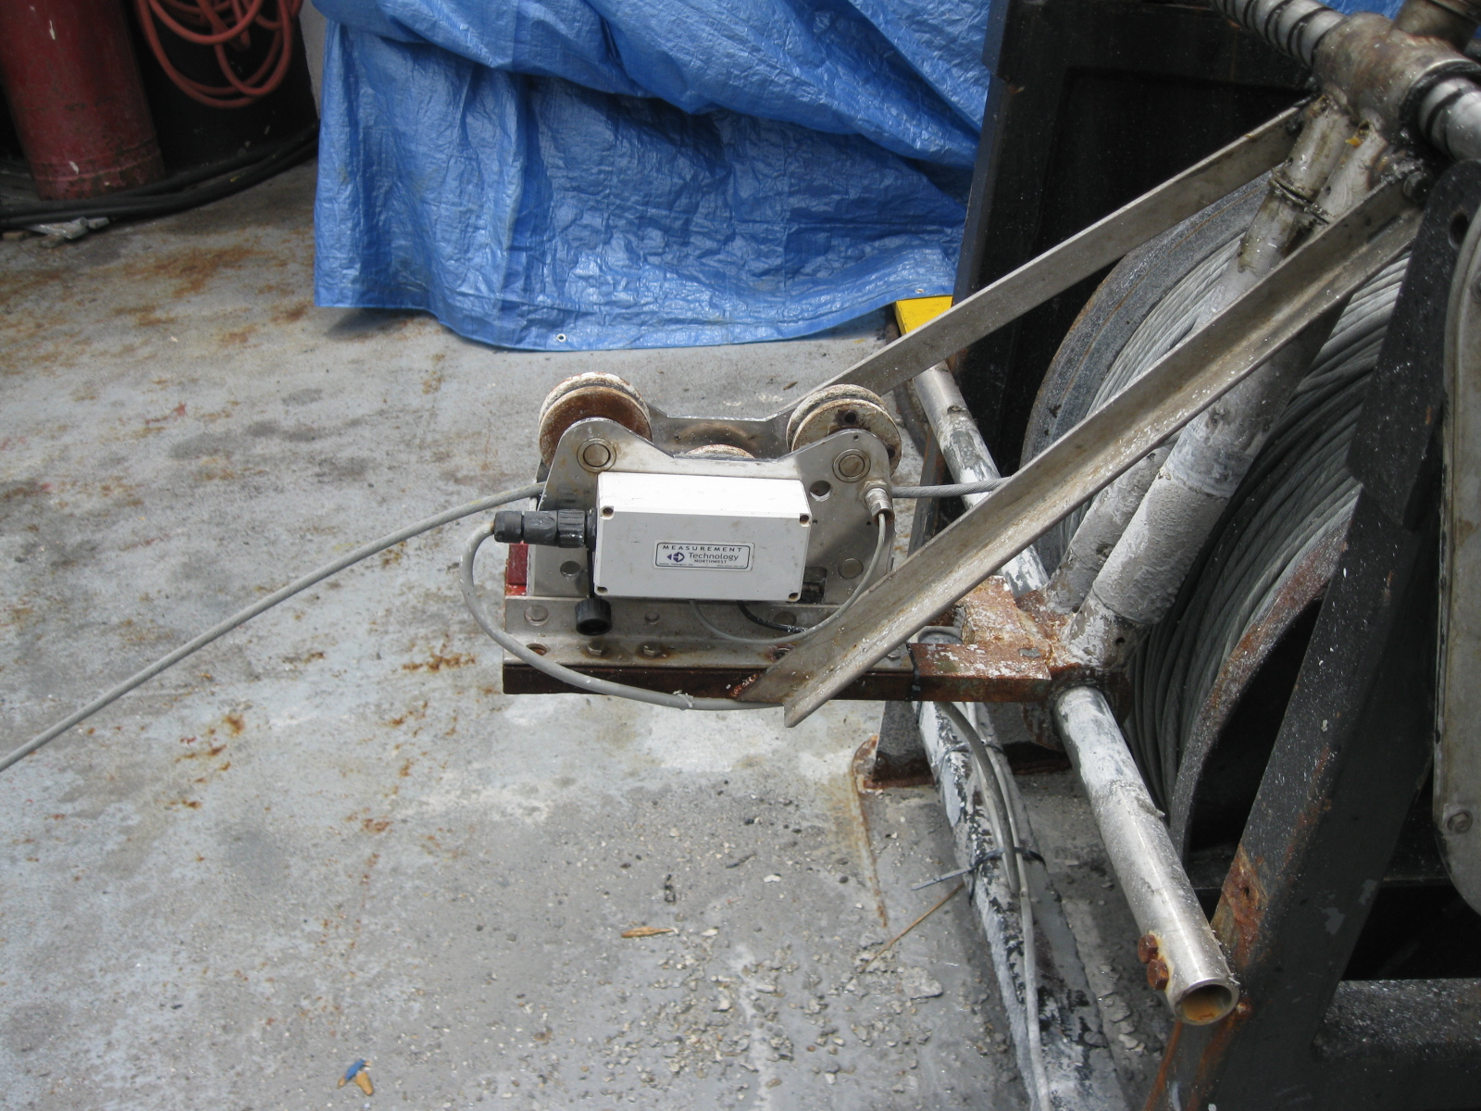
Figure 1: Line Controller Instrument Assembly

The Line Control Instrument can be used in several different configurations, but the system used onboard the Ocean Veritas will be discussed here. The sensor assembly is attached to the winch such that the line passes through the assembly as the winch spools in or out. The sensor assembly consists of three sheave wheels that are configured such that the line touches each sheave wheel for about 120degrees of each sheave wheel circumference.
The sheave wheel used to measure spool distance and spool rate has four magnets attached to it at 90degree increments. Two magnetic proximity switches are typically fixed to the sensor assembly such that these magnets pass the switches as the sheave wheel rotates. In order to perform as a quadrature encoder, the magnetic proximity sensors are positions 90-degrees apart from each other. The above photograph shows only one magnetic sensor with the missing sensor apparent by the empty mounting hole. This one-sensor configuration will be discussed below. The two-proximity sensor configuration produces a quadrature step pulse as shown in the figure below. The magnetic proximity sensors are labelled A and B and produce steps that are 90-degrees out of phase due to the 90-degree physical installation. A complete cycle or turn of the sheave wheel is completed when all four magnets pass over both magnetic proximity sensors and complete four phases. Two proximity sensors are used to determine the direction of rotation. Only Payout and Payout Rate can be determined if there is only one proximity sensor available.
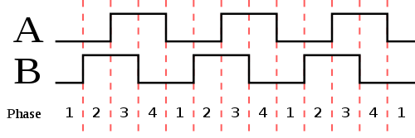
Figure 2: Quadrature Step Diagram

The step diagram shown above represents the method used to transmit line motion information to the display. The display factors in these step pulses along with a Payout Scale to show both Payout and Payout Speed. The Payout Scale is calculated using the following formula:
Payout Scale = Number of Targets / Sheave Circumference
In this case, the sheave wheel had four magnets (Targets) and a Sheave Wheel radius of 0.0375meters. The Sheave Wheel Radius is the distance from the center of the sheave wheel to the center of the line or wire rope being spooled. This radius is used to calculate the Sheave Circumference using the following formula:
Sheave Circumference = 2 x PI x SheaveRadius

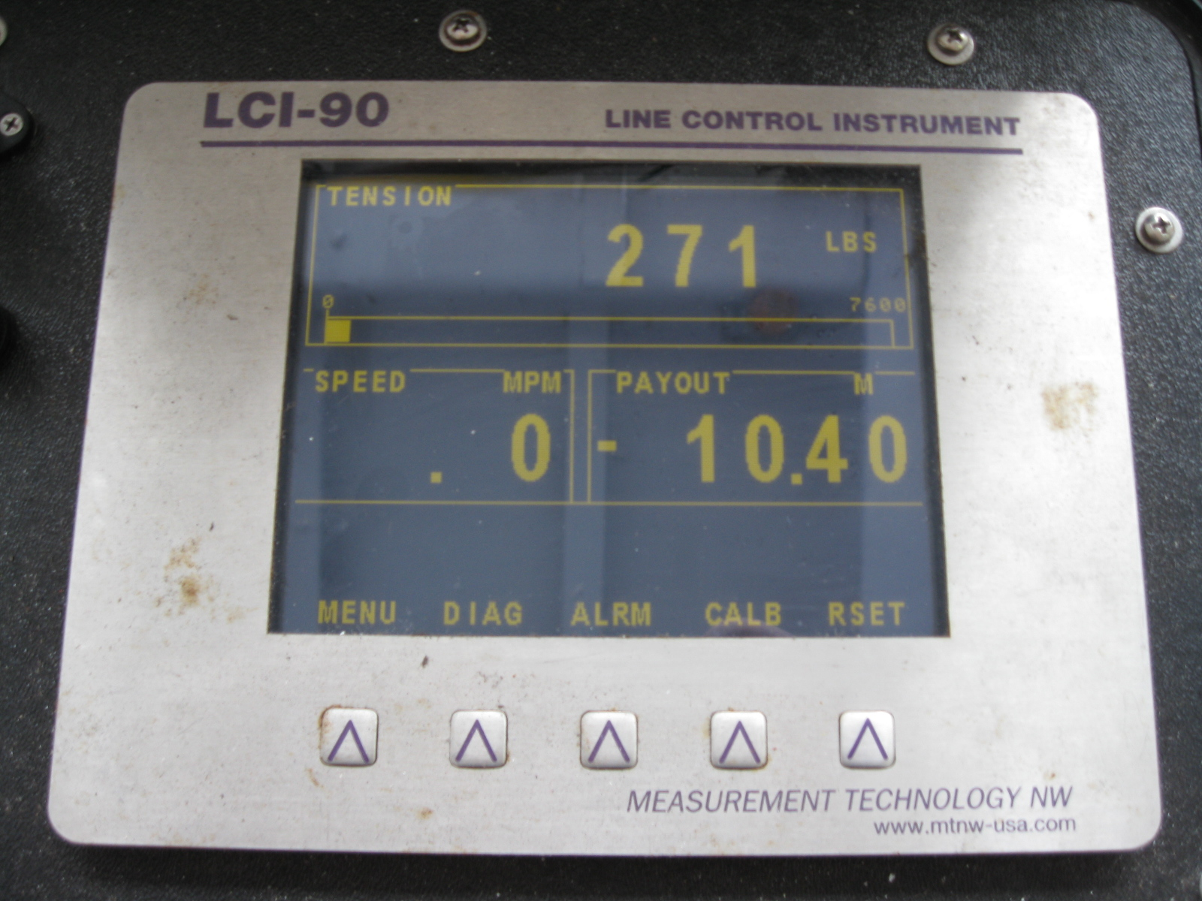
Figure 3: Line Control Instrument Display

- Payout Calibration with only one proximity sensor
Since the Line Control Instrument on the Ocean Veritas had only one proximity sensor attached, the Payout Scale discussed above need to be reduced by half. This electronic correction factor is analogous to physically removing two of the magnetic targets or doubling the circumference of the sheave wheel. The decision was made to reconfigure electronically rather then physically altering the sensor assembly.
The calibration procedures are discussed in the LCI-90 manual, section 5.9 on “Payout Calibration”. Start the calibration by pressing the respective “CALB” button on the display. Then change the Payout Scale value to match the above formula results for Payout Scale. Since only one magnetic proximity sensor was available on the Ocean Veritas, the calculated Payout Scale was cut in half to account for the missing second proximity sensor. Even though this corrected the problem, it is still recommended that a second magnetic proximity sensor be installed to provide spool direction and more reliable Payout and Payout Rate measurements.
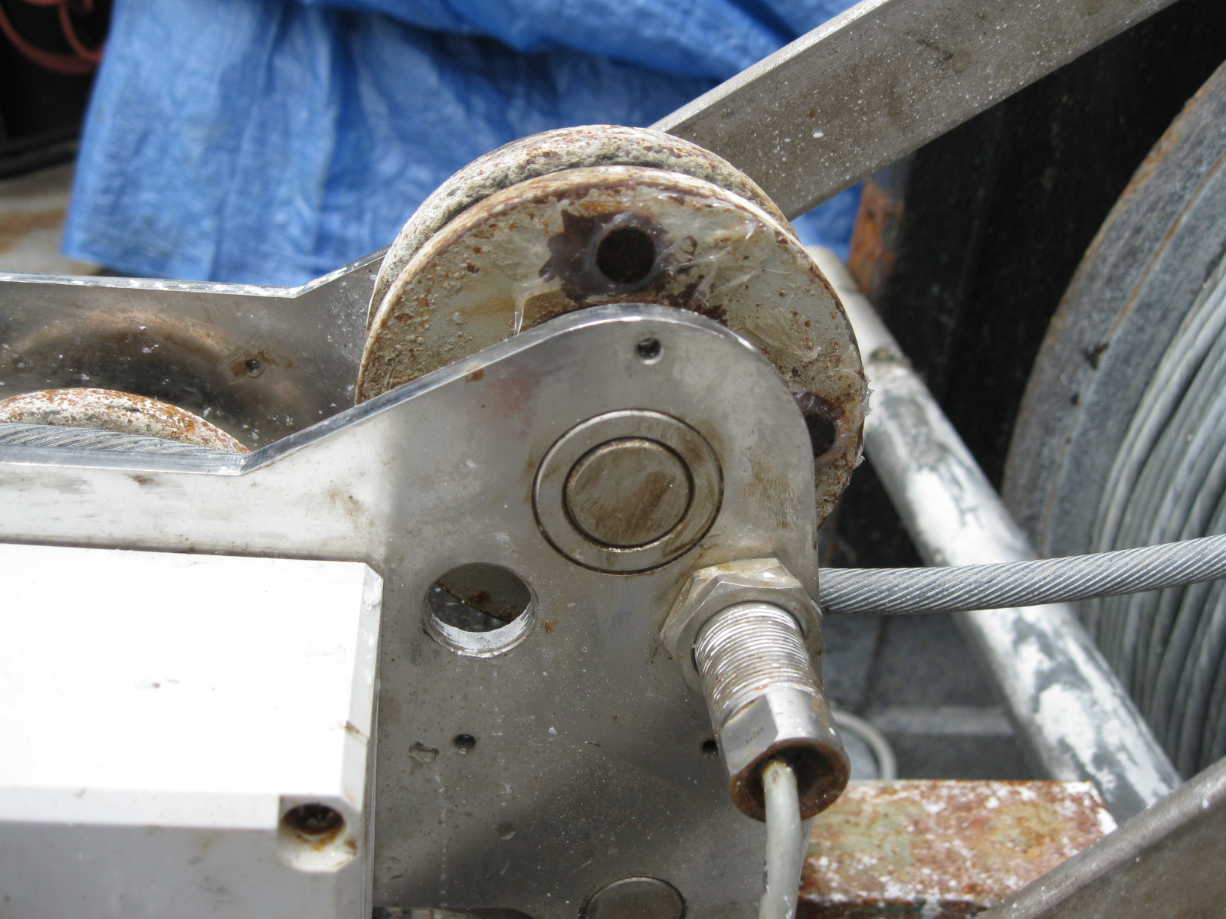
Figure 4: Line Position Sensor

