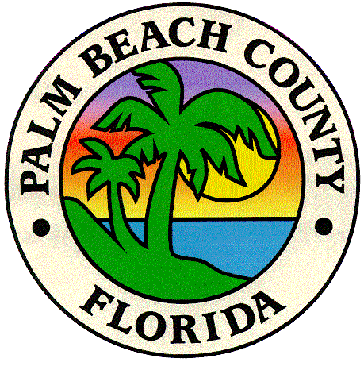

PHOTOINTERPRETATION KEY
FOR THE
PALM BEACH COUNTY
2007 HABITAT MAPPING PROJECT

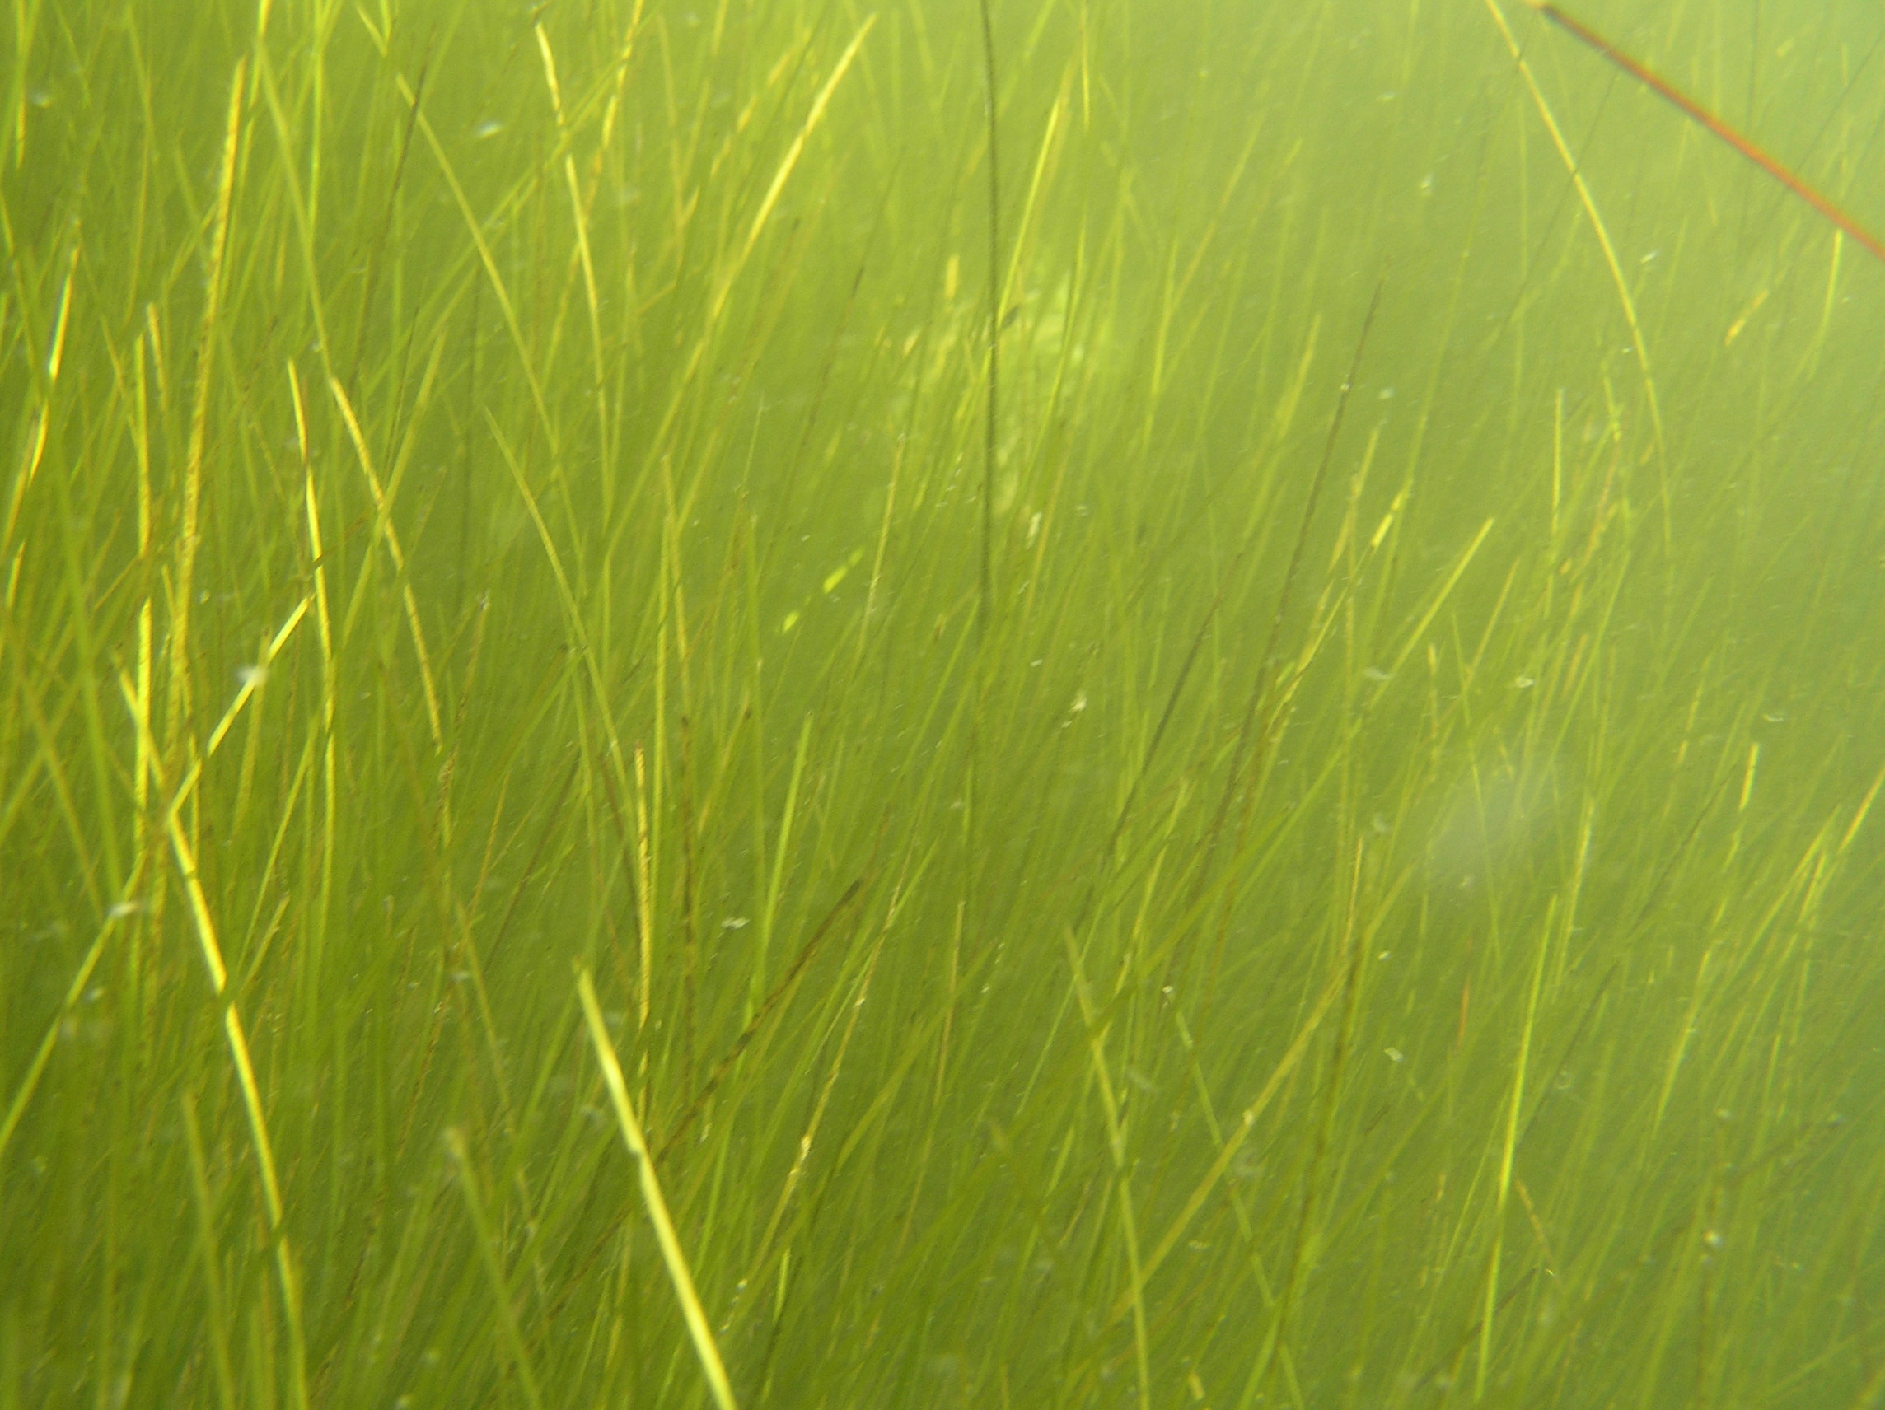

Report Date:
November 20, 2007

Prepared by:
Avineon, Inc.



15500 Lightwave Drive, Suite 200
Clearwater, FL 33760
727-539-1661
PREFACE

Avineon Inc. of Clearwater, Florida was contracted by Applied Technology and Management (ATM) and Palm Beach County ERM to produce a spatially, thematically, and technically accurate Geodatabase of the Submerged Aquatic Vegetation and other selected covertypes occurring within the Lake Worth Lagoon system and the ICW throughout Palm Beach County. The classification system used for this project was a modification of the Florida Land Use / Cover Classification System (FLUCCS), which was originally compiled by the Florida Department of Transportation, State Topographic Bureau.

The following Photointerpretation Key was developed in order to document the decisions and mapping conventions applied during the photointerpretation process. The key was used to help ensure that the photointerpretation was consistent throughout the project. It was designed to provide descriptions of the visual and spatial distribution characteristics of the classification types used for the project and to document any special mapping conventions that were developed. The key also serves to provide insight for future users into the rationale for the delineation and classifications appearing within the database.

PHOTOINTERPRETATION KEY
FOR THE
2007 HABITAT MAPPING PROJECT

Table of Contents

I. CLASSIFICATION CODES 4
II. CLASSIFICATION SYSTEM 5

I. CLASSIFICATION CODES

- Seagrass, continuous, dense

- Seagrass, patchy

- Unvegetated bottom

- Tidal Flats

- Algae Beds

- Mangrove Swamp

- Oyster Bars / Reef

- Cordgrass (Spartina sp.)

0 Not Classified (Land, islands etc)

CLASSIFICATION SYSTEM

The following section describes the classification system used for the 2007 Habitat Mapping Project.

For each classification type, a definition is included along with a written description of the photosignature. The photosignature describes how each classification category appears on the 1:10,000 scale natural color aerial photography, from a photointerpretation perspective. Tone, color, shape, size, association, texture, and typical location are described. Also included is a Digital photograph taken in the field along with a digitized aerial photograph showing the photointerpreted delineations.

Seagrass, continuous, dense (9116)

Definition

The dominant feature of these seagrass beds is that they are continuous in nature, with interconnected areas of seagrass. These beds may contain many small, interspersed patches of sparsely vegetated or unvegetated bottom. The dense aspect means that the area should contain more vegetated bottom than unvegetated bottom, and thus would have a lower limit of about 50% cover of seagrass. Only sand patches of greater than 0.25 acres are distinguished within a continuous, dense bed. Species composition is not mapped.

Description

The photosignature for 9116 is smoother than that of 9113 but still has some texture. It also can be bluish-gray to almost black, but has only a few areas of open bottom showing through to interrupt the continuous signature. 9116 usually can be found in the center of large, healthy seagrass beds and sometimes runs parallel to the shoreline for hundreds of meters. These larger beds usually have some sparse growth between the continuous areas (i.e. they are not always composed of a uniform thickness, but are still considered continuous).

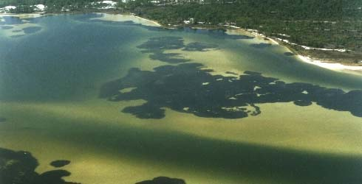

9116 Continuous Seagrass

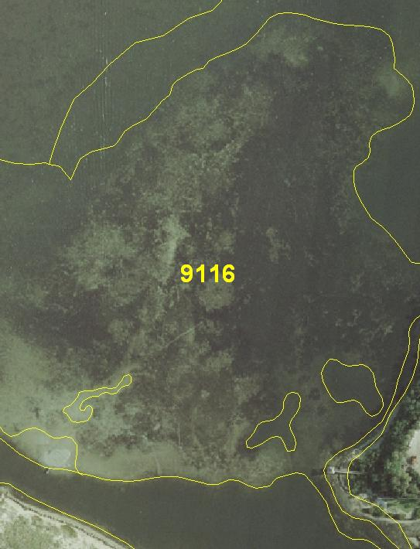

Delineated photograph showing 9116

Seagrass, patchy (9113)

Definition

Areas 0.25 acres or greater in size that consist primarily of greater than 50% bare bottom in which many small patches (each less than 0.25 acres) of seagrass are scattered, and where the seagrass patches are not interconnected.

Description

The photosignature for the 9113 classification usually has a rough texture when viewed through a stereoscope and is bluish-gray to almost black depending on water depth and turbidity. Patchy seagrass polygons can be found on the deeper and shallower edges of continuous seagrass beds or can be large and expansive and cover the entire bed. The actual seagrass beds will look like small circular colonies that are close enough together to be combined into a seagrass polygon. These areas can occur because of new growth on a previously unvegetated substrate, or within areas of previously continuous seagrass that is deteriorating due to changing water conditions such as salinity, turbidity, and temperature or pollution levels.

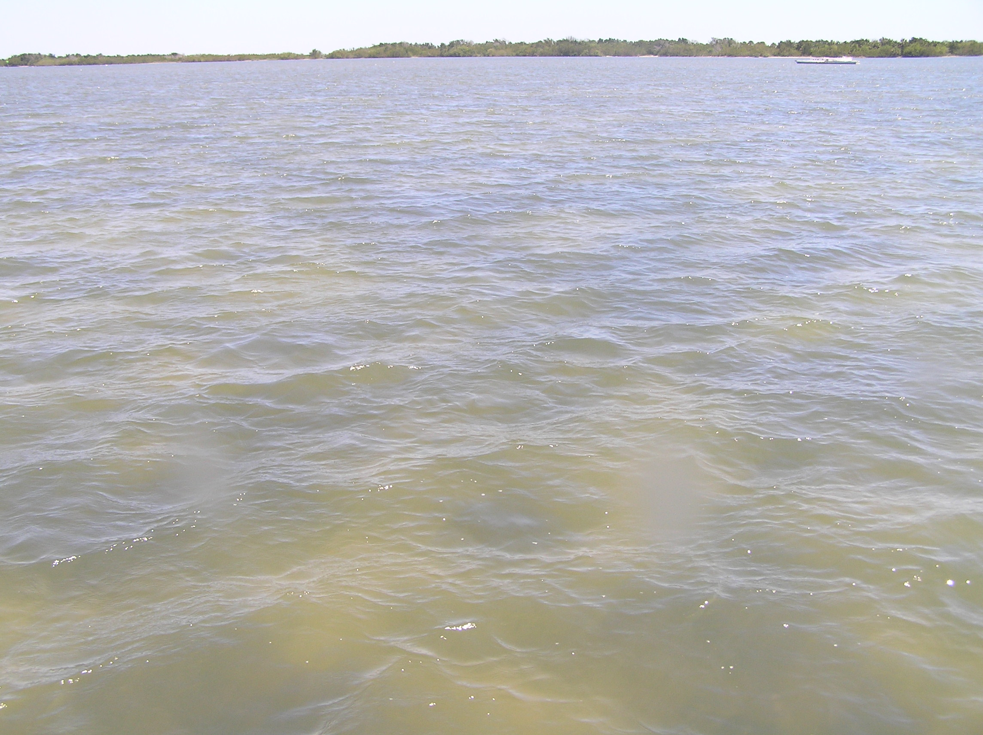

9113 Patchy seagrass

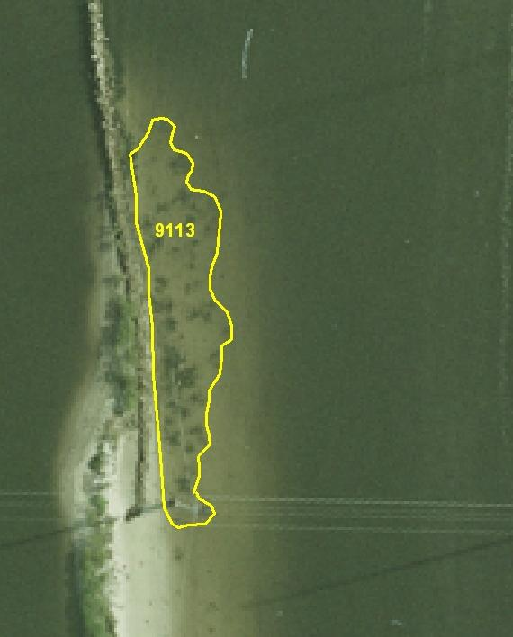

Delineated photograph showing 9113

Unvegetated bottom (5400)

Definition

Barren substrate with little or no perceptible seagrass (<10%) or algae. The lower limit of what constitutes a seagrass bed is approximately 10% cover. Areas with <10% cover are considered “Unvegetated bottom”.

Description

The 5400 classification has many different photosignatures and will depend on the characteristics of the area where it is occurring. These signatures can be divided into two distinctly different categories, which are dependent on depth.

Deepwater 5400 is usually a smooth, bluish-green color, but can sometimes appear dark blue or brown depending on water depth and turbidity levels. It can usually be found on the deeper edges of seagrass beds and in residential canals. Sometimes a deepwater 5400 polygon will be elongated and linear with straight edges, denoting a man-made channel dredged through a shallow water area (i.e. the Intracoastal Waterway and inlets).

The photosignature for the shallower water 5400 classification is usually a very smooth and flat area (i.e. sandbars). This signature can be many different colors depending on water depth and turbidity levels. If the water is relatively clear, the very shallow, sandy areas will appear white as opposed to the light green or turquoise of the slightly deeper sandy areas. Murky or tannin-stained water will create a gray or light brown colored photosignature respectively. Most of these types of 5400 polygons will be found on the shallower edges of seagrass beds, either along the shoreline or on the crest of a barrier-type seagrass bed.

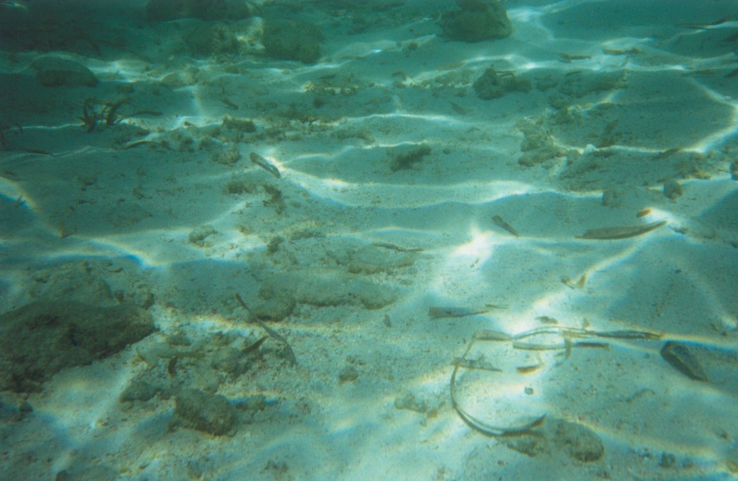

5400 Unvegetated Bottom

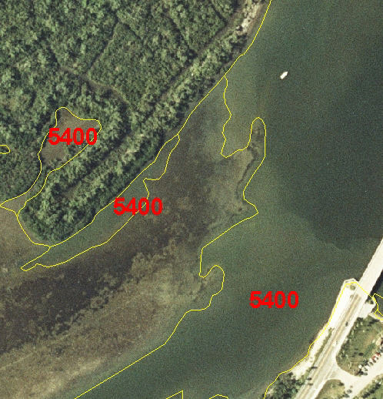

Delineated photograph showing 5400

Tidal Flats (6510)

Definition

Non-vegetated areas of sand or mud that are exposed at least once during the year or are capable of supporting seagrass populations for that segment of the water body (i.e. approximately six feet of depth).

Description

The photo signature for 6510 is very smooth and obviously unvegetated. The signature can be different colors depending on water depth and turbidity levels. It can appear white (very shallow, sandy areas), light green (deeper, sandy areas), gray (murky water), or even light brown in some tannin-stained areas. 6510 is usually found on the shallower edges of seagrass beds, either along the shoreline or on the crest of a barrier-type seagrass bed

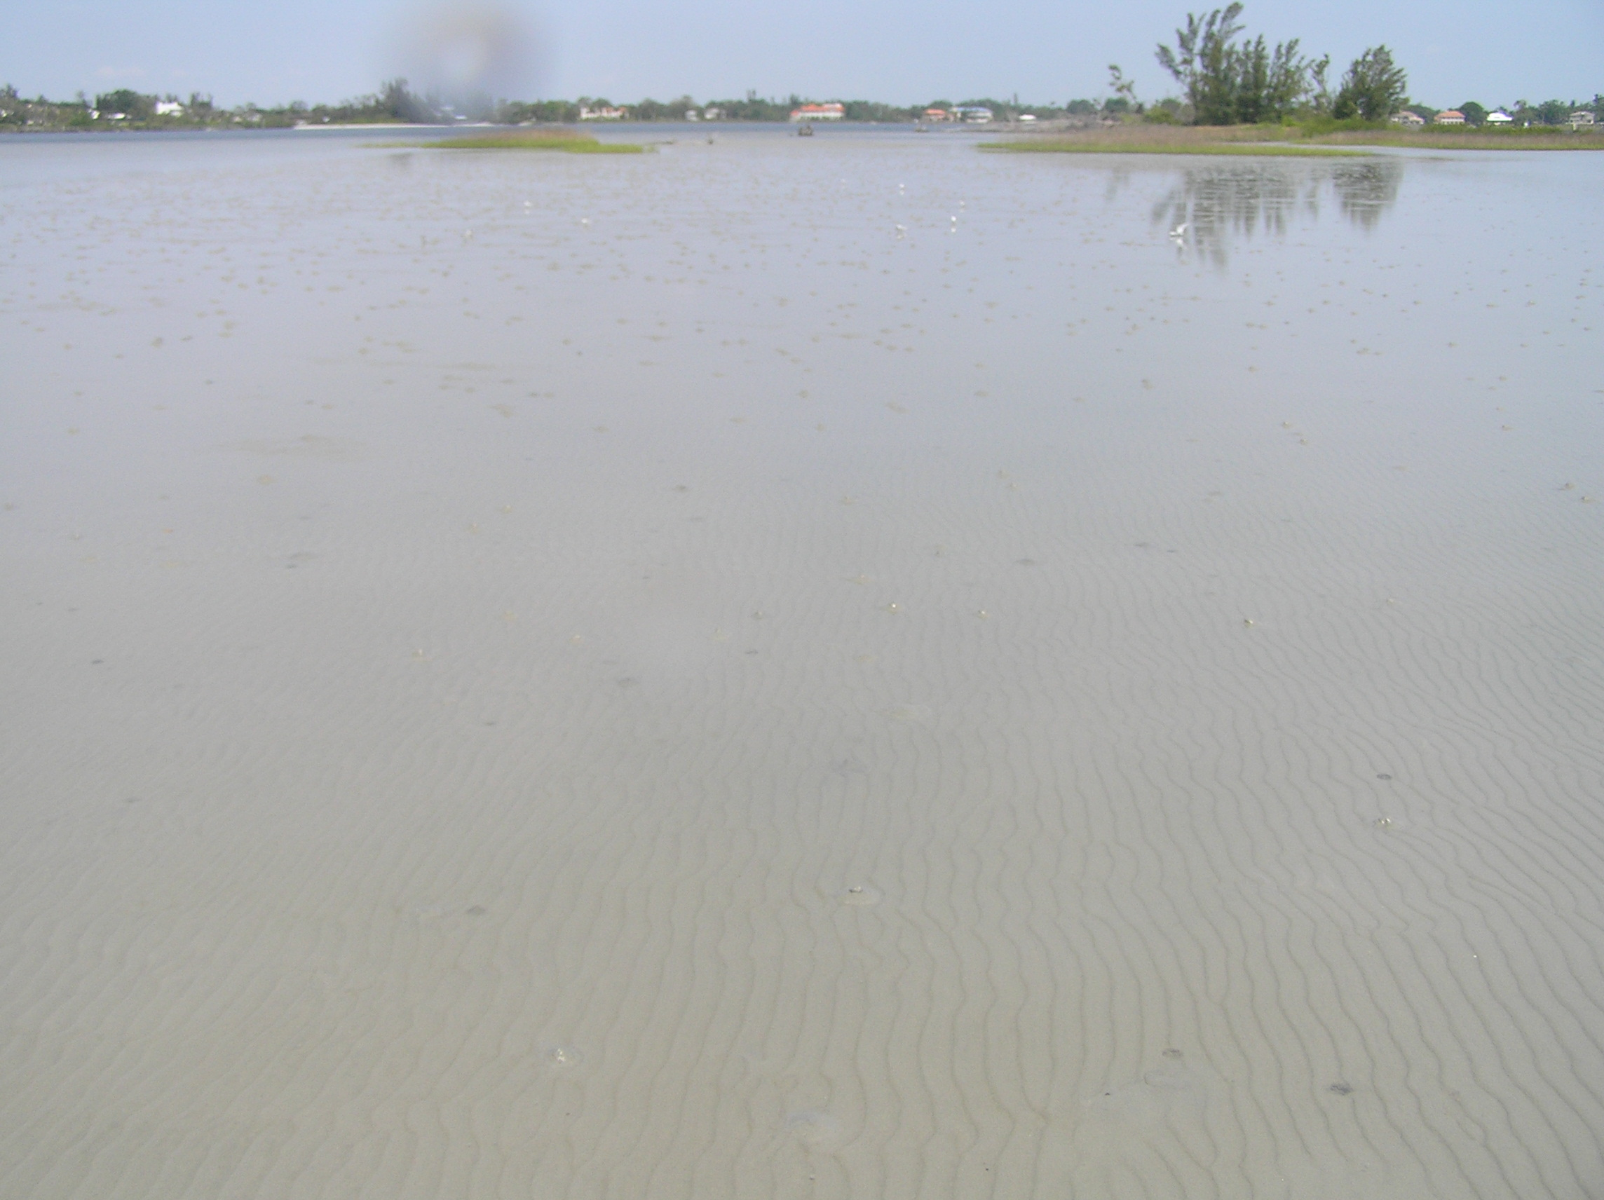

6510 (Tidal Flat)

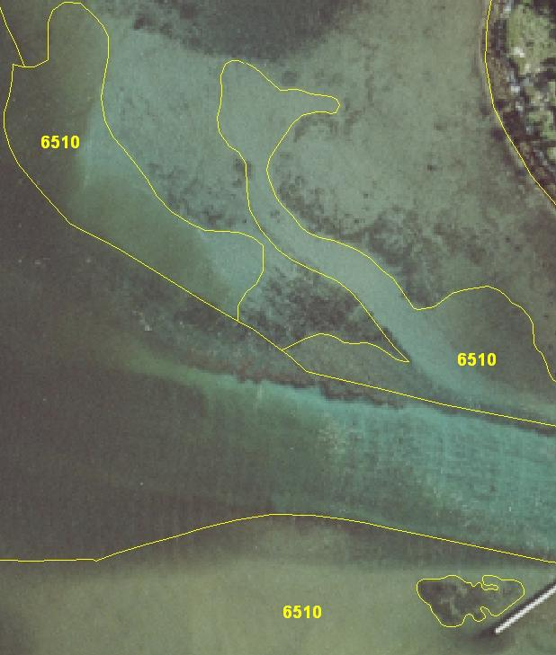

Delineated photograph showing 6510

Algae beds (9121)

Definition

In a few cases, beds of algae may be distinguishable from seagrass. Where these areas have been identified on the photography and field checked, they are mapped (if > 10% cover), although this is not a high priority and there was no intent to accurately map all algae beds as part of the mapping project. In many cases, drift algae accumulates in seagrass beds. In these cases, the area should be mapped as seagrass, and the density should be based on seagrass density only, not algae density.

Description

The photosignature for the 9121 classification is very similar to that of the patchy and continuous seagrass beds. It exhibits the same bluish-gray color and can have either a rough or smooth texture depending upon the amount and thickness of the algae present. Algae beds can consist of either attached algae or drift algae. The attached algae photosignature is exactly the same as that of seagrass and can only be differentiated through field reconnaissance. On the other hand, the drift algae can usually be found in clumps and windrows (chevron shaped accumulations) that have been affected by the current. It is usually found spread out over large, flat areas (which are on the deeper edges of the seagrass beds), or in thick accumulations that are clumped together against some type of current blocking structure (i.e. spoil islands or channel edges). It is also identifiable by depth (anything deeper than 2 meters is probably algae).

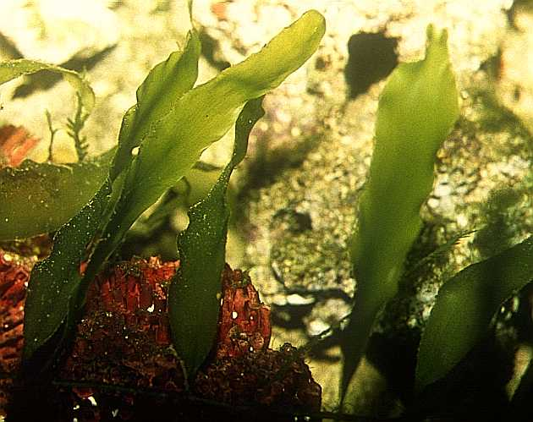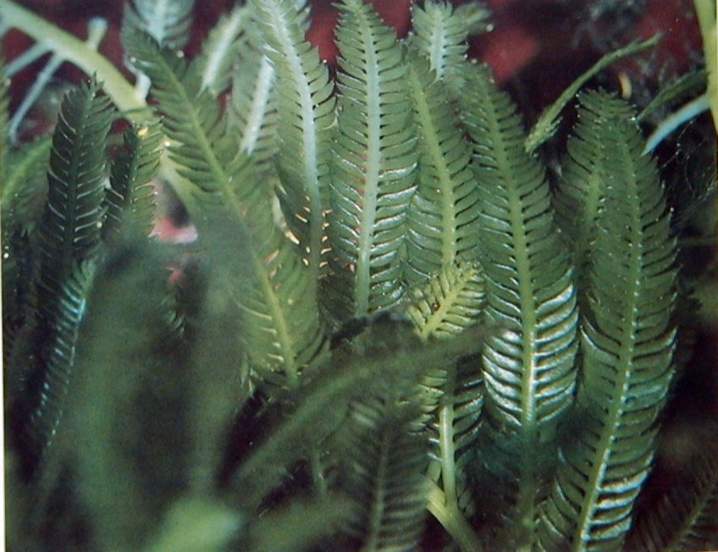

9121 Caulerpa prolifera 9121 Caulerpa taxifolia

Algae beds (9121), continued

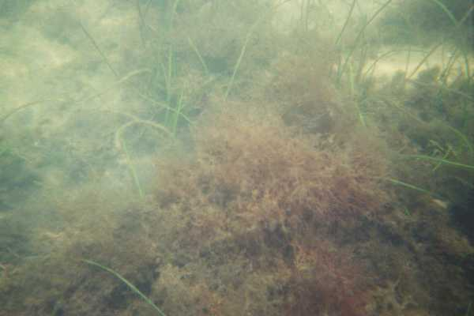

9121 Drift Algae beds (9121), continued

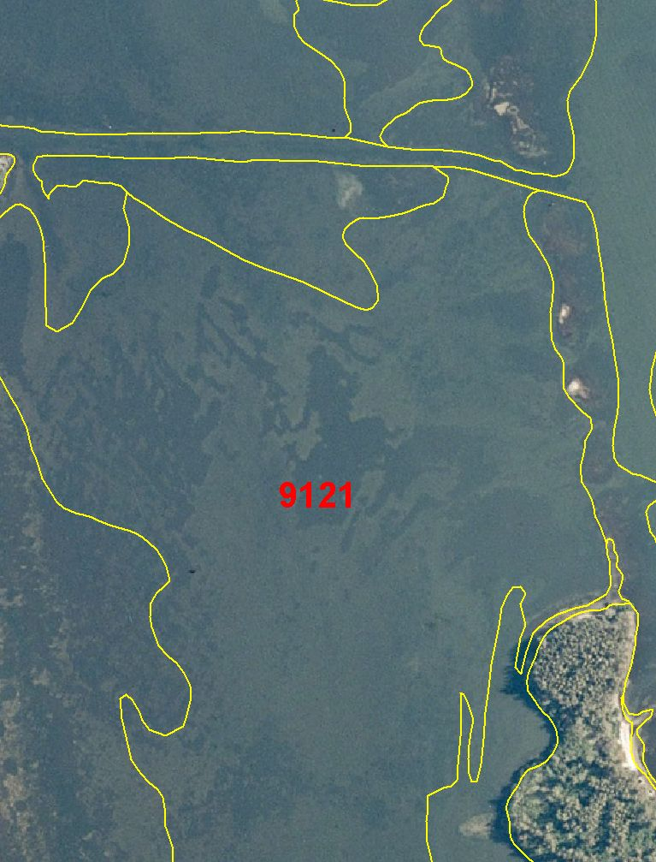

Delineated photograph showing 9121

Mangrove Swamp (6120)

Definition

This coastal hardwood community is dominated by red, white, and/or black mangrove. The major associated species include buttonwood, Brazilian pepper, cabbage palm and sea grape. Mangrove Swamp will be classified where mangrove occupies 75% or more of an area.

Description

Primarily found in, but not limited to, coastal areas subject to periodic or continual inundation by salt or brackish water. Red mangroves extend to the open water, with black mangroves towards the landward edge, and white mangrove in the most landward, least inundated.

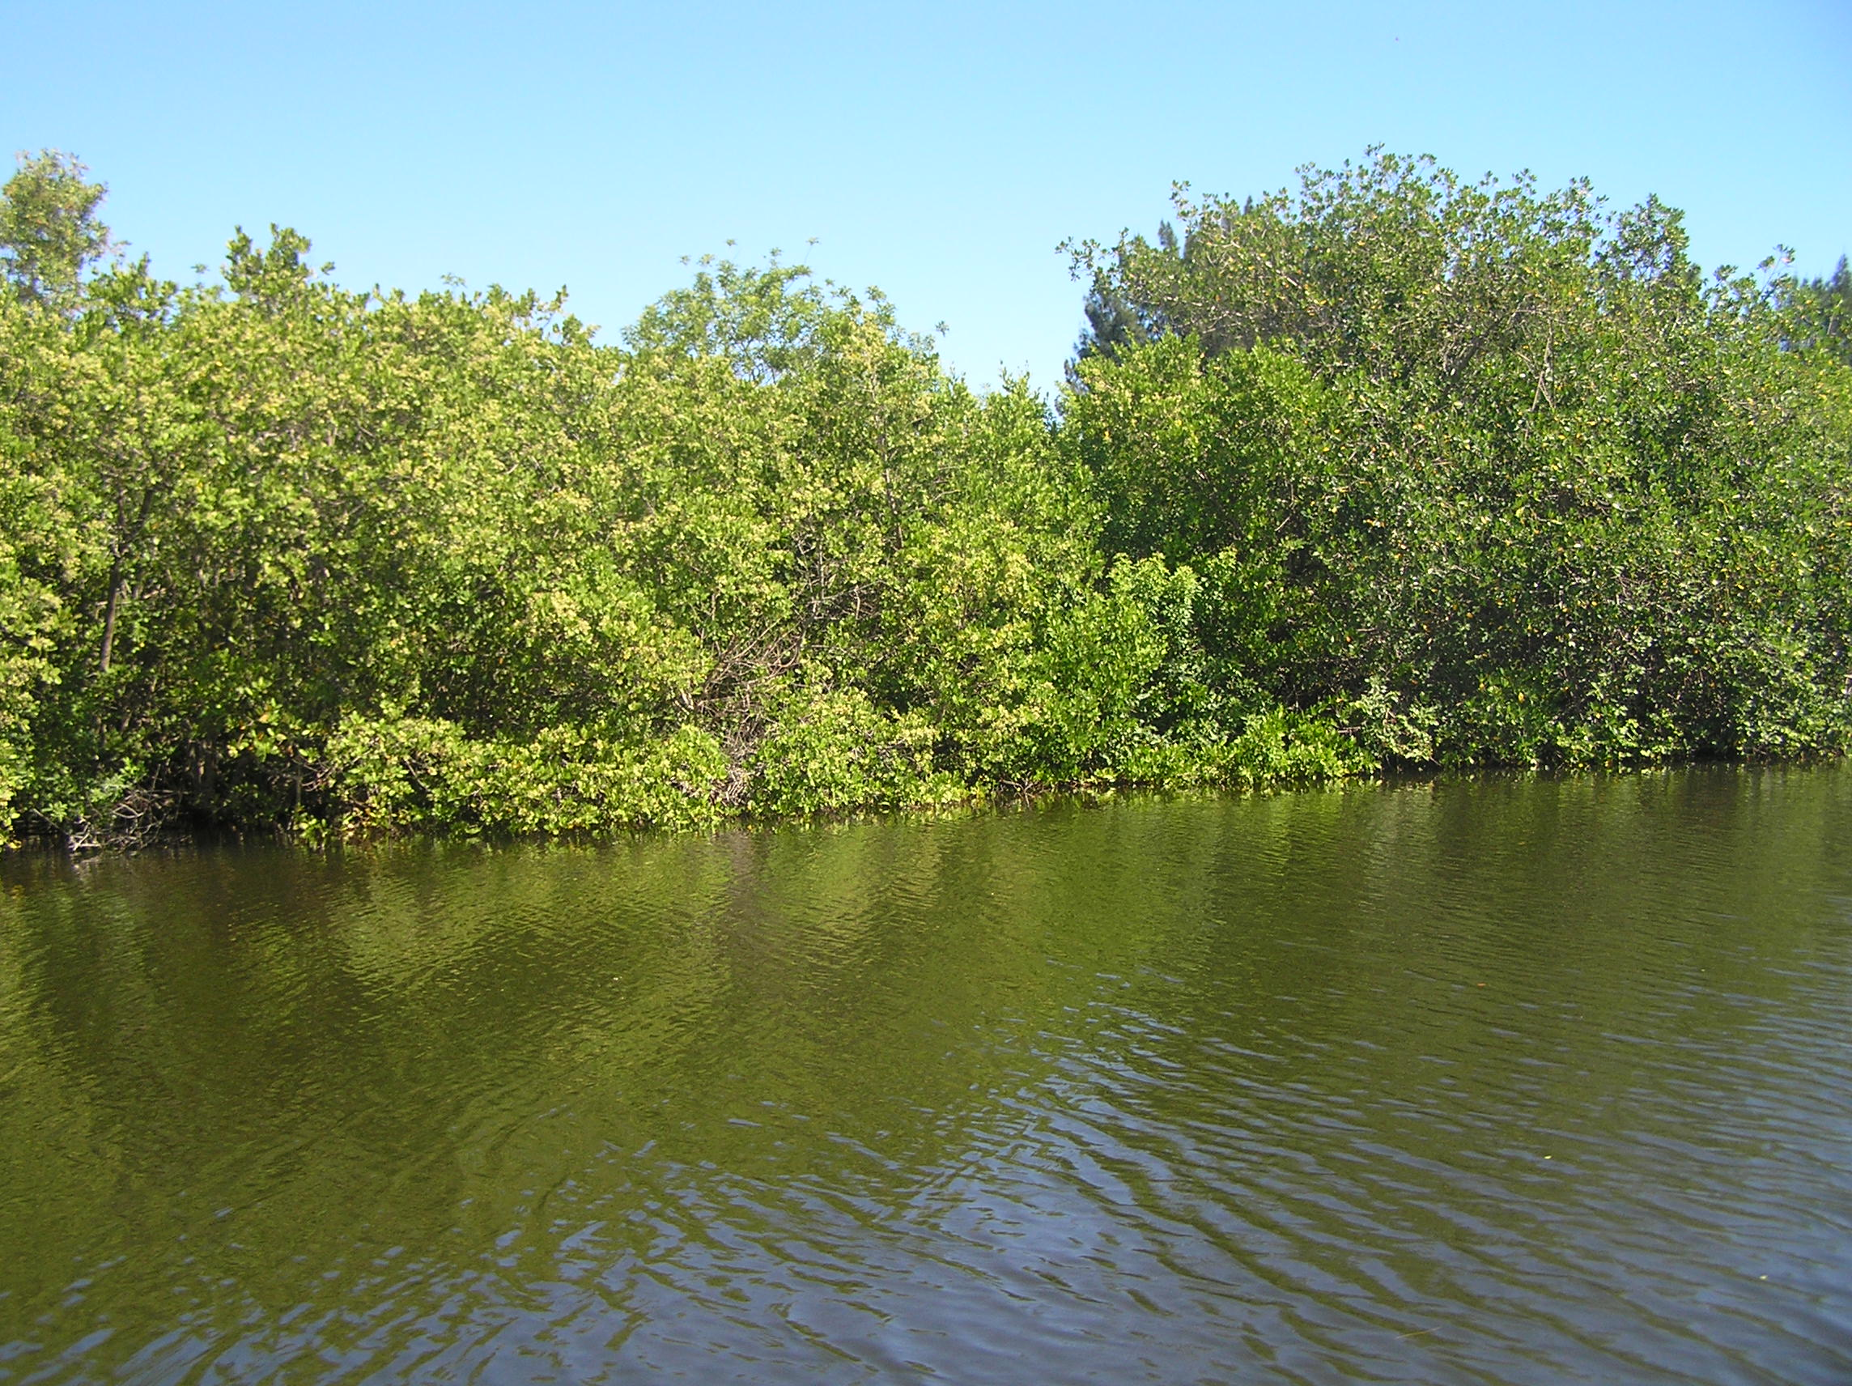

6120 Mangrove Swamp

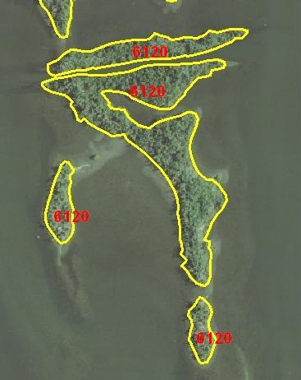

Delineated photograph showing 6120

Oyster Bars / Reefs (6540)

Definition

This classification includes oyster bars / reefs and oyster shell hash. Both live and dead oyster habitat will be classified under this class if they achieve dominance within the
covertype and meet the minimum mapping unit.

Description

The photo signature for 6540 is bright white to light gray with a distinctive ridge often visible when the beds are exposed at the surface. The beds can also appear dark gray to black in color when algae are growing or have accumulated on the shells. The texture of submerged oyster beds is mottled in appearance when viewed in stereo while exposed beds are smooth in texture. 6540 is usually found in shallow brackish water creeks (10% salinity or more), flats, and near docks and jetties.

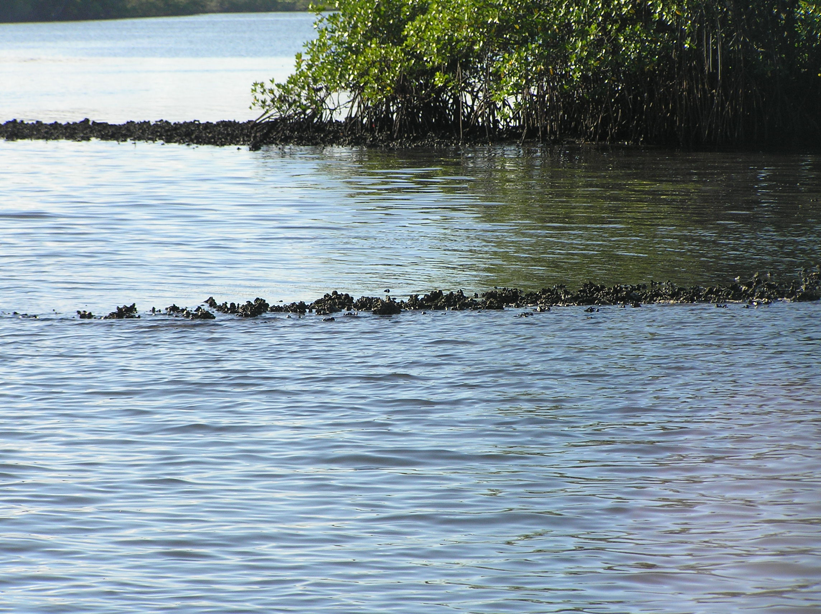

6540 Oyster Bars / Reef

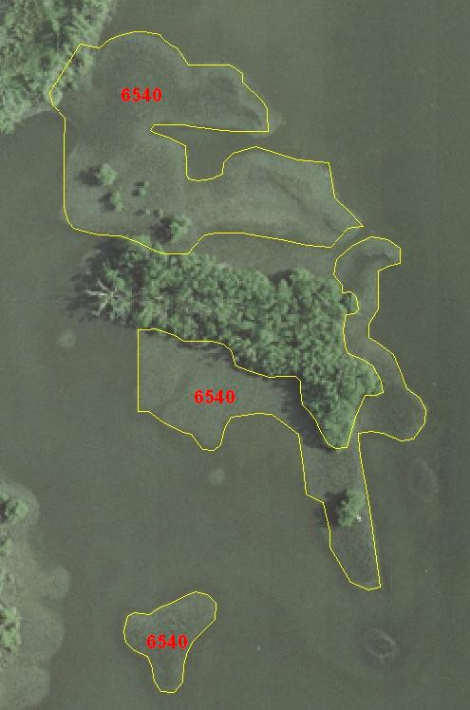

Delineated photograph showing 6540
Cordgrass Spartina sp. (6421)

Definition

This community of non-woody, salt-tolerant plants occupying intertidal zones that are at least occasionally inundated with salt water. They exist at the interface of land and marine waters, wherever wave energy is sufficiently low to allow their development and where mangrove trees are not dense enough to shade out the characteristic vegetation. This class will be mapped if Spartina occupies 66 percent of the community.

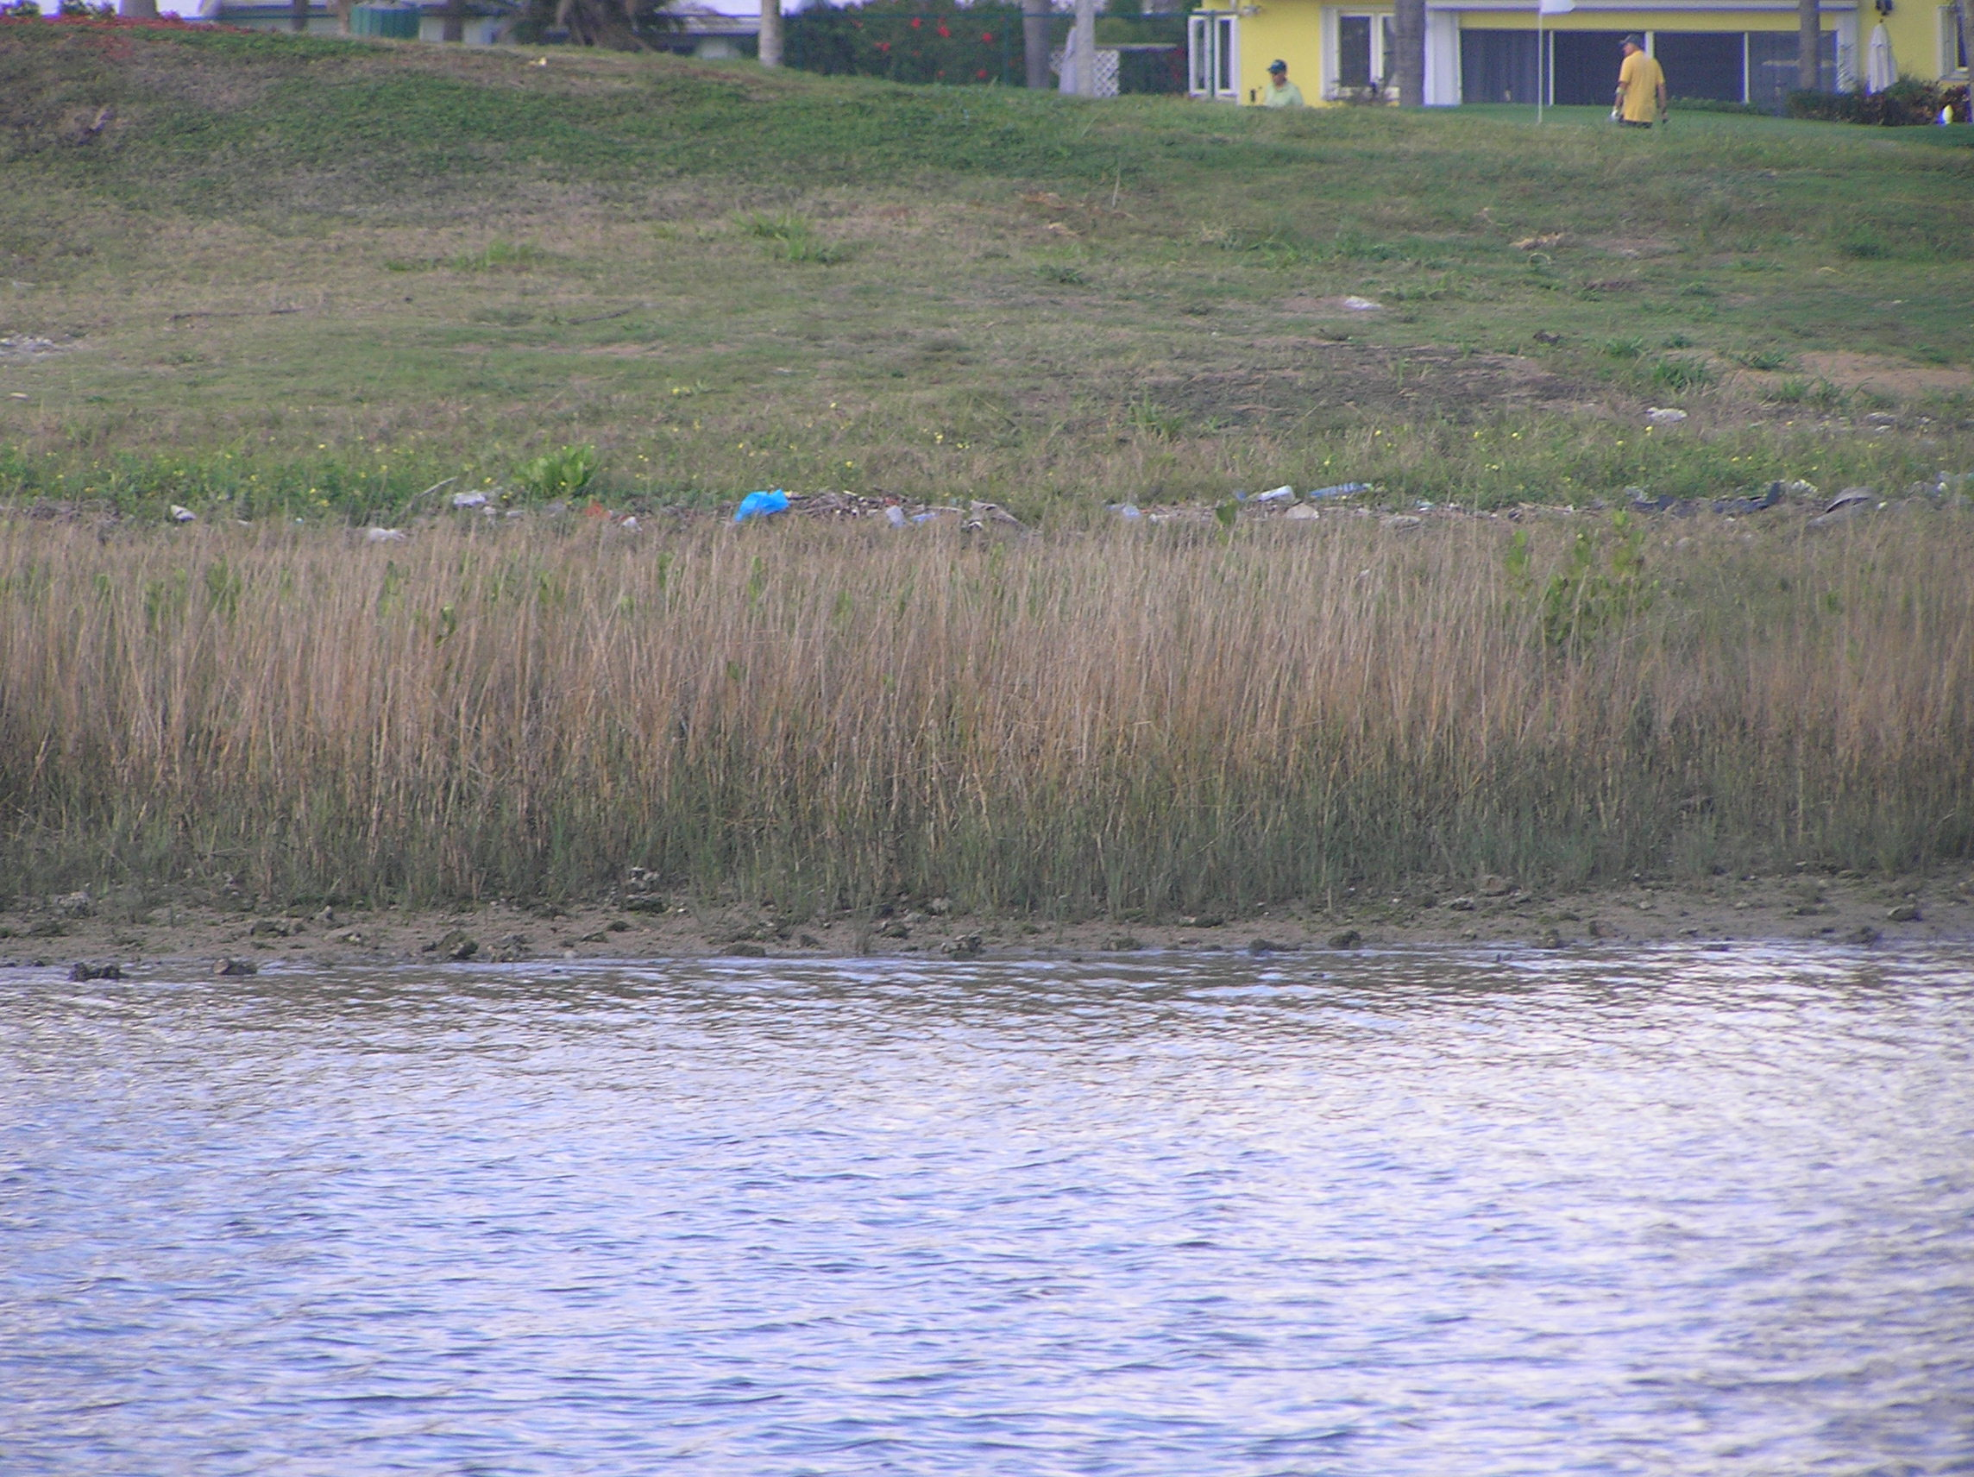

6421 Cordgrass Spartina

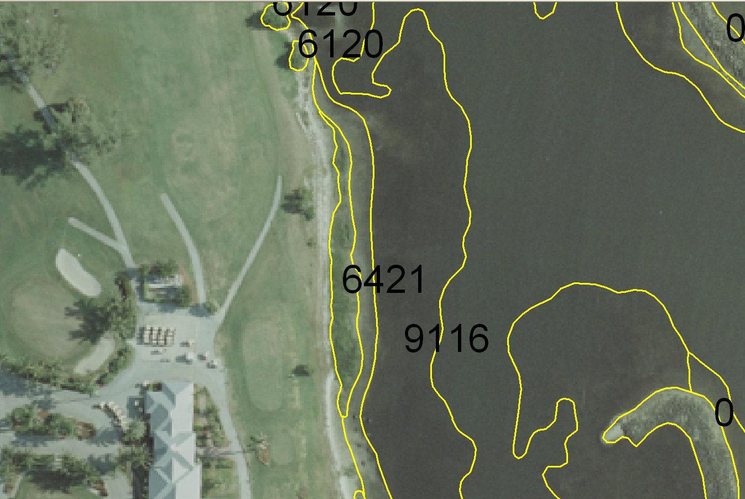

Delineated photograph showing 6421
Not Classified Land (0)

Definition

Land for the 2007 Habitat Project will be considered all covertypes that are not included within the other classification types.
Mainland, islands and other land normally above the high tide line are also considered Land. The line delineating the water/land interface may be formed anywhere between the extreme low and extreme high tide marks.

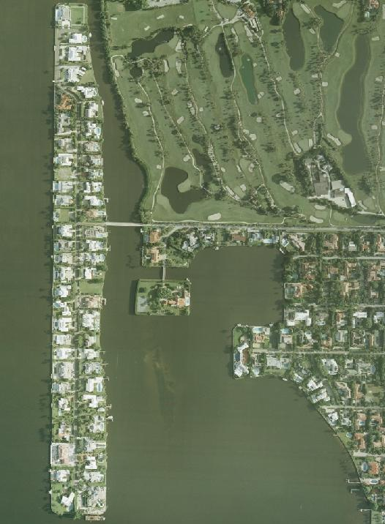

0 Not Classified (Land, islands etc)

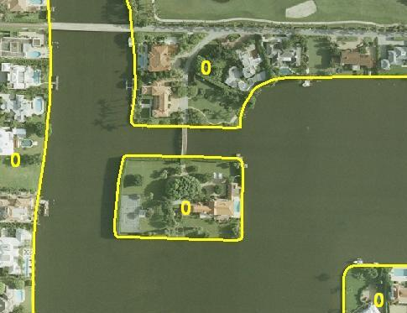

Delineated photograph showing 0 Not Classified (Land, islands etc)

