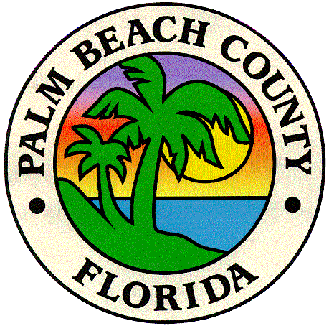
Final Project Report
For the
Palm Beach County
2007 Habitat Mapping Project

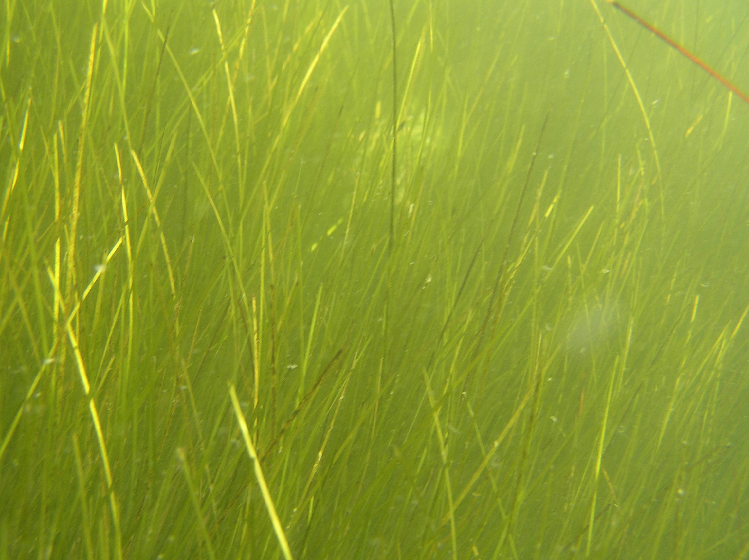

Prepared under Task Order 0688-01A
by:



Avineon Inc.
15500 Lightwave Drive, Suite 200
Clearwater, FL 33760
Tel (727) 539-1661

Report Date: 6/30/08

Table of Contents

1.0 Overview 1
1.1 Project Participants 1
2.0 Project Area 2
3.0 Mapping Methodology 4
3.1 Source Information 4
3.2 Aerial Photography 5
3.3 Aerial Photography Comparison 5
3.4 Digital Aerotriangulation Methods and Digital Orthophotography 6
3.5 Photointerpretation Key 7
3.6 Photointerpretation 7
3.7 Trend Analysis 10
3.8 Project Metadata 12
3.9 Quality Assurance and Quality Control 12
3.10 Final Deliverables 15
4.0 Project Problems and Their Solutions 16
5.0 Conclusion 16
APPENDIX 17
APPENDIX A: Fully Analytical Aerial Triangulation Report 17
APPENDIX B: Photointerpretation Key 17
APPENDIX C: Trend Analysis Acreage Statistics 17
APPENDIX D: Plotted Maps 17
APPENDIX E: Metadata Documentation 17

1.0 Overview

Avineon Inc. was contracted to complete aerotriangulation, digital orthophotography, fieldwork, photointerpretation, mapping, trend analysis, and GIS data delivery within the Lake Worth Lagoon and the adjacent Intracoastal Waterway. Avineon performed the project under subcontract to Applied Technology and Management (ATM) for Palm Beach County’s Environmental Resources Management (ERM) department. The 2007 mapping effort will enable ERM to determine the aerial extent selected estuarine habitats existing within the county.

Avineon has completed and delivered a final geodatabase to the County depicting seagrass, unvegetated bottom, tidal flats, algae beds, mangrove swamp, oyster bars/reefs, cordgrass (spartina sp.), and shoreline.

This report summarizes the project results and explains the methodology used to produce the project deliverables. It also contains references to additional reports that were delivered during the course of the project.

1.1 Project Participants

The following is a listing of the project management staff who participated on the project.

County Project Manager
Eric Anderson, Environmental Analyst
Palm Beach County
Department of Environmental Resources Management
2300 North Jog Road, 4th Floor
West Palm Beach, FL 33411-2743
Phone: (561) 233-2514, Fax: (561) 233-2414
Email: Eanderson1@co.palm-beach.fl.us

County Alternate Contact
Julie Bishop, Environmental Program Supervisor
Palm Beach County
Department of Environmental Resources Management
2300 North Jog Road, 4th Floor
West Palm Beach, FL 33411-2743
Phone (561) 233-2446, Fax (561) 233-2414
Email: Jbishop@co.palm-beach.fl.us

Consultant Project Manager
Michael Jenkins, PhD, PE
Coastal Engineering Team Leader
Applied Technology and Management
400 S. Australian Ave., Suite 855
West Palm Beach, FL 33401-5045
Phone: 561-659-0041 x15
Fax: 561-659-3733
Email: mjenkins@appliedtm.com

Subconsultant Project Manager
Keith Patterson, PSM
Avineon, Inc.
15500 Lightwave Drive, Suite 200
Clearwater, FL 33760
Phone: 727-539-1661 x 321
Email: kpatterson@avineon.com

Subconsultant Project Manager
Mike O’Leary
U.S. Imaging, Inc.
475 South First Ave
Bartow, FL 33830
Phone: 863-519-0032
Email: moleary@usimaging.com

2.0 Project Area

The overall project area includes the entire Lake Worth Lagoon system and the Intracoastal Waterway (ICW) throughout Palm Beach County.

The map contained on the following page depicts the area mapped by Avineon.

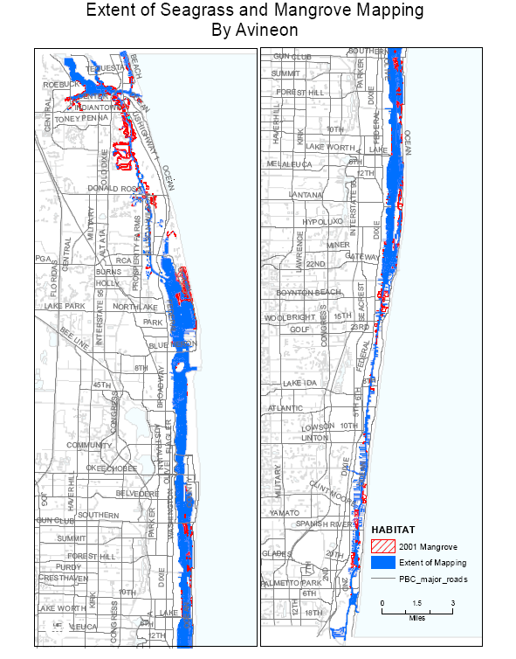

3.0 Mapping Methodology

The following section outlines the methodology that Avineon used for the creation of the deliverables for the project.

3.1 Source Information

The following items were provided by the County and used during the project:

- 1985 and 2001/2003 habitat shapefiles from past mapping projects

- Winter 2007 Countywide digital orthophotography imagery

- ArcView shapefiles of the county shoreline and waterways

- ERM’s metadata requirements

- Printed copy of the 1990 Lake Worth Lagoon Resource Inventory

- A .dwg file of the 1990 Lake Worth Lagoon Resource Inventory

- Existing maps and shapefiles of ERM and Florida Department of Environmental Protection (FDEP) Boat Facility Siting Plan

- ArcGIS Shapefile of the seagrass map created from 2001 aerial photography by ATM/Avineon

- All deliverables created from the 1985 and 2001 aerial photography previously delivered by ATM/Avineon. These include the GIS maps, digital orthophotography, and reports generated for the previous 2004 effort

- ArcGIS Shapefiles of the 1985 and 2001 mangrove maps created by ATM/Avineon

- PLSS Section corner coordinates covering the project area

- Sub-basin boundary files in ArcGIS

3.2 Aerial Photography

The following aerial photography was utilized for the project.

Photography Date | Scale | Type | Coverage Area | Source
June 20, 2007 | 1:10,000 | natural color | Lake Worth Lagoon and ICW | ATM/ U.S. Imaging, Inc. for this project
June 22, 2007 | 1:10,000 | natural color | Lake Worth Lagoon and ICW | ATM/U.S. Imaging, Inc. for this project
July 1, 2007 | 1:4,800 | natural color | Loxahatchee Estuary | SFWMD
July 21, 2007 | 1:10,000 | natural color | Lake Worth Lagoon and ICW | ATM/U.S. Imaging, Inc. for this project
August 4, 2007 | 1:10,000 | natural color | Lake Worth Lagoon and ICW | ATM/U.S. Imaging, Inc. for this project
August 8, 2007 | 1:10,000 | natural color | Lower Indian River Lagoon | SJRWMD

The ATM/U.S. Imaging, Inc. aerial photography acquired for the project produced 134 stereo models from 12 flight lines. These aerial photographs were captured using a Wild RC30 photogrammetric camera, serial number 5334, with a Wild Universal Aviogon /4-S lens with serial number 13374. This camera has a calibrated focal length of 153.799 mm and the calibration date was January 5, 2007.

In addition to the ATM/U.S. Imaging aerial photography acquired specifically for the part of the project area, the St. Johns River and South Florida Water Management Districts provided existing aerial photography for northern areas of the project.

3.3 Aerial Photography Comparison

Avineon compared the project’s summer 2007 aerial photography to the countywide imagery captured during the winter of 2007. This task was performed in order to estimate whether or not a significant difference in benthic habitat signatures is apparent on imagery captured during the winter versus the summer.

Aerial imagery captured for the east coast of Florida has historically been acquired during the late spring/summer months (i.e. May through August). Severe weather and water conditions in fall/winter may cause submerged seagrasses to lose most of their leaves, thus making them difficult to see on aerial photography until new blades emerge in spring. In mild years, this wholesale leaf loss does not occur.

In terms of weather conditions, generally there are more predictably clear skies during the winter months on the east coast of Florida. This fact allows for more windows of opportunity to capture suitable aerial photography. Sun angles are also more favorable in winter allowing for longer flight days than in the summer. In practice, the project was delayed a year due to the absence of suitable conditions in 2006.

When visually comparing the two imagery sets it appears that more areas of silt/sediment/turbidity are present within study area on the summer photography. However the clearer conditions evident on the winter photography do not necessarily reflect a better camera system or a more optimal season to fly. They merely could reflect conditions on a particular day rather than a season. The conditions could have easily been reversed between summer and winter. While more areas of turbidity were present in the summer photography, the summer photos did capture submerged features better in the portion of the lagoon south of image 434403.

We compared distinct edges of seagrass beds on the summer and winter photography. No visual trend was evident between the two photography sets where gain or loss was greater in one set or the other, meaning both imagery sets showed losses and both showed gains. Additionally, both imagery sets showed edges of beds clearly with no apparent difference in area extent. One area of focus was in the southern portion of Palm Beach County on summer mosaic 434717. This area depicts clear water conditions in both imagery sets and clearly shows no change in the edge of bed.

Our evaluation concluded that both the summer and winter aerial photography sets adequately depict seagrass habitats suitable for aerial mapping efforts. However, the winter photography was captured strictly by chance during optimal water conditions. The winter photography acquisition was only confined by weather conditions rather than water conditions within the study area. A more reliable comparison would be to compare seasonal imagery sets that are both designed for benthic habitat mapping and both acquired under the same specifications. Our evaluation was based off of visual comparisons of the same features located within the different imagery sets. No linework was compiled for this study.

3.4 Digital Aerotriangulation Methods and Digital Orthophotography

Avineon utilized ground control acquired from previous mapping efforts within Palm Beach County. Most of these control points were recovered from documentation and were photo-identifiable on the 2007 imagery. Additional photo-identifiable ground control coordinates were extracted from the digital orthophotography provided by the county.

An aerotriangulation solution was computed across the project area, using ImageStation Automatic Triangulation (ISAT) software issued by Z/I Imaging Corporation. Utilizing ground control coordinates, camera calibration reports, and the raw scans of photography, ISAT created a solution that meets the USGS National Map Accuracy Standards for 1:24,000 scale maps. Checkpoint coordinates were then used to test and verify the solution.

Upon completion and quality assurance acceptance of the aerotriangulation solution, the adjusted control points and camera orientation parameters were used to set up the stereo models for photointerpretation and to produce the project’s digital orthophotography.

APPENDIX A: Fully Analytical Aerial Triangulation Report contains the aerotriangulation report (i.e. Report of Survey) certified by a Florida PSM

The orthophotography process was performed in an automated batch process. By using the raw imagery in combination with the aerotriangulation results described above along with a USGS digital elevation model, our softcopy system generated the digital orthophotography. These were then mosaiced and tiled by PLSS sections according to the PLSS section file supplied by the County.

3.5 Photointerpretation Key

Avineon delivered a photointerpretation key for the project. The key contains examples of all Florida Land Use Cover and forms Classification System (FLUCCS) covertypes delineated for the study. The Key includes textural descriptions of the classification types along with several examples of delineated aerial photography to show users the representative habitat signatures appearing on the photos.

APPENDIX B: Photointerpretation Key contains a copy of the photointerpretation key.

3.6 Photointerpretation

Photointerpretation for the project was accomplished on Avineon’s ImageStation Stereo Displays (ISSD) software. These photogrammetric workstations allow stereo 3D viewing and stereo-compilation of the project’s imagery.

Habitat covertype boundaries were photogrammetrically digitized using CadMap/dgn software in conjunction with ISSD, running on workstations with the Windows XP operating system. The software facilitates digitizing into MicroStation (Bentley Microsystems, Inc.) for later importation to ArcGIS.

Photointerpreters utilized previously collected field data along with other available collateral data such as transect data provided by Palm Beach County to assist in their interpretation. Throughout the photointerpretation process, positional accuracy of habitat boundaries were maintained according to the photographic signatures apparent on the photography.

The following coding and classification system was applied during photointerpretation:
CODE CLASS NAME

9116 Seagrass — Continuous, Dense
9113 Seagrass — Patchy
5400 Unvegetated Bottom
6510 Tidal Flats
9121 Algae Beds
6120 Mangrove Swamp
6540 Oyster Bars/Reefs
6421 Cordgrass (Spartina sp.)
0 Not Classified (Land, islands, etc)

The following classification conventions were used in order to ensure consistency of delineation:

1. Seagrass, continuous, dense -- FLUCCS code 9116. The dominant feature
of these seagrass beds is that they are continuous in nature, with
interconnected areas of seagrass. These beds may contain many small,
interspersed patches of sparsely vegetated or unvegetated bottom. The
dense aspect means that the area should contain more vegetated bottom
than unvegetated bottom, and thus would have a lower limit of about 50%
cover of seagrass. Only sand patches greater than 0.25 acres should be
distinguished within a continuous, dense bed. Species composition is not
mapped.

2. Seagrass, patchy -- FLUCCS code 9113. Areas 0.25 acres or greater in size
that consist of primarily (greater than 50%) bare bottom in which many small
patches (each less than 0.25 acres) of seagrass are scattered, and where the
seagrass patches are not interconnected.

3. Unvegetated bottom -- FLUCCS code 5400. Barren substrate with little or
no perceptible seagrass (< 10%) or algae. For this study, the lower limit of
what constitutes a seagrass bed is approximately 10% cover; areas with <10
% cover are considered “unvegetated bottom”.

4. Tidal Flats -- FLUCCS code 6510. Non-vegetated areas of sand or mud that
are exposed at least once during the year or are capable of supporting
seagrass populations for that segment of the water body (i.e. approximately
six feet of depth). It is recognized that the typical depth for tidal flats to be exposed once a year is -1 feet. However, the -6 feet depth was retained for consistency with other studies.

5. Algae beds -- FLUCCS code 9121. In a few cases, beds of algae may be
distinguishable from seagrass. Where these areas have been identified on
the photography AND field checked during the field trips conducted for
seagrass mapping, they should be mapped (if > than 10% cover), although
this is not a high priority and there is no intent to accurately map all algae
beds as part of this project. (In many cases, drift algae will accumulate in
seagrass beds. In these cases, the area should be mapped as seagrass).

6. Mangrove Swamp – FLUCCS code 6120. This coastal hardwood community
is dominated by red, white, and/or black mangrove. The major associated
species include buttonwood, Brazilian pepper, cabbage palm and sea grape.
Mangrove Swamp will be classified where mangroves occupy 75% or more of
an area.

7. Oyster Bars / Reefs – FLUCCS code 6540. This classification includes
oyster bars / reefs and oyster shell hash. Both live and dead oyster habitat
will be classified under this class if they achieve dominance within the
covertype and meet the minimum mapping unit.

8. Cordgrass (Spartina sp.) – FLUCCS code 6421. This class will be mapped if
Spartina occupies 66 percent of the community.

9. Not Classified – FLUCCS code 0. Not Classified for the project will be considered all covertypes that are not included within the other classification types. Mainland, islands, and other land normally above the high tide line are also considered Not Classified.

The following guidelines were followed as a means of standardizing the photo-interpretation for this task:

1. Outer boundaries of beds are more important than internal structure
(patchiness, shapes of sand patches within, etc.) of beds.

2. Outer boundaries of beds are more important than density categorization
within beds.

3. The minimum mapping unit is 0.25 acres. It’s more important to include small
isolated patches than similar sized patches that are part of a large matrix. Care
should be taken in mapping small areas of seagrass when only a small amount
of seagrass is present, e.g., around a spoil island.

(a) When deciding whether an area with patches of seagrass is one polygon of patchy seagrass or individual seagrass polygons, apply Guideline #3 with a minimum mapping unit of 0.25 acres. Err on the side of lumping except in areas where small patches are the only seagrasses present.

(b) If an area has only a few patches, all <0.25 acres: Include the area within the polygon of patchy seagrass if the total seagrass area is >0.25 acres. Err on the side of including these rather than excluding them.

The 2001 shoreline provided by the County was re-used during photointerpretation wherever possible. The shoreline remained unchanged for most of the project area. However in selected areas where the shoreline experienced significant change, it was re-digitized to reflect the 2007 imagery.

At the conclusion of the photointerpretation task the Cadmap/dgn data file produced on Avineon’s ImageStation Stereo Displays (ISSD) was translated to ArcGIS. Once the data was exported to ArcGIS, processes for building topology and validating the map coverage were completed.

3.7 Trend Analysis

Habitat acreage totals were summarized for each map timeframe using ArcGIS. Trend analysis was completed by comparing 2007 habitat acreages to the historical acreages on the 2001 and 1985 map coverages.

Changes in the area coverage for each habitat were calculated except for Cordgrass and Oysters which were not mapped in 1985 and 2001.

A bounding polygon was first established to ensure that the total project area between 1985, 2001, and 2007 remained identical. The shoreline was not used to define the project boundary for statistical reporting because it changed in area extent between map eras.

Acreage statistics were further broken down by pre-defined segments within the project study area. Shapefiles of each of the segment boundaries were provided by PBC ERM for segmenting the study area.

Acreages were summarized according to the segments as defined below.

1. PBC General Distribution Segments - The project study area was divided into three general distribution segments:

a. North Intracoastal Waterway (NICW): Begins at the northern county line and continues south to the line where the AIWW meets the LWL.

b. Lake Worth Lagoon (LWL): Begins at the line where the ICW meets the LWL, includes Little Lake Worth, and continues south to the Ocean Avenue Bridge in Boynton Beach.

c. South Intracoastal Waterway (SICW): Begins at the Ocean Avenue Bridge in Boynton Beach and continues south to the county line.

2. Lake Worth Lagoon Sub-Basin Segments - The Lake Worth Lagoon General Distribution segment was further divided into three sub-basins categories:

a. Northern Zone: Begins at the PGA Boulevard Bridge and continues south to the Royal Park Bridge in West Palm Beach.

b. Central Zone: Begins at the Royal Park Bridge in West Palm Beach and continues south to the Ocean Ave. Bridge in Lantana.

c. Southern Zone: Begins at the Ocean Avenue Bridge in Lantana and continues south to the Ocean Avenue Bridge in Boynton Beach.

Totals for each of the habitats were calculated from shapefiles and were summarized in Microsoft Excel spreadsheets.

Acreages within the above segments were calculated within the following acreage statistics spreadsheets which were delivered for the project.

- PBC 2001 Summary by General Distribution
- LWL 2001 Summary by General Distribution

- PBC 2007 Summary by General Distribution
- LWL 2007 Summary by General Distribution

- PBC 2001-2007 Submerged Habitat Change
- LWL 2001-2007 Submerged Habitat Change

- PBC 1985-2001-2007 Mangrove Habitat Change
- LWL 1985-2001-2007 Mangrove Habitat Change

- PBC 2007 Oyster Reef Habitat
- LWL 2007 Oyster Reef Habitat

- PBC 2007 Cordgrass Habitat
- LWL 2007 Cordgrass Habitat

- PBC 2007 Seagrass General Distribution
14. LWL 2007 Seagrass General Distribution

APPENDIX C: Trend Analysis Acreage Statistics contains the trend analysis tables delivered to Palm Beach County for the project

Selected map plots were also generated for the project.

APPENDIX D: Plotted Maps contain plotted maps generated for the project.

3.8 Project Metadata

A digital metadata template was completed for the project and delivered to the County. The metadata provides additional documentation on the project and the ArcGIS data produced as a deliverable.

APPENDIX E: Metadata Documentation contains a printed copy of the metadata.

3.9 Quality Assurance and Quality Control

Avineon establishes, documents, implements and maintains a quality management system and continually improves its effectiveness in accordance with the requirements of our ISO 9001:2000, Quality Management System.

Quality control reviews were ongoing throughout the project. The datasets were examined for adherence to mapping conventions, the PI Key, spatial and classification accuracy, and photointerpretation consistency. Below is a description of the quality control steps that were used for the project.

Aerial Photography Quality Assurance

Avineon inspected the project’s aerial photography for tonal balance and contrast, completeness of aerial coverage, and defects prior to acceptance. Specifically, the aerial photography was inspected for its suitability for mapping submerged features within the Lake Worth Lagoon and ICW.

Spatial Accuracy

Residuals from the AT solution were checked and approved by a Florida licensed Professional Surveyor and Mapper (PSM) prior to stereo-compilation.
The positional accuracy of the photointerpreted data was checked by comparing it with positions extracted from ancillary digital orthophotography. The accuracy of the orthophotography was additionally checked by surveyed ground control collected by a Trimble Pro XR receiver during field work performed for the project.
In-Process Photointerpretation Quality Assurance

Avineon’s Project Manager and the designated quality assurance (QA) photointerpreter systematically reviewed seagrass, tidal flat, mangrove, oyster/reef, and spartina delineations and classifications interpreted from the aerial photographs.
During quality control reviews, all the delineations interpreted on the aerial photographs were inspected by the QA photointerpreter who made revision comments where necessary. The original photointerpreter completed the required revisions and resubmitted the data back to the QA photointerpreter. The work was checked again by the QA photointerpreter prior to delivery as a draft product to the County.
Logical Consistency Checks

Logical consistency checking was done during photointerpretation and quality assurance. This check involved quality assurance to ensure that a certain habitat was not classified within deep water, deep channels, or other areas where it is unlikely to occur. The overall distribution of each photointerpreted class was reviewed in association with surrounding classes to ensure logical consistency.

GIS Quality Control

The quality of the ArcGIS digital data was monitored by a combination of manual and automated analyses. A set of automated quality control programs were used to check for errors, such as missing polygon label points, label points with no attributes, invalid attribute codes, missing attributes, and two adjacent polygons with the same attribute.

Groundtruthing

The project’s photointerpreters conducted field trips to compare mapped data with actual field conditions. The field trips were utilized to answer photointerpretation questions and to check representative areas of the map during photointerpretation. Fieldwork was conducted on 11/13, 11/14, 11/15 of 2007 and 2/26, 2/27 of 2008. A total of 158 checksites were attributed in shapefile format while in the field. A rugged field laptop coupled with a GPS allowed for navigation and attribution in real-time. This also allowed the field crew to access the digital imagery and linework while assessing the locations habitat.

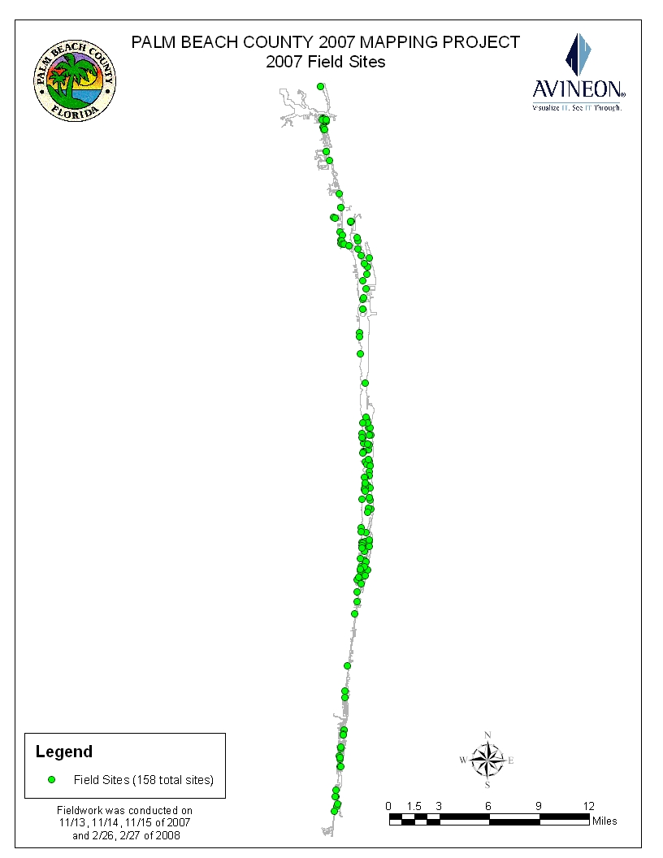
Map of PBC 2007 field checksites.

3.10 Final Deliverables

Avineon submitted selected draft products for inspection by the County during the course of the project. Below is a listing of the final deliverables produced by Avineon for the project.

- A seagrass polygon and shoreline file in ArcView shapefile format of the entire mapping project boundary area.

- A seagrass polygon and shoreline file in ArcGIS geodatabase format of the entire mapping project boundary area.

- A seagrass change map that shows 2001-2007 trends in seagrass presence or absence in ArcView shapefile, and ArcGIS geodatabase format of the entire mapping project boundary area.

- A mangrove polygon and shoreline file in ArcView shapefile format of the entire mapping project boundary area.

- A mangrove polygon and shoreline file in ArcGIS geodatabase format of the entire mapping project boundary area.

- A mangrove change map that details 1985-2001-2007 trends in mangrove presence or absence in ArcView shapefile and ArcGIS geodatabase format of the entire mapping project boundary area.

- An oyster reef polygon and shoreline file in ArcView shapefile format of the entire mapping project boundary area.

- An oyster reef polygon and shoreline file in ArcGIS geodatabase format of the entire mapping project boundary area.

- A spartina and shoreline map in ArcView shapefile format of the entire mapping project boundary area.

- A spartina polygon and shoreline file in ArcGIS geodatabase format of the entire mapping project boundary area.

- Photointerpretation Key

- Digital Orthophotography

- Metadata Report

- Final Report

4.0 Project Problems and Their Solutions

No significant problems were encountered with photointerpretation, trend analysis, map production, or during field work.

The project was delayed due to the delay in acquiring the aerial photography for the study area. The timing of aerial photography acquisition is critical and the photography must be captured during ideal conditions. It is important to allow sufficient time for the acquisition of aerial photography for benthic habitat mapping due the mission constraints which must be considered within the imagery acquisition schedule.

As mentioned above, Avineon produced digital orthophotos and mosaic tiles as one of the final deliverables. Upon receipt of this deliverable Palm Beach County noticed a green hue to the imagery and requested that this hue be removed. This green hue was also apparent in Avineon’s raw source photography eliminating the mosaic and ortho process as a contributing cause. After much research, it was determined that this hue was the result of the negative Kodak masked color film which contains a heavy orange-red acetate base. When processed, the orange-red base scans as green. To correct this problem Avineon re-processed the images by applying a modified tonal lookup table to the images that reduced the green tones and redelivered the digital orthos and mosaics. This green hue was not as noticeable when zoomed in and was corrected on the fly by photointerpreters using Z/I’s Image Station Stereo Display, so photointerpretation was not compromised.

5.0 Conclusion

The project was a success and the resultant data is accurate and suitable for the future trend analysis of selected habitats within Palm Beach County. The data produced provides a valuable inventory of the mapped habitats and summarizes the changes to those habitats over time.

APPENDIX

APPENDIX A: Fully Analytical Aerial Triangulation Report

APPENDIX B: Photointerpretation Key

APPENDIX C: Trend Analysis Acreage Statistics

APPENDIX D: Plotted Maps

APPENDIX E: Metadata Documentation

APPENDIX A: Fully Analytical Aerial Triangulation Report

APPENDIX B: Photointerpretation Key

APPENDIX C: Trend Analysis Acreage Statistics

APPENDIX D: Plotted Maps

D1: 2007 Palm Beach County Habitat (all habitats)

D2: 2007 Palm Beach County Submerged Habitat

D3: 2001 Submerged Habitat

D4: 2001 – 2007 Change in Seagrass Distribution

D5: 2007 Mangrove Habitat

D6: 2001 Mangrove Habitat

D7: 1985 Mangrove Habitat

D8: 2001- 2007 Change in Mangrove Habitat

D9: 1985 – 2007 Change in Mangrove Habitat

D10: 1985 – 2001 Change in Mangrove Habitat

D11: 2007 Oyster Habitat

D12: 2007 Cordgrass Habitat

APPENDIX E: Metadata Documentation

